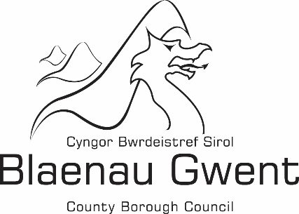

Financial Statement -

Building Regulations Chargeable and Non-Chargeable Account

Financial Statement 2019/2020

Blaenau Gwent County Borough Council's financial statement for 2019/20 is shown below:

 | Chargeable |  | Non-Chargeable |  | Total
 | £ |  | £ |  | £
Expenditure
Employee Expenses | 299,051 |  | 24,870 |  | 323,921
Transport | 6,382 |  | 0 |  | 6,382
Supplies and Services | 11,055 |  | 1,946 |  | 13,001
Third Party Payments | 1,124 |  | 0 |  | 1,124
Central and support service charges | 63,249 |  | 0 |  | 63,249
Total Expenditure | 380,861 |  | 26,816 |  | 407,678
Income
Building Regulations Charges | 106,966 |  | 0 |  | 106,966
Miscellaneous Income | 0 |  | 5,162 |  | 5,162
Total Income | 106,966 |  | 5,162 |  | 112,128
(Deficit)/Surplus for the year | (273,896) |  | (21,654) |  | (295,550)

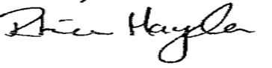
Approved by: …………………………………………………………………………………… (Section 151 Officer)

Date: -------------------------------------------------------------------------------------------------------------------

