Blaenau Gwent County Borough Council - Person Specification
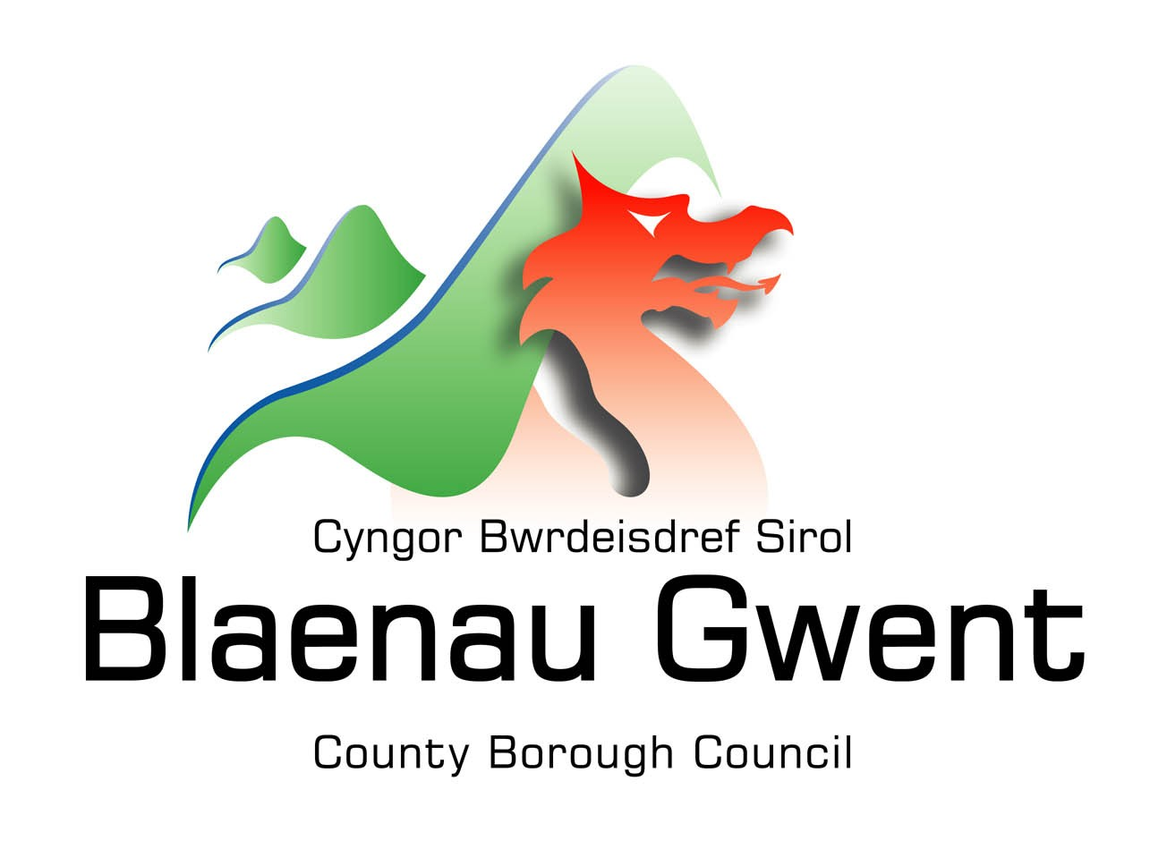
Directorate: Education

Position: Chaperone

Assessment  Criteria | Essential | Desirable
Qualifications | No formal qualifications are required
Experience and Knowledge | Experience of paid and/or voluntary work with children or caring for children  - To have undertaken Child Protection Training as directed by Blaenau Gwent County Borough Council or have a commitment to undertake it before a licence can be granted. | - Experience of theatre, TV or modelling work  - First Aid Qualification  - Awareness of Theatre Health and Safety
Specialist Knowledge | Knowledge and understanding of:  - the role and responsibilities of a licence holder  - the role of a chaperone. | Knowledge and understanding of:  - Regulation 17 of The Children (Performances and Activities) (Wales) Regulations 2015  - Keeping young performers safe Guidance to accompany the 2015 child performance regulations (Wales).
Personal Skills | - Ability to demonstrate a commitment to equal opportunities and anti- discriminatory practice.  - Ability to understand, abide by, and enforce, relevant legislation to protect children from exploitation.  - Ability to challenge those in authority where a child’s needs are being compromised.  - Ability to listen, communicate and empathise with young people whilst maintaining appropriate boundaries.  - Good organisational skills including written communication skills  - Positive role model, honest, reliable and punctual.
Personal Requirements | - Commitment to keep written records as required.
Special Conditions | - Satisfactory Enhanced DBS Check  - Satisfactory references  - Satisfactory self-disclosure form

