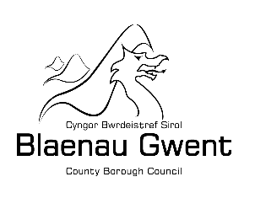
Blaenau Gwent Electric Vehicle
On Street Charging Trial
Expression of Interest
We are currently exploring a small-scale trial to understand the potential interest for electric vehicle charging for on street charging solutions in Blaenau Gwent. This would help us to work through the issues currently associated with access to electric vehicle charging on residential streets without off street parking in Blaenau Gwent.
The trial is intended to last for 12 months from the date of installation and will involve installation of on-street charging solutions. We appreciate that every home and everyone’s individual needs vary, and that this trial will look at multiple solutions. Innovative solutions will be considered for this trial and kept under review as the outcomes of trials are further understood, technology developed, and practical issues explored. This trial will be used to assess effectiveness of the solutions, combined with feedback from residents who participate.

Site selection process
Site selection for the solution will take place in stages. The first stage is an initial expression of interest to register. The second stage will be to assess the site suitability against available solutions, and we will make contact with those whose have expressed an interest once this has taken place.

What if I can't take part in the trial?
If the solutions are not deemed suitable for your home we will keep your details on a register for consideration of future solutions that become available on the market.
How do I register my interest?
If you would like to register your interest and potentially take part in an upcoming trial, please email: EVCharging@Blaenau-Gwent.gov.uk and include your address and why you would like to take part.

