Community Meals
Service

New Customers 01495 315700
Existing customers 01495 369638

About the service
We deliver hot, tasty and nutritious meals and most recently Afternoon Tea to anyone who lives in the Blaenau Gwent area. Our caring, friendly team also carry out vital welfare checks while they are delivering your meal. Anyone of all ages can apply for our delivery service. You do not need a referral from social services or your GP.

Details of the service
- We deliver hot meals between 11.00am and 1.30pm, 5 days a week Monday to Friday, the meal is ready to eat straight away. In addition to this, we also deliver frozen meals which will need to be heated in a traditional oven.

- You can choose from a wide-ranging menu offering a number of choices.

- Afternoon Tea, freshly baked/prepared;

Example 1 | Sandwiches (variety of fillings) inclusive of a salad garnish, crisp and a desert of your choice i.e. Cake- Trifle - Scone with fresh clotted cream/jam.
Example 2 | Ham Salad, a boiled egg and crisp.

Please are see our enclosed Afternoon Tea menu. Most specific dietary requirements can be accommodated, inclusive of; diabetic – vegetarian - low fat and gluten free. We also provide a full Allergen list of all ingredients.

The person delivering your meal will support you in;
How can we help you?
- Encourage you to eat your meal.
- Support you with small tasks such as; preparing cutlery - removing packaging – plating up/ cutting up your meal if you are unable to.
- We will also check that you are comfortable and secure, we will do this each time we visit you and, if there is a problem we can contact your family- friend or Doctor if you need them.

How much does the service cost?

- One hot meal including one dessert = £6.10
- One Frozen meal including one frozen dessert = £6.10
- Afternoon Tea = £3.90

If you’re not going to be in!!

- If you’re going out and won’t be home to take delivery of your meal, please let us know by calling 01495 369638.
- If you wish to cancel your meal on the same day it is due to be delivered, please ensure you call us before 9.00am to avoid being charged.

Please note: our Driver will not leave your hot meal on the doorstep for you to reheat later – if you allow it to cool and then reheat, you are at risk of food poisoning.

If you have any queries, or need advice please contact call; 01495 369638

Yours Sincerely

Community Meals Service

Community
Meals

Telephone 01495 355949

Afternoon Tea Box
Menu

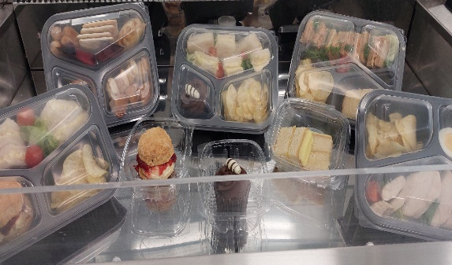
We are pleased to introduce our Tea time boxes which consists of a variety of options for you to choose from. Order from the comfort of your home and we will deliver to your door!!!
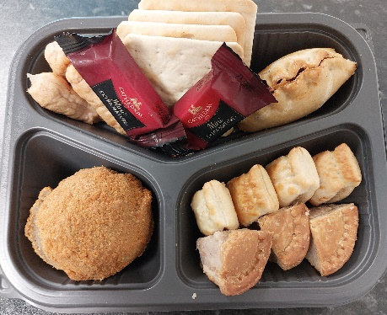
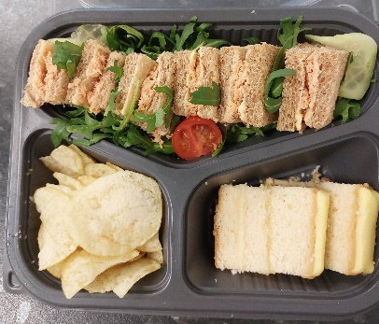
We have 3 options for you to choose from: (Sandwiches are prepared with White or Brown bread, please specify when ordering…

Menu Choices
Telephone 01495 369638
Option 1
1 x Sandwich with one filling inclusive of a Salad garnish and crisps, plus one cake or desert of your choice (Choose from menu below) £3.90p
Option 2
Sliced Ham Salad on a bed of crispy salad along with a boiled egg and Crisps
£3.90
If you have a favourite Sandwich filling or Tea Time foods which we have not included, please let us know as we value your comments
Sandwiches fillings | Cakes
 | Scone – freshly baked with Jam and Clotted Cream
Sliced Ham | Lemon Drizzle cake
Corned Beef | Cupcake - Coffee / Chocolate
Cheese & Onion | Victoria sponge
Tuna Mayo | Black Forest Gateaux
Egg Mayo | Deserts
 | Trifle – Strawberry / mixed fruit
 | Ice Cream

We thought you would like to see what you’re your chosen Tea Time Box will look like

Egg Mayo Sandwich with Salad garnish, Crisps and Chocolate Cup Cake £3.90

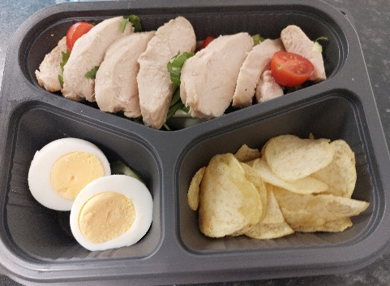
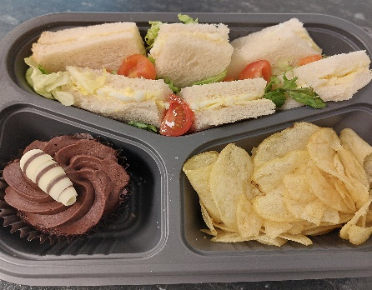
Salad tray – Boiled Egg and Crisps £3.90

“Ewch i food.gov.uk/ratings i ganfod sgôr hylendid bwyd ein busnes neu gofynnwch inni beth yw ein sgôr hylendid bwyd wrth archebu./ Go to food.gov.uk/ratings to find out the food hygiene rating of our business or ask us for our food hygiene rating when you order.”
‘Before ordering, please speak to a member of staff if you have any food allergies or intolerances.’

