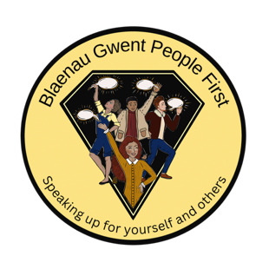

Blaenau Gwent People First - Creative Hackathon Event
2nd December 10 am. Tabour Centre, Brynmawr

Booking form:

Name: ----------------------------------------------------------------------------------------------------

Email address:-------------------------------------------------------------------------------------------

Dietary Requirements

I confirm that I will be attending the Hackathon Event on 17th November 2025.

Please return booking form to dawn@rctpeoplefirst.org.uk
Closing date for bookings Monday 17th November 2025

