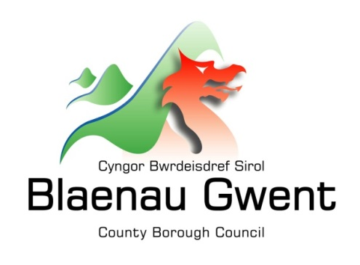

Privacy Notice – Council Tax

This notice is provided for clarification on what information the council needs in order to process Council Tax. It is necessary for the council to gather, collect, store and process personal information relating to council tax payers. The council puts measures in place to protect the privacy of individuals throughout this process.

Who is responsible for your information?
All personal information is held and processed by Blaenau Gwent County Borough Council in accordance with Data Protection legislation. For information on the role of the Data Controller, Data Protection Officer and Contact Details for the Council, please refer to the ‘Data Protection’ page of the Council’s website:
https://blaenau-gwent.gov.uk/en/Council/data-protection-foi/data-protection-act/

What Information do we need?
Blaenau Gwent County Borough Council will collect personal information about you, and if necessary, your family and other parties. This information may include:
• Details about you, such as, your name, address, telephone number, email address, bank/payment details, family composition, your financial circumstances, employment details, educational details, your health details;
• Other relevant information needed to process your council tax account.

We may check some of the information with other sources to ensure the information you have provided is accurate.

Why do we need your information?
This information is required by the council in order to carry out its duties under the Local Government Finance Act 1992.

This council is required by law to participate in National Fraud Initiative (NFI) data matching exercises and council tax and council tax support information may be provided to the Cabinet Office for NFI purposes and will be used for cross-system and cross-authority comparison for the prevention and detection of fraud.

The Council is required to administer UK Government and Welsh Government schemes that assist the residents of Blaenau Gwent.

Who will we share your information with?
To enable the Council to process your Council Tax account and comply with our legal obligations, we will share your information with partner organisations, including:

• Valuation Office and other Government departments;
• HM Land Registry;
• Gwent Police and other criminal investigation agencies;
• Welsh Government;
• Private Letting Agencies;
• Public Services Ombudsman for Wales;
• The Information Commissioner’s Office;
• Enforcement Agencies;
• Electoral Registration;
• Registrars;
• The Office for National Statistics (ONS);
• External regulators.
• Other Departments within Blaenau Gwent Council

The Council will also use the information for the purpose of performing any of its statutory enforcement duties. It will make any disclosures required by law and may also share this information with other bodies responsible for detecting/preventing fraud or auditing/administering public funds.

What is the Lawful basis for processing?
In order to comply with GDPR, personal data shall only be processed where a condition is met under article 6 of the legislation.

In this case, the lawful basis for processing is:

- a legal obligation that requires us to process your personal information;

- carrying out a public task, for instance, performing our safeguarding role, planning or waste services function.

How long do we keep your information?
The Council will only keep your information for as long as necessary. Full details of how long the Council retains your information can be obtained by contacting the relevant Department responsible for the services you require.
Council contact centre: info@blaenau-gwent.gov.uk / 01495 311556.

Providing accurate information
It is important that we hold accurate and up to date information about you in order to assess your needs and deliver the appropriate services. If any of your details have changed, or change in the future, please ensure that you tell us as soon as possible so that we can update your records.

Automated Decision Making
Some decisions are computer-based as the Council uses automated systems to support its services. If your personal data is processed by automated means, you will be notified of the outcomes and a summary of the criteria used in this process. The results are subject to a final decision by the relevant service manager.

