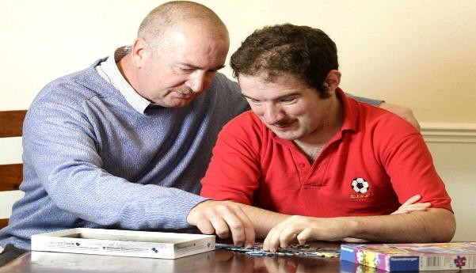

This guide is aimed to provide you with information about direct payments as an easy read document

However, if you need support to read or understand this document, please ask someone you know to help you, which could be a family member, a friend, your social worker, or someone else you may know.

# What are Direct Payments?

Your Local Authority will give you money

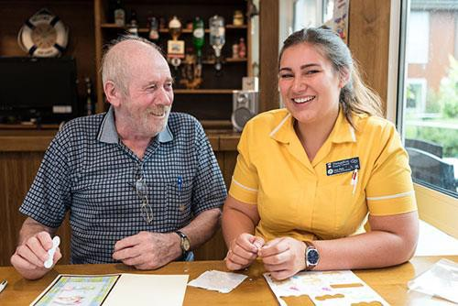You will use the money to arrange your own care and support, instead of the Local Authority arranging this for you.

You are in charge. You choose who supports you, when they support you, and how they support you.

# 

# Who can have a Direct Payment?

Anyone who is **assessed** as being **eligible** to receive care and support from social services and: -

* You are aged 16 or over
* You are a recognised unpaid carer who is aged 16 or over
* You have parental responsibility for a child with a disability

# What can a Direct Payment be used for?

# 

To employ a Personal Assistant to support you with your daily living tasks.

Daily living tasks could include, supporting you to get washed and dressed, accessing the community, socialising with others or helping at home….

To purchase care from a care agency, or for respite or residential care home

Buying equipment with specialised software installed to help you live more independently

# What is a Personal Assistant?

A personal assistant is someone you employ to support you with your daily living tasks.

It could be someone you know like a friend or neighbour, or the Local Authority can help you find someone suitable.

# 

# What Support will I Receive?

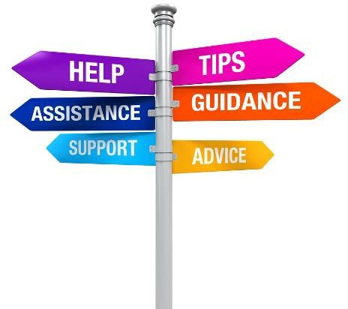The Authority’s Direct Payments Team will provide you with support, help and advice on how to set up and manage your Direct Payment.

**How much money will I receive?**

The amount of money you receive will depend on the outcome of your assessment, which will identify, your care and support needs, and personal outcomes, and how they can be met

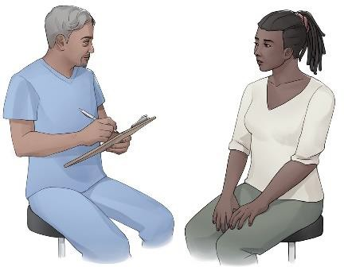

It is important for you to talk to your Social Worker about how you think your needs can be met. Together you will agree a care and support plan.

**How much will I have to pay?**

You may be asked to pay a contribution towards the cost of your care and support. The Local Authority will carry out a financial assessment to see if this applies to you.

**How will I get paid?**

The money can be paid to an accountancy company or payroll provider who will manage the money on your behalf.

Alternatively, the money can be paid to you, but you must open a separate bank account for money to be paid into. (This account will be audited annually by the Local Authority).

# Would you like to find out more about direct payments?



Team Email Address:

[Directpayments@blaenau-gwent.gov.uk](mailto:Directpayments@blaenau-gwent.gov.uk)

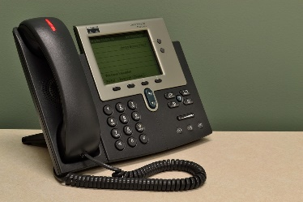Team Telephone Numbers:

01495 369624 / 01495 369623