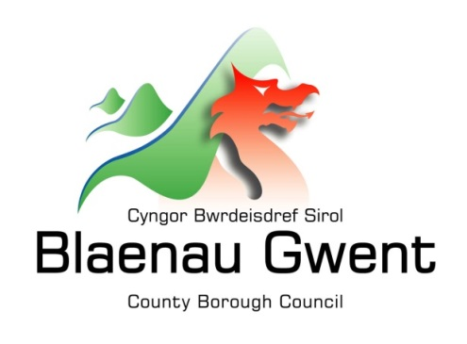

Privacy Notice – Petitions (including ePetitions)

This notice is provided for clarification on what information the Council needs in order to process all petitions received. It is necessary for the Council to gather, collect, store and process personal information in order to deliver its services. Your personal data will be processed for the purposes of starting and signing petitions to raise issues with Blaenau Gwent County Borough Council. The Council puts measures in place to protect the privacy of individuals throughout this process.

Who is responsible for your information?
All personal information is held and processed by Blaenau Gwent County Borough Council in accordance with Data Protection legislation. For information on the role of the Data Controller, Data Protection Officer and Contact Details for the Council, please refer to the ‘Data Protection’ page of the Council’s website:
https://blaenau-gwent.gov.uk/en/Council/data-protection-foi/data-protection-act/

What Information do we need?
Blaenau Gwent County Borough Council will collect personal information about you and this information will include details such as your:

- Name
- Address
- Telephone number
- Email address
- Signature

We will use this information to process your petition request and administer the necessary action. We may check some of the information with other sources to ensure the information you have provided is accurate.

Why do we need your information?
We require this information to carry out our duties under the:
- The Local Government and Elections (Wales) Act 2021 (Petitions Scheme)

We use your personal data to:
- Check that you’re eligible to sign a petition.
- Make sure that people only sign a petition once.
- Contact you about petitions you start either via email, or phone.
- Send you updates and actions taken about petitions you have signed.
If you start a petition and we accept it, your name will be published with the petition for the time it is open for signatures. We won’t publish any other personal information about you.

Who will we share your information with?
To enable the Council to process petitions and comply with our legal obligations, we will share your information:
- Internally within Blaenau Gwent Council for business purposes only.
The Council will also use the information for the purpose of performing any of its statutory duties only if necessary.

How long do we keep your information?
The Council will only keep your information for as long as necessary. Full details of how long the Council retains your information can be obtained by contacting the relevant Department responsible for the services you require.
Council contact centre: info@blaenau-gwent.gov.uk / 01495 311556.

Providing accurate information
It is important that we hold accurate and up to date information about you in order to assess your needs and deliver the appropriate services. If any of your details have changed, or change in the future, please ensure that you tell us as soon as possible so that we can update your records.

Automated Decision Making
Some decisions are computer-based as the Council uses automated systems to support its services. If your personal data is processed by automated means, you will be notified of the outcomes and a summary of the criteria used in this process. The results are subject to a final decision by the relevant service manager.

