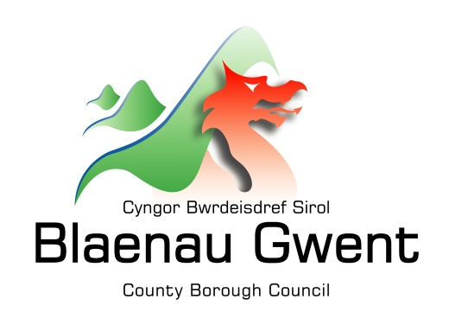
APPLICATION FOR

FINANCIAL ASSISTANCE

IN THE FINANCIAL YEAR 2021/2022 FROM THE WELSH CHURCH FUND administered by

Blaenau Gwent County Borough Council

Closing date for receipt of all completed application forms is: 31st August 2021

1. | ORGANISATION DETAILS:
a | Name and Full Postal Address of Organisation that will benefit from an award
b | What does your Organisation do?
c | How long has your Organisation been running?
d | Is the Organisation registered as a Charity? | YES  NO
e | If yes, what is its Charity number?
f | Payment Details:  Name in which account is held  Sort Code  Account Number  Roll/Other Number  (only required for Building Societies)  Payment to successful applicants will be made by direct bank transfer – please ensure correct bank details are provided. | ……………………………………………….  / /  ……………………………………………….
2. | CONTACT DETAILS:
a | Name of Contact
b | Address of Contact  (if different from above in 1a)
c | Telephone / E-mail contact details | Daytime : ………………………………...  Evening : ………………………………...  Email : …………………………………...

3. | PROJECT DETAILS:
a | What do you require the funding for?  (continue on a separate sheet, if necessary)
b | Who/How many will benefit from it?
c | Has the organisation previously applied for a Grant from the Welsh Church Fund?  If so, in which year and amount? | YES  NO  …………………. £ ……………
d | Have any other bodies or Council Departments been approached for assistance? If so, which and with what results, if known

4. | FINANCIAL DETAILS:
a | Please set out the costs for the whole of the project for which you are applying  (these should include all running and equipment costs. Please provide as much information as possible including where appropriate, costings, estimates, sketch plans, etc.)
 | PROJECT BUDGET
 | Description of Expenditure | COST (£)
 | Total Cost of Project (£) | £
b | Will your project generate any income, such as ticket sales or fees? – if so please tell us how much is projected to be raised. | £ ……………….
c | Are you using any of your organisations own funds towards the cost of the project?  If so, how much? | £ ……………….
d | Are you doing any other fund raising events for this project? If so, how much income do you expect to raise towards the funding of this project? | £ ……………….
e | How much does your organisation presently hold in its accounts to finance itself? | £ ……………….

If your organisation has been running for more than two years, please supply a copy of your last annual accounts – these will be held in a confidential manner. If there are no annual accounts, please supply the latest balance sheet or income / expenditure statements or bank statements.

f | How much money are you asking for from the Welsh Church Fund towards your project? | £ ……………….
g | Can you tell us briefly what your organisation gives to your community (such as volunteer hours, premises, equipment, fund raising etc.)?  This helps us to build a picture of the value voluntary groups such as yours give to their community.

5. | PROJECT MANAGEMENT AND EVALUATION:
a | If you receive funding for the project, when will it start and finish? (actual / projected) | Start Date: ………………………………….  Finish Date: ………………………………...
b | How do you intend to ensure that your project and organisation is sustainable going forward?

6. AUTHORISATION DETAILS

6a To ensure that organisations are applying for funding with the consent of their Governing Committee, can the Chair Person (if this is not the contact person) or other authorised officer (stating their position) sign the application please.

Name (Print) …………………………………………………………………………………

Signature ……………………………………………………………………………………….

Position in Organisation ………………………………………………………………………

Date …………………………………………………………………………………………….

6b Signature of contact person for the project

Name (Print) …………………………………………………………………………………...

Signature ………………………………………………………………………………………

Position in Organisation ………………………………………………………………………

Date …………………………………………………………………………………………….

6c I confirm that this application is worthy of consideration

Councillor (Print Name) ………………………………………………………………………

Signed …………………………………………………………………………………………..

Electoral Ward ………………………………………………………………………………...

Date …………………………………………………………………………………………….

WHEN COMPLETED THIS FORM SHOULD BE RETURNED TO:

Mr John Griffin
Blaenau Gwent County Borough Council
Resources Department
Anvil Court
Abertillery
Blaenau Gwent
NP13 1DB

Tel. No. 01495 355140
Email: grants2@blaenau-gwent.gov.uk

Please check that you have:

- Filled in all the questions – Incomplete forms may result in delays to your application
- Obtained Signatures for Section 6 (including the Councillor supporting your application (it is the applicant’s responsibility to ensure the form is signed by their local Councillor)
- Enclosed copies of recent accounts, bank statements or a balance sheet
- Bank details are correct and accurate or payment will not be made
- Ensure the application is submitted before the closing date: 31st August 2021 (any applications received after this date will not be considered).

