

**Planning Advisory Note (PAN 7)**

**GREEN INFRASTRUCTURE STATEMENTS &**

**BIODIVERSITY ENHANCEMENT SCHEMES**

***This PAN is prepared to assist in completing the Green Infrastructure Statement Proforma***

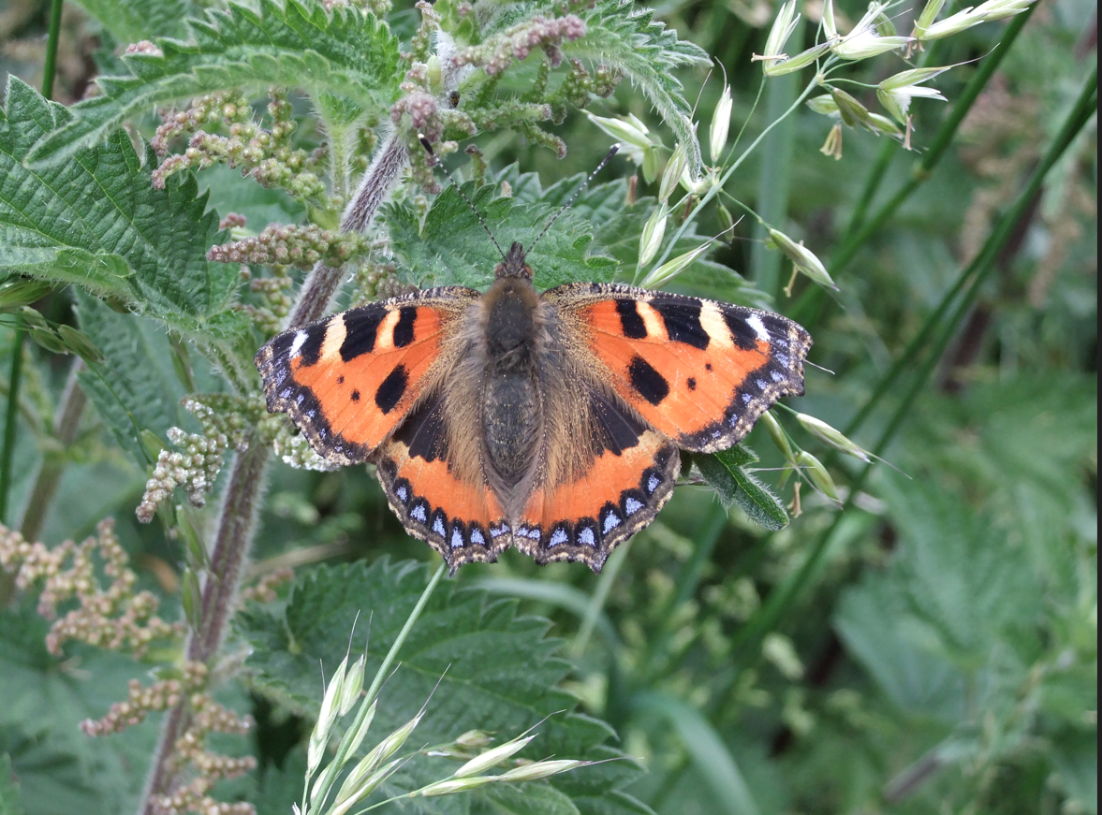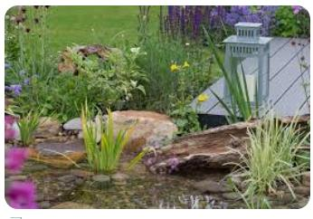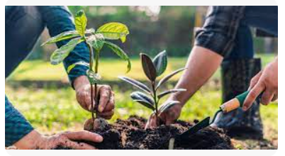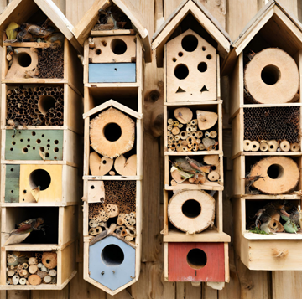

**Q. What is a Green Infrastructure (GI) Statement?**

A Green Infrastructure Statement describes how the natural value of a site (trees, hedges, and sustainable drainage (SuDs)) has been incorporated into the development proposal. A GI Statement should be proportionate to the scale and nature of the development.

**Q. Why do I need a Green Infrastructure Statement?**

A GI Statement is required on all developments following revisions to Planning Policy Wales (PPW)12, Chapter 6 published by Welsh Government and duties under the Environment (Wales) Act 2016. This requires new development to have a **net benefit** to biodiversity and green infrastructure. This information is **not** appropriate to seek ‘retrospectively’ by way of a condition and must be provided as part of the planning application process.

**Q. What is a Biodiversity Enhancement Scheme?**

To comply with the requirements, new developments must include details of biodiversity enhancement measures. These don’t always need to be costly or large in scale. It could, for example, include simple measures like bird boxes, insect boxes and the planting of native shrubs or flowers suitable for bees and other pollinators.

**Q. How do I provide the information?**

To assist in providing the information the Council requires, the associated form can be completed to provide the specific Green Infrastructure details that relate to each step of your proposed development.

**Example of completed Green Infrastructure Statement and Biodiversity Enhancement Form**

|  |  |
| --- | --- |
| Form completed by: | *A. N Other* |
| Date: | *DD/MM/YYYY* |
| Address of site: | *1 High Street, The Town, Anyshire, XX00 0XX* |
| Description of Proposal: | *New extension to rear of property, requiring removal of one tree and translocation of hedge to facilitate new driveway.* |

1. **Details of all existing green infrastructure and biodiversity enhancements (e.g. trees, hedges, ponds, bird/bat boxes, insect houses etc) on site:**

|  |  |
| --- | --- |
| Boundary 1: | *Privet hedge* |
| Boundary 2: | *Boarded fence* |
| Boundary 3: | *Non-native hedge* |
| Boundary 4: | *N/A Wall* |
| Front Garden: | *2 no. trees (Apple and cherry)* |
| Rear Garden: | *5 no. trees (Apple, Oak, Oak, Birch and Rowan)* |
| Other: | *Scattered shrubs in front and rear garden* |

1. **What green infrastructure features have already been removed from site and/or require**

**removal to facilitate the development?**

|  |  |
| --- | --- |
| Boundary 1: | *None* |
| Boundary 2: | *N/A -Fence* |
| Boundary 3: | *3 metre section removed for new access –* ***Already removed.*** |
| Boundary 4: | *N/A - Wall* |
| Front Garden: | *None* |
| Rear Garden: | *1 no. Oak -* ***Requires removal*** |
| Other: | *2 no. shrubs -* ***Require removal in rear garden*** |

1. **How will the retained features be protected during development (i.e. BS5837:2012**

**Tree Protection Works)?**

|  |  |
| --- | --- |
| Boundary 1: | *2 metre buffer zone from base of hedge using heras fencing (see below).* |
| Boundary 2: | *N/A* |
| Boundary 3: | *2 metre buffer zone from base of hedge using heras fencing (See below).* |
| Boundary 4: | *N/A* |
| Front Garden: | *Majority of garden fenced off during development with heras fencing* |
| Rear Garden: | *Garden fenced off during development with heras fencing* |
| Other: | *See attached BS5837 Tree Report* |

1. **What green infrastructure is being planted as mitigation for losses?**

|  |  |
| --- | --- |
| Boundary 1: | *N/A* |
| Boundary 2: | *N/A* |
| Boundary 3: | *Translocated hedge in sections either side of new entrance* |
| Boundary 4: | *N/A* |
| Front Garden: | *N/A* |
| Rear Garden: | *3 no. trees (Oak, Hazel, Willow)* |
| Other: | *or: See attached Landscape Plan* |

1. **What Landscaping is being planted to enhance Green Infrastructure?**

|  |  |
| --- | --- |
| Boundary 1: | *N/A* |
| Boundary 2: | *N/A* |
| Boundary 3: | *Translocated hedgebank in sections either side of new entrance* |
| Boundary 4: | *N/A* |
| Front Garden: | *N/A* |
| Rear Garden: | *3 no. trees (Oak, Hazel, Willow)* |
| Other: | *or: See attached Landscape Plan* |

1. **How will the new planting be managed or maintained?**

*3 no. trees planted for every tree removed.*

*Trees will be planted in areas previously cleared of all weeds, grass, and vegetation.*

*The trees are to be of ‘Selected Standard’ size, 10-12 cm girth, 2.75-3.0 metres tall, bare-root or root-balled and healthy and vigorous.*

*Trees will be planted in planting holes 1.2m x 1.2m x 900mm deep, with the topsoil mixed with a minimum of 20 litres of suitable tree planting compost and replaced carefully around the roots and lightly compacted every 150mm layer.*

*Trees will be supported with a treated timber stake and rubber ties*

*Planting to be undertaken in first planting season following the implementation of the development.*

*Plants/trees/shrubs will be watered as necessary during periods of dry weather.*

*Any failures will be replaced on a like-for-like basis in the next available planting season.*

*Native hedges will have 6 plants per metre in two staggered rows about 25cm apart (or 40-60cm apart in each row).*

1. **Biodiversity enhancements**

The enhancements do not need to be directly attached to the proposed new construction; they can be attached to the existing house or placed within the garden, but they do need to be on land within the red or blue line that identifies the boundary of the planning application. The principle is that the enhancements will lead to a ‘net benefit’ for biodiversity. The following biodiversity enhancements have also been added:

|  |  |  |
| --- | --- | --- |
| Type | Location | Info |
| *Bat box* | *Side of house (gable 4m metres) from ground level* | *West Facing* |
| *Hedgehog hole* | *In fence along Boundary 2* | *Agreed with neighbour* |
| *Bird Box* | *Back of house – under eaves* | *North Facing* |

1. **Declaration**

Please check the box to confirm that the information provided is to the best of your knowledge.

**Example showing how block plan could be annotated** (showing the approximate plan of the features of the development site):

|  |  |
| --- | --- |
| *Retained trees (Green circle)* | *Bat box – (Blue cross)* |
| *Removed tree (Red circle)* | *Bird box (Green cross)* |
| *New trees (Orange circle)* | *Hedgehog hole in fence (Blue cross)* |
| *Protective fencing (Purple line)* | *Hedge section translocation (Orange arrows)* |

**Site photos (examples)**

**Q. What other advice is there to help me?**

The following links relate to Green Infrastructure matters and Biodiversity Enhancements that can assist in providing details:

* [Tree Preservation Order and Conservation Area interactive map](https://www.pembrokeshirecoast.wales/planning/planning-advice/trees-and-hedge-management/)
* [Trees and Shrubs native to Pembrokeshire](https://www.pembrokeshirecoast.wales/wp-content/uploads/2019/04/Advice-Note-2015-Trees-and-shrubs-native-to-Pembrokeshire.pdf)
* [Advice note relating to Grass and Wildflower Seed Mixes](https://pembrokeshirecoast-my.sharepoint.com/personal/mikehi_pembrokeshirecoast_org_uk/Documents/Desktop/Advice%20note%20relating%20to%20Grass%20and%20Wildflower%20Seed%20Mixes).
* [Green Roof guide](https://www.pembrokeshirecoast.wales/wp-content/uploads/2020/04/green_roof_leaflet.pdf)
* [Pembrokeshire hedgebanks](https://www.pembrokeshirecoast.wales/wp-content/uploads/2020/04/hedgebank_leaflet.pdf)
* [Guidance on Selection of Trees and Shrubs in Pembrokeshire](https://www.pembrokeshire.gov.uk/objview.asp?object_id=8652&language=)
* [Boundary planting](https://pembrokeshirecoast-my.sharepoint.com/personal/mikehi_pembrokeshirecoast_org_uk/Documents/Desktop/•%09https:/www.pembrokeshirecoast.wales/wp-content/uploads/2020/09/Advice-Note-Hedge-and-Boundary-planting.pdf)
* [Implementing soft landscaping](https://www.pembrokeshirecoast.wales/wp-content/uploads/2019/04/Advice-Note-2015-Development-landscaping-and-planting.pdf)
* [Apple varieties suited to West Wales](https://www.pembrokeshirecoast.wales/wp-content/uploads/2019/04/Advice-Note-2015-Apple-varieties-and-rootstock-selection.pdf)
* [PCNPA Supplementary Planning Guidance (Biodiversity)](https://www.pembrokeshirecoast.wales/wp-content/uploads/2021/06/Post-Cons-Bio-SPG-Eng-1.pdf)
* [Pembrokeshire Green Infrastructure Statement](https://www.pembrokeshirecoast.wales/pembrokeshire-green-infrastructure-assessment/)
* [Planning Policy Wales 12 (PPW 12)](https://www.gov.wales/sites/default/files/publications/2024-02/planning-policy-wales-edition-12_1.pdf)
* [Environment (Wales) Act 2016](https://www.legislation.gov.uk/anaw/2016/3/contents/enacted)
* [Technical Advice Note 5 (TAN 5) – Nature Conservation and Planning](https://www.gov.wales/sites/default/files/publications/2018-09/tan5-nature-conservation.pdf)

**Q. How is the stepwise approach used to result in Net Benefit of Green Infrastructure?**

[1]

**Q. What are examples of biodiversity enhancements in gardens?[2]**

**For more information please contact:**

**Development Management   
Blaenau Gwent County Borough Council**

**Steelworks Road**

**Ebbw Vale**

**NP23 6DN**

**Email:**

[planning@blaenau-gwent.gov.uk](mailto:planning@blaenau-gwent.gov.uk%20)

**Telephone: 01495 364847**

**Green Infrastructure Team:**

Trees: Damian Assinder E: [damian.assinder@blaenau-gwent.gov.uk](mailto:damian.assinder@blaenau-gwent.gov.uk) 01495 355547

Ecology: Nadine Morgan E: [Nadine.morgan@blaenau-gwent.gov.uk](mailto:Nadine.morgan@blaenau-gwent.gov.uk) 01495 356070

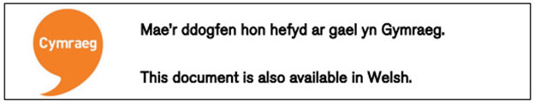

1. Figure 12 of PPW12
2.