Planning Site Notice

Town and Country Planning (Development Management Procedure) (Wales) Order 2012
Town & Country Planning (EIA) (Wales) Regulations 2017

NOTICE OF APPLICATION FOR PLANNING PERMISSION
Application for planning permission accompanied by an Environmental Statement and the proposed development does not accord with the provisions of the development plan in force in the area in which the application land is situated.

Development at Land North and East of Rassau Industrial Estate, Rassau, Ebbw Vale.

I give notice that CiNER Glass Property Ltd is applying to Blaenau Gwent County Borough Council for planning permission for Application to vary condition 3 (approved plans & documents) and remove condition 33 (great crested newts) of planning permission C/2021/0278 (Construction and operation of a purpose-built glass manufacturing facility, and associated development) (ref no C/2023/0209).

Members of the public may inspect key documents from the application at https://www.blaenau-gwent.gov.uk/en/resident/planning/ciner-glass-factory/ Alternatively, a hard copy can be made available for inspection by prior appointment by contacting 01495 355555 or email planning@blaenau-gwent.gov.uk

Members of the public may purchase a hard copy of the Environmental Statement (ES) from Mr. Luqmaan KKholwadia at luqmaan.kholwadia@arup.com so long as stocks last at a charge of £150 or the Addendum to the ES at £25

Anyone who wishes to make representations about this application should either email planning@blaenau-gwent.gov.uk or write to the Planning Team, General Offices, Steelworks Road, Ebbw Vale NP23 6DN by 13 November 2023.

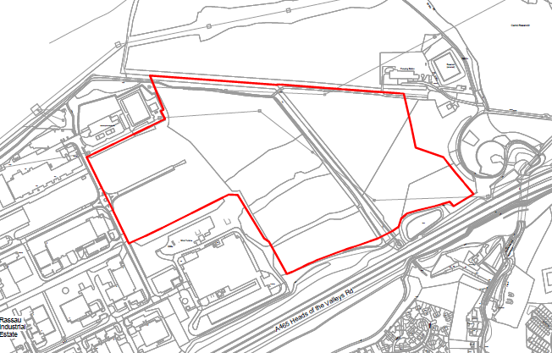
Hysbysiad Safle Cynllunio

Gorchymyn Cynllunio Tref a Gwlad (Gweithdrefn Rheoli Datblygu) (Cymru) 2012
Rheoliadau Cynllunio Gwlad a Thref (Asesiad o’r Effaith Amgylcheddol) (Cymru) 2017

HYSBYSIAD YNGHYLCH CAIS AM GANIATÂD CYNLLUNIO
Cais am ganiatâd cynllunio a gyflwynir gyda Datganiad Amgylcheddol lle nad yw’r datblygiad arfaethedig yn cydymffurfio gyda darpariaethau’r cynllun datblygu sydd mewn grym yn yr ardal lle mae’r tir y gwneir y cais amdano.

Datblygiad ar Dir i’r Gogledd a’r Dwyrain o Stad Ddiwydiannol Rasa, Rasa, Glynebwy.

Hysbysaf fod CiNER Glass Property Cyf yn gwneud cais i Gyngor Bwrdeistref Sirol Blaenau Gwent am ganiatâd cynllunio ar gyfer Cais i amrywio amod 3 (cynlluniau a dogfennau a gymeradwywyd) a dileu amod 33 (madfallod cribog) o ganiatâd cynllunio C/2021/0278 (Adeiladu a gweithredu safle pwrpasol cynhyrchu gwydr a datblygiad cysylltiedig. (cyfeirnod C/2023/0209).

Gall aelodau’r cyhoedd archwilio dogfennau allweddol o’r cais yn https://www.blaenau-gwent.gov.uk/en/resident/planning/ciner-glass-factory/ neu gellir darparu copi caled i’w archwilio drwy wneud apwyntiad ymlaen llaw drwy gysylltu â 01495 355555 neu e-bost planning@blaenau-gwent.gov.uk

Gall aelodau o’r cyhoedd brynu copi caled o’r Datganiad Amgylcheddol gan Mr. Luqmaan Kholwadia yn lugmaan.kholwadia@arup.com cyhyd ag mae stoc ar gael am gost o £150 neu’r Ychwanegiad at y Datganiad Amgylcheddol am £25.

Dylai unrhyw un sy’n dymuno gwneud sylwadau am y cais hwn naill ai anfon e-bost at planning@blaenau-gwent.gov.uk neu ysgrifennu at y Tîm Cynllunio, Swyddfeydd Cyffredinol, Heol Gwaith Dur, Glynebwy NP23 6DN 13 Tachwedd 2023.

