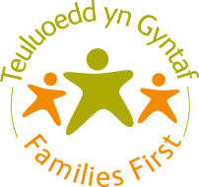
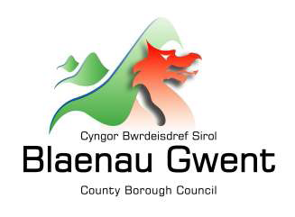
Ref No.

Together Everyone Achieves More
Cyflawni Mwy Gyda’n Gylydd
Blaenau Gwent Families First
Referral Form
Type of Referral: |  |  |  | Initial Referral  Self-Referral  Re-referral |  |  |  | Step Down Referral  Is the family remaining open to SSD? Y/N  Please attach Integrated Assessment/last Care & Support Plan
Family Name/Names:
Address:
Telephone Number/s:
Previous Addresses:
Previous JAFF Assessment: |  |  |  |  |  | Yes |  |  |  | No
Is this a Flying Start Family: |  |  |  |  |  | Yes |  |  |  | No
Does any family member have needs relating to a disability? |  |  |  |  |  | Yes |  |  |  | No
Family affected by imprisonment? |  |  |  |  |  | Yes |  |  |  | No
Name of Referring Agency:
Name & Contact Details of Referring Worker:
Referring Worker’s Signature
Date of Completion
I understand that the information in this form will be added to the Families First database and may be shared with other service providers in order to meet my needs. This database is used by Families First for administration, service delivery and monitoring and evaluation.
I understand that the data will be stored and shared in accordance with the Data Protection Act 1998.
Has informed consent been obtained from the Family/Young Person/Child to make this referral:
Yes: Verbal: Written:

No: If not, why not:

Brief Summary of Family Circumstances:
Reason for Referral/Support Required:

WCCIS  Number | Status Within Family (e.g. Mother) |  | Surname |  | First Name |  |  |  | DOB |  | Gender  (M/F) |  | Ethnicity | Household Members  Y/N

Families First Office Use Only
Referral Outcome/Decision:

Signature:

Date:

Please return form marked CONFIDENTIAL to:
Blaenau Gwent Families First Team
Heart of the Valleys Integrated Children’s Centre
High Street
Blaina
Blaenau Gwent
NP13 3BN
Email: familiesfirstduty@blaenau-gwent.gov.uk
Telephone: 01495 355584

