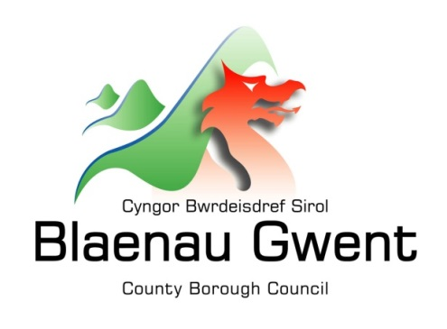

Privacy Notice – Development Services - Development Plans

This notice is provided for clarification on what information the council needs in order to prepare the Local Development Plan (LDP) and associated Supplementary Planning Guidance (SPG). It is necessary for the council to gather, collect, store and process personal information relating to people submitting candidate sites, those participating in the preparation or commenting on the Plan or associated documents including Supplementary Planning Guidance. The council puts measures in place to protect the privacy of individuals throughout this process.

Who is responsible for your information?
All personal information is held and processed by Blaenau Gwent County Borough Council in accordance with Data Protection legislation. For information on the role of the Data Controller, Data Protection Officer and Contact Details for the Council, please refer to the ‘Data Protection’ page of the Council’s website:
https://www.blaenau-gwent.gov.uk/en/council/data-protection-foi/data-protection-and-gdpr/

What Information do we need?
Blaenau Gwent County Borough Council may collect the following information:
- Name and address
- Contact information including email address
- Other information you might submit as part of the development plan process

We will use this information to process candidate sites and views or comments received on the Plan or associated Supplementary Planning Guidance.

Why do we need your information?
We require this information to carry out our duties under the:
- Town & Country Planning Act 1990 and associated Regulations
- Planning and Compensation Act 1991 – amended the above Act
- Planning and Compulsory Purchase Act 2004 – amended the Town and Country Planning Act 1990
- Planning Act 2008 – supplements the 2004 Act
- Planning (Wales) Act 2015 amends the 1990 and 2004 Acts
- The Town and Country Planning (Local Development Plan) Regulations 2005 (as amended)

We need this information to:
- process your candidate site submission
- report on participation in developing the Preferred Strategy
- process comments on the Development Plan (Preferred Strategy, Deposit Plan, Sustainability Appraisal/ Strategic Environmental Assessment and Habitat Regulation Assessment)
- process comments and report on Supplementary Planning Guidance.
- to contact you for research purposes to enable us to improve the services we offer. We may contact you by email, letter or phone.

Who will we share your information with?
To enable the Council to deal with your involvement in the process and comply with our legal obligations, we will share your information with partner organisations, including:

- Internally within Blaenau Gwent Council
- Your legal representatives
- Planning and Environment Decisions Wales
- ICT service provider – SRS (Shared Resource Service Wales)

What is the Lawful basis for processing?
In order to comply with GDPR, personal data shall only be processed where a condition is met under article 6 of the legislation.

In this case, the lawful basis for processing is:
- a legal obligation that requires us to process your personal information;
- carrying out a public task, for instance, performing our safeguarding role, planning or waste services function.

If we have your consent to use your personal information, you have the right to remove it at any time. If you want to remove your consent, please contact DataProtection@blaenau-gwent.gov.uk and tell us which service you’re using so we can deal with your request.

How long do we keep your information?
The Council will only keep your information for as long as necessary. However, there may be circumstances where we may need to keep your information for longer. Full details of how long the Council retains your information can be obtained by contacting the relevant Department responsible for the services you require.
Council contact centre: info@blaenau-gwent.gov.uk / 01495 311556.

Providing accurate information
It is important that we hold accurate and up to date information about you in order to assess your needs and deliver the appropriate services. If any of your details are incorrect or incomplete, please ensure that you tell us as soon as possible so that we can update your records.

December 2025

