Early Years Additional Learning Needs (ALN) Guidance and Process

September 2025
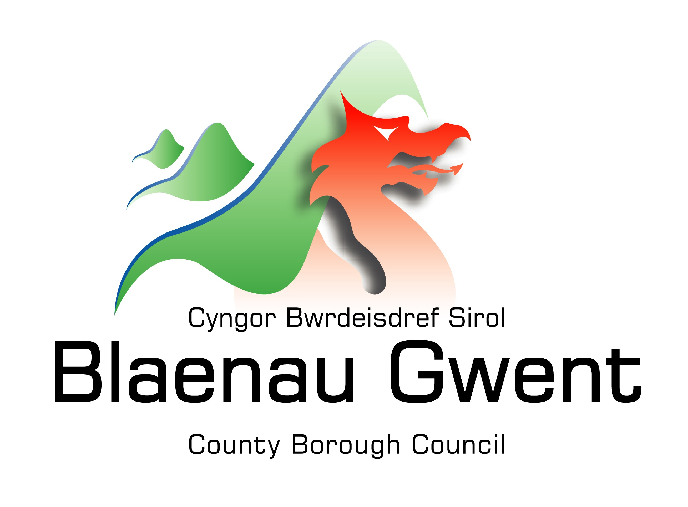
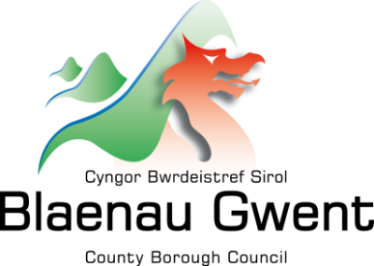

Contents

Introduction
Additional Learning Needs and Education Tribunal Act 2018 & Key Changes
Definition of Additional Learning Needs (ALN)
Definition of Additional Learning Provision (ALP)
Equality Act 2010
Definition of Disability
Discrimination
Vision
Inclusion for All
Early Years Additional Learning Needs Lead Officer (EY ALNLO)
Fig 1: One Page Profile
Fig 2: Graduated Response and Levels of Support
Person Centred Planning
Transition to Maintained Settings

Appendix:
Notification of ALN and the Statutory Process Pathways

Introduction
This Early Years Additional Learning Needs (ALN) Guidance and Process document outlines the Blaenau Gwent Local Authority approach to supporting Early Years settings (maintained and non-maintained) with their responsibilities under the Additional Learning Needs and Education Tribunal Act (ALNET) 2018 and The ALN Code for Wales 2021. The approach within this guidance intends to meet the needs of our young children with additional needs (AN) and/ or Additional Learning Needs (ALN), to overcome barriers and challenges to enable those children to reach their full potential.
This guidance is inclusive of the Early Years 0-5 age range and the ALN Act 2018 The ALN Code for Wales 2021 The pathways to support children with Additional Needs and/or with Additional Learning Needs are included as appendices within this guidance.
The authority has a designated Early Years ALN Lead Officer in post and this role works in partnership with health and social care colleagues.
This document should be read in conjunction with:
- Blaenau Gwent, Additional Learning Needs Policy
- Blaenau Gwent, Meeting the Healthcare Needs of Children and Young people - Guidance and Process

The Additional Learning Needs and Education Tribunal Act 2018 (ALNET)
The Additional Learning Needs and Education Tribunal Act 2018 (ALNET) was implemented in Wales from September 2021.
The principles underpinning the ALN system are:
- A rights-based approach
- Early identification, intervention, and prevention
- Collaboration and integration
- Inclusive education
- A bilingual system

There are 11 key changes from the previous legislation.
The core Principles are:
- The Introduction of the term Additional Learning Needs (ALN) - Replacing the term ‘Special Educational Needs’ with ‘Additional Learning Needs’ (ALN) and ‘Special Educational Provision’ with ‘Additional Learning Provision’ (ALP)
- 0–25 age range - Improved transition between early years education providers and schools
- A unified plan - Individual Development Plans (IDP) will replace Statements of Special Educational Needs and other non-statutory SEN plans for children.
- Increased participation of children and young people - The Act requires that the child’s views should always be considered as part of the planning process, along with those of their parents.
- High aspirations and improved outcomes - The emphasis of IDPs will be on identifying ALP that delivers appropriate positive outcomes for all
- Clear and consistent rights of appeal - Childs and their parents will have the right to appeal to the Education Tribunal against decisions made by a Local Authority (LA) in relation to their ALN or their ALP.
- Increased collaboration - Improved collaboration and information sharing between agencies including education, health and social services, which will be essential to ensuring that needs are identified early and the right support is put in place to enable children and young people to achieve positive outcomes.
- Avoiding disagreements and earlier disagreement resolution - Where disagreements occur about an IDP or the provision it contains, the matter is considered and resolved at the most local level possible.
- Clear and consistent rights of appeal - When disagreements about an IDP cannot be resolved at a local level, parents and young people will have the right to appeal to Tribunal.
- ALN Code - The ALN code will impose mandatory requirements in respect of decisions about ALN; preparation, content, form, review and revision of IDPs and ceasing IDPs.
- A bilingual system - The Act requires that services must consider whether a child or young person needs ALP in Welsh. If they do, this must be documented in the IDP and ‘all reasonable steps’ must be taken to secure the provision in Welsh.

Definition of Additional Learning Needs (ALN)

The Additional Learning Needs Code for Wales 2021, provides a clear definition of what constitutes an Additional Learning Need:

2.3. Definition of additional learning needs:
(1) A person has additional learning needs if he or she has a learning difficulty or disability (whether the learning difficulty or disability arises from a medical condition or otherwise) which calls for additional learning provision.
(2) A child of compulsory school age or person over that age has a learning difficulty or disability if he or she —
(a) has a significantly greater difficulty in learning than most others of the same age, or
(b) has a disability for the purposes of the Equality Act 2010 which prevents or hinders him or her from making use of facilities for education or training of a kind generally provided for others of the same age in mainstream maintained schools or mainstream institutions in the further education sector.
(3) A child under compulsory school age has a learning difficulty or disability if he or she is or would be if no additional learning provision were made, likely to be within subsection (2) when of compulsory school age.
(4) A person does not have a learning difficulty or disability solely because the language (or form of language) in which he or she is or will be taught is different from a language (or form of language) which is or has been used at home.

Just because a child or young person has a disability or a medical condition, this doesn’t automatically mean that they have ALN. It is only if their disability or medical condition prevents them from accessing mainstream provision and/or they need ALP to access education facilities that they are considered to have ALN.

2.18. Those children and young people who are considered ‘more able and talented’ do not have a difficulty in learning based on their enhanced ability or talent. These children and young people may require enhanced opportunities and challenge to reach their full potential, but this ought to be provided as part of differentiated teaching.

Definition of Additional Learning Provision (ALP)

The Additional Learning Needs Code for Wales 2021, provides a clear definition of what constitutes an Additional Learning Provision:

2.4. Definition of additional learning provision:
(1) “Additional learning provision” for a person aged three or over means educational or training provision that is additional to, or different from, that made generally for others of the same age in—
(a) mainstream maintained schools in Wales,
(b) mainstream institutions in the further education sector in Wales, or
(c) places in Wales at which nursery education is provided.
(2) “Additional learning provision” for a child aged under three means educational provision of any kind.
(3) In subsection (1), “nursery education” means education suitable for a child who has attained the age of three but is under compulsory school age.

2.15. ALP for those aged under three can take many forms; for instance, group work or individual support - where it is educational provision of any kind. This might include, for example, educational provision in Flying Start or specialist health, physical, communication or sensory support. This can take place in an education setting or elsewhere.

2.42. In the case of young children, learning ought to provide the opportunity to develop their knowledge, skills and understanding of the world through exploratory play and experiences. Childs with ALN might require ALP in the form of exploratory play, or other ALP to enable them to access appropriate play opportunities/activities.

The Equality Act 2010
The Equality Act 2010 states that we must promote equality of opportunity and must not discriminate against, harass or victimise children with a disability. Maintained and non-maintained settings have a duty to make reasonable adjustments to ensure that children with a disability are not at a substantial disadvantage compared with their peers. This duty is anticipatory: settings must look ahead and anticipate what disabled children might need and what adjustments might need to be made to prevent any disadvantage.
Definition of Disability
The Act defines that a person has a disability if they have a physical or mental impairment that has a substantial and long-term adverse effect on their ability to carry out normal day-to-day activities.

Discrimination
The law prohibits ‘direct discrimination’, for example if a setting refused to offer a child a place because the child has a disability; and ‘indirect discrimination’ where policies or practices within a setting may particularly disadvantage children who share a particular ‘protected characteristic’ including, race/ethnicity, gender, disability, religion and belief. This means that all children and adults should be treated with equal concern and respect and that the setting complies with relevant anti-discriminatory legislation and good practice in all areas, including employment, training, and admission to settings and access to the resources, activities and facilities available. The setting is responsible for ensuring that there is an equal opportunities policy, which is consistent with current legislation and guidance and is regularly reviewed. All practitioners and volunteers understand and implement this policy and it is available to parents.

Vision
The vision of the Welsh Government is to deliver a fully inclusive education system for the children of Wales; Blaenau Gwent Local Authority is in full support of this approach. Planning should be flexible and responsive, and professionals should be skilled and confident in identifying needs. The child should be at the centre of everything we do, and they and their parents or carers seen as equal partners in their learning; this is known as Person Centred Practice (PCP).

Inclusion For All
The vision for Wales is to have strong and inclusive setting committed to excellence, equality and wellbeing. All children should have their needs met enabling them to participate, benefit from, and enjoy learning and play in a diverse growing and changing world.
All children will be welcomed and included in all settings across Blaenau Gwent. Where children require additional or particular support to meet their needs, care will be taken by practitioners to identify and implement this both inclusively and sensitively.
Successful inclusive practice happens primarily when practitioners accept, understand, and attend to a child’s physical, social, cognitive, emotional and academic differences and diversity. In its simplest form, inclusive practice means that every child, no matter what their barrier to learning or play, has equal access to learning and opportunities to succeed.

The Early Years Additional Learning Needs Lead Officer (EYALNLO)
It is a duty for Local Authorities to designate an Early Years ALN Lead Officer. This statutory role has responsibility for coordinating the Local Authority’s Early Years ALN functions under the 2018 Act (Chapter 10 ALN Code of Practice).
The EYALNLO will:
- Hold the register of all AN and ALN children in the Early Years sector in Blaenau Gwent. This is known as the Early Years ALN Cohort.
- Work with children up to statutory school age (term after 5th Birthday) if they are not accessing a maintained setting.
- Work with Early Years colleagues across the authority and beyond to ensure appropriate identification and support for children.
- Co-ordinate PCP meetings for those children identified as requiring assessment for ALN and be responsible for ensuring the statutory process is followed and the IDP is developed where necessary.
- Co-ordinate transition meetings with maintained nursery settings for learners with emerging needs or ALN.
- Have a role in the strategic planning for any Inclusion budgets and/or any funding the authority provides for children under compulsory school age.
- Be directly involved with the development of the authority’s guidance and processes regarding ALN provision for children under compulsory school age.
- Develop and deliver training to settings on matters related to ALN and Inclusion, engaging other professionals where appropriate for specialist input.
- Maintain their own continuing professional development in the field of ALN to remain an authoritative and expert source of knowledge.

The Local Authority Duties Include:
- Deciding whether a child has an ALN and the designation of an officer to be to be responsible for coordinating the actions required to make that decision and if an IDP is required, to be responsible for preparing it.
- Preparation of a Local Authority Individual Development Plan (IDP) in line with a statutory 12-week timeline.
- Maintaining a LA IDP and securing the Additional Learning Provision (ALP) identified and described in the document.
- Reviewing and revising an IDP.
- Reviewing the ALP arrangements.
- Making arrangements to provide advice and information and taking reasonable steps to make the arrangements known to parents and case friends of children in its area.
- Making arrangements for the avoidance and resolution of disagreements and promoting the use of them to parents.
- Making arrangements for the provision of independent advocacy services.
- Outline any action the Local Authority will undertake following its consideration to ensure the child’s needs are met if the child does not have ALN at this time.
Fig 1: One Page Profile

A one-page profile is a simple summary of what is important to a child or young person and how they want to be supported.
This information will be gathered during the PCP review meeting with children with an Additional Need (AN) or with identified children with an Additional Learning Need (ALN).

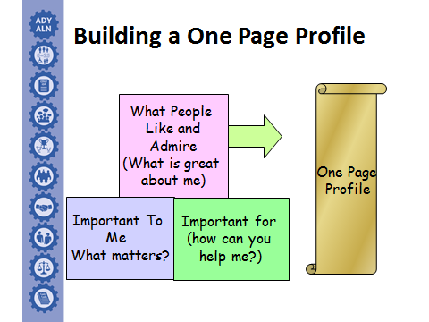

The information that is included on a One Page Profile / All About Me is as follows:
- What is great about me? – What do people like and admire about the child? This can include personal attributes such as ‘I am always happy’.
- What and who is important to me? – What and who really matters to the child from their perspective? What is needed for them to have a good day?
- What is unique about me? – Is there anything specific people might need to know about the child? This might include allergies or additional needs.
- What do I need a little help with? How can you help me? – What is needed to keep the child safe, healthy and to help them develop?

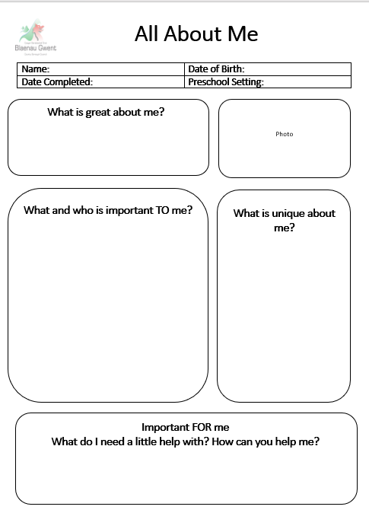

Fig 2: Graduated Response

Early intervention is key in Early Years, and we apply a graduated response. Support and strategies are put in place when children are exhibiting emerging or lower-level needs. This support may prevent a child from developing significant needs and escalation of an ALN.

Significant Needs/ALN

Lower-Level Additional Needs

Emerging Needs

Graduated Response - Levels of Support

Provision for a child with additional needs will differ depending on the individual needs of the child but should fall into one of three categories:
- Ordinarily Available Provision - Learning environments are tailored to meet the needs of all children, so they are able to make progress in learning and have wellbeing needs met.

- Targeted Support - Professionals working with the child have appropriate knowledge and skills to monitor the specific needs. They can act accordingly if additional help is needed.

- Specific Support - The child has a complex need which means that specialised/specific individualised provision is required to meet the child’s needs and enable them to make progress. This is Additional Learning Provision (ALP).

As the triangle suggests, most children will access the ordinarily available offer, some will be receiving targeted support, and a small number of children will require specific support (ALP).

Ordinarily Available Provision
Specific
Targeted
Child has a complex need, involved with health and other professionals and receives specific individualised support informed by specialists, as well as access to targeted and ordinarily available provision
Child may have a One Page Profile and action plan or IDP (ALP)

Interventions and/or strategies employed to support child, this will include Health input and other professionals.
Child may have a One Page Profile and action plan.

Inclusive settings delivering effective, differentiated experiences with reasonable adjustments made to suit a child’s needs.
Ordinarily Available Provision constitutes the ordinarily available strategies and interventions that have been identified as good practice for enriching and inclusive learning experiences.
This may also include a health care plan for children with an identified health care need.

Person Centred Practice (PCP)

Person Centred Practice (PCP) means focusing on the child and keeping them at the centre of everything we do.
A person-centred approach is all about:
- Understanding the child’s needs and wishes.
- Thinking about what is important to them and for them.
- Thinking about what is working and not working.
- Making sure that the child gets the best support from everyone involved.

All meetings that are held in relation to children should be person centred.
If there are concerns that a child may have Additional Learning Needs, and a graduated response to meeting the child’s needs has been undertaken (please see fig 2 above), a PCP meeting will be arranged by the EY ALN Lead Officer to gather and share further information with all professionals involved as well as the parents/carers of the child. This will help in the determination of whether a child requires Additional Learning Provision and therefore has an Additional Learning Need that requires an Individual Development Plan (IDP).
Following the PCP meeting, the Early Years ALN Lead Officer will refer the case as a submission to the Blaenau Gwent ALN Statutory Panel.

Transition to Maintained Nursery Settings
The Additional Learning Needs Lead Officer (ALNLO) will co-ordinate PCP transition meetings to nursery settings in a maintained school for those learners who have:
- Additional Learning Needs
During these meetings all information will be shared according to child’s need to allow the school to plan for transition and to ensure the appropriate support is in place on entry.

During the first term of integration to maintained nursery setting, the ALNLO will follow up with the school ALNCo (Additional Learning Needs Co-ordinator) to ensure that the child is settled and to offer further guidance and support, including signposting to agencies, if needed.

---------------------------------------------------------------------------------

Appendix

Appendix | ALN Notification of ALN and Pathway – early Years

For any queries regarding this guidance and/or the processes, please email: ALNEnquiries@blaenau-gwent.gov.uk

This document should be read in conjunction with the Blaenau Gwent ALN Policy and further information, available on our website via the link below:
Additional Learning Needs (ALN) | Blaenau Gwent CBC (blaenau-gwent.gov.uk)

