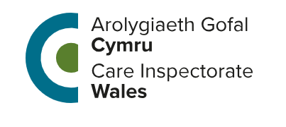

An Assurance Check by CIW

Will you help us with our work?
This leaflet tells you what the assurance check is all about.
It also tells you why we want to hear your views and the sort of things we may ask you.
Who are CIW?

We are a team of inspectors looking at how people are helped, protected and looked after in the area where you live.

Why are inspectors visiting?

Inspectors want to see what is working well and what could work better for people who need help and support from the local authority.
Why have I been asked to take part?

We want to know what you think of the help you have been given and how well professionals work together to help you.
What will I be asked to do?

Inspectors may:
- Meet with you on a computer or on the phone or face to face to speak about the help you receive.
- Ask if you would be happy to complete a short survey.

Inspectors are there to see how you are helped – they are not there to check on you.

You do not have to share personal information with them.
Do I have to take part?

Not if you don’t want to. You will always be asked before any meeting if you are happy for the inspector to be there or speak with you.

We do want to hear your views but it’s up to you – you can say ‘no thanks’ at any time.

What will the inspector do with the things I tell them?

What you tell us is private unless the inspector thinks that you or someone else is being harmed. If we need to tell someone else what you have said, we will tell you as soon as we can. For more about how we use information about you, please see our Privacy Notice at: https://careinspectorate.wales/how-we-use-your-information
What happens at the end of the assurance check?

We will tell senior managers at social services about what we have heard so that they can think about what is working well and what make improvements should be made.

What if I want to complain about the assurance check?

The inspector can tell you how to do this, or you can:

Write to us:
Care Inspectorate Wales
Welsh Government Offices
Rhydycar Business Park
Merthyr Tydfil
CF48 1UZ
Call us on the phone:
0300 790 0126

Send us an email:
CIWLocalAuthority@gov.wales

Visit our website:
https://careinspectorate.wales

