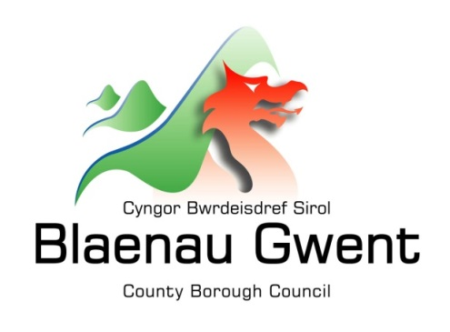

Privacy Notice – Education Transformation

This notice is provided for clarification on what information the council needs in order to process Education Improvement and Inclusion information. It is necessary for the council to gather, collect, store and process personal information relating to claimants. The council puts measures in place to protect the privacy of individuals throughout this process

Who is responsible for your information?
All personal information is held and processed by Blaenau Gwent County Borough Council in accordance with Data Protection legislation. For information on the role of the Data Controller, Data Protection Officer and Contact Details for the Council, please refer to the ‘Data Protection’ page of the Council’s website:
https://blaenau-gwent.gov.uk/en/Council/data-protection-foi/data-protection-act/

What Information do we need?
Blaenau Gwent County Borough Council will collect personal information about you, and if necessary, your family and other parties. This information will include:
- Personal details
- Family details
- Lifestyle and social circumstances
- Employment and education details
- Student and pupil records
- Case file information
- Physical or mental health details
- Racial or ethnic origin
- Religious or other beliefs of a similar nature

We will use this information to process/administer your involvement with Education Improvement and Inclusion services. We may check some of the information with other sources to ensure the information you have provided is accurate.

Why do we need your information?
This information is required by the council in order to carry out its duties under the Education (Wales) Act 2014 and other related legislation in order to deliver the services to which you are entitled or have requested.

Who will we share your information with?
To enable the Council to process your request and comply with our legal obligations, we may share your information with partner organisations, including:
- Family, associates or representatives of the person whose personal data we are processing
- Healthcare, social and welfare organisations
- Educators and examining bodies
- Local and central government
- Press and the media
- Professional advisers and consultants
- Courts and tribunal
- Trade unions
- Professional bodies
- Survey and research organisations
- Police forces
- Voluntary and charitable organisations
- Students and pupils including their relatives, guardians, carers or representatives
- Data processors
- Regulatory bodies
- Local and central government
- Partner agencies and approved organisations
- Service providers
- Healthcare professionals
- Current past and prospective employers and examining bodies
- Law enforcement and prosecuting authorities
- Legal representatives / defence solicitors
- The disclosure and barring service
It may sometimes be necessary for the Council to transfer personal information overseas. When this is needed information may be transferred to countries or territories around the world. Any transfers made will be in full compliance with all aspects of the Act.

The Council will also use the information for the purpose of performing any of its statutory enforcement duties. It will make any disclosures required by law and may also share this information with other bodies responsible for detecting/preventing fraud or auditing/administering public funds.

How long do we keep your information?
The Council will only keep your information for as long as necessary. However, there may be circumstances where we may need to keep your information for longer. Full details of how long the Council retains your information can be obtained by contacting the relevant Department responsible for the services you require.
Council contact centre: info@blaenau-gwent.gov.uk / 01495 311556.

Providing accurate information
It is important that we hold accurate and up to date information about you in order to assess your needs and deliver the appropriate services. If any of your details have changed, or change in the future, please ensure that you tell us as soon as possible so that we can update your records.

Automated Decision Making
Some decisions are computer-based as the Council uses automated systems to support its services. If your personal data is processed by automated means, you will be notified of the outcomes and a summary of the criteria used in this process. The results are subject to a final decision by the relevant service manager.

