**Croeso**

Soft Drinks

Coke

7Up /Fanta Orange

Bottled Water

Cakes

Panini ‘s

Sandwiches

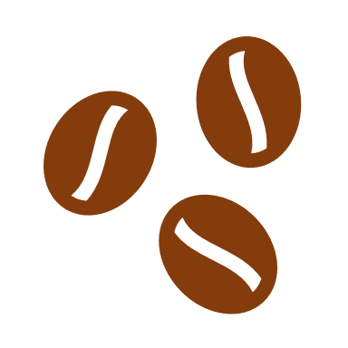 **Coffee**

* Cappuccino
* Latte
* Freshly ground.
* Instant

Tea

Hot chocolate

**Welcome to the ‘Stute Café where we pride ourselves on being a happy and friendly place!!! Please place your order at the counter and, we will be happy to bring your order to your table.**

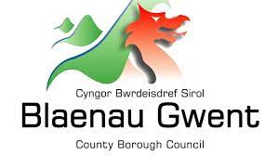

**BCIL**

*1893*

**In partnership with BGCBC**

|  |  |
| --- | --- |
| **Drinks**  **Tea for 0ne--------------------------------- £1.20**  **7up------------------------------------------- £1.10**  **Coke Diet------------------------------------ £1.10**  **Orange Tango------------------------------ £1.10**  **Water---Spring/Still---------------------- £1.00**  **Fruit Shoot--------------------------------- £0.80**  **Coffee’s**  **Cappuccino ------------------------ £2.50**  **Latte --------------------------------- £2.50**  **Americano black/white--------- £2.50**  **Instant ------------------------------ £1.85**  **Hot Chocolate & cream--------- £2.70**  **Thick Toast with Butter--------- £1.50**  **Sandwiches fillings**  **Ham & Tomato ------------------- £3.00**  **Egg Mayo--------------------------- £3.00**  **Tuna Mayo------------------------- £3.00**  **Cheese & onion------------------- £3.00**  *All sandwiches are served with a salad garnish.*    **Sandwich box**  **Includes; a sandwich/side salad/ Crisps & a cake -----------------------------------£5.75** | **Cakes**  **Lemon cupcake---------------------------------- £1.30**  **Chocolate Cupcake----------------------------- £1.30**  **Coffee Cupcake---------------------------------- £1.30**  **Victoria Sponge---------------------------------- £1.50**  **Fresh scone, cream & Jam--------------------- £1.95**  **Tea Cake with butter--------------------------- £1.40**  **Panini & fillings** (freshly made)  **Ham & Cheese ------------------------------------ £3.50**  **Ham & Tomato------------------------------------ £3.50**  **Tuna Melt (onion & cheese)------------------- £3.50**  **Cheese & Onion----------------------------------- £3.50**  *All sandwiches are served with a salad garnish.*  **Crisps------------------------------------------------- £0.75**  **Chocolate bars------------------------------------- £1.00**  **Pre-Order only**  **Afternoon Tea - (**freshly made).  Assorted sandwiches , selection of cakes, savoury items, and unlimited tea-------------------------**£8.95**  Baseball hat with solid fill Baseball hat with solid fill |

**“Ewch i food.gov.uk/ratings i ganfod sgôr hylendid bwyd ein busnes neu gofynnwch inni beth yw ein sgôr hylendid bwyd wrth archebu./ Go to food.gov.uk/ratings to find out the food hygiene rating of our business or ask us for our food hygiene rating when you order.” ‘Before ordering, please speak to a member of staff if you have any food allergies or intolerances.’**



