Is the Council using its resources economically, efficiently and effectively?

How Well We Are Doing and How Do We Know

Evaluation Rating 3:  Adequate | Evaluation Narrative:  The Council, like all local authorities in Wales, is facing a wide range of financial pressures which will impact the way we deliver our services now and in the future. Areas outside of the Council’s control, such as, energy costs, inflation and demand create a significant challenge for the organisation, and we will not be able to deliver services in the same way as we have in the past. The Council will continue to do what it can through engaging with residents when setting our budget, as undertaken during the 2022/23 budget setting process where more than 5.5% of the community contributed to and assisted in shaping the decisions made by Council. We will also continue to implement our bridging the gap programme, review the assets that the Council has and also identify commercial opportunities to generate income. As part of their audit of accounts for 2020/2021, Audit Wales identified errors within our Fixed Asset Register. Work is underway to remedy this, and the progress made in this area will be reported in our next self-assessment.

Finance and Resources
The Council will have to make some difficult decisions about services following its financial settlement from the Welsh Government, which, at 6.5%, is significantly below the all Wales increase of 7.9%. Like all organisations, the Council is facing some well-publicised financial pressures, despite increased funding from Welsh Government to almost £140 million. These pressures include the global pandemic, cost pressures, rising inflation, soaring energy and fuel costs and social care demands.

The Budget for 2023/24, was agreed by Council in early 2023 following widespread engagement with residents on savings ideas and spending priorities. Our engagement programme gave people the opportunity to share their views to help us plan our budget and services from April 2023 until March 2024 and beyond. The programme consisted of a number of public events, surveys and other ways to engage people to help shape the decision making process. A total of 3,736 questionnaires were returned which equates to over 5.5% of the area’s population. This is by far the highest level of response witnessed for a budget engagement survey carried out by the council (previous response levels have never been above 600).

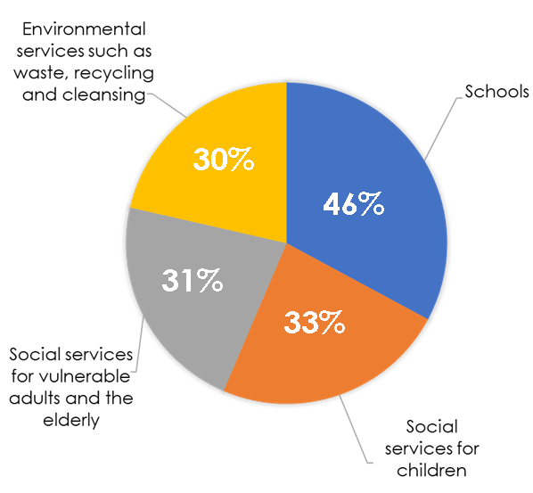
Councillors actively listened to and considered residents’ concerns about savings proposals when preparing and setting the Council budget. A range of savings, efficiencies, and income-generating projects worth just over £3million was agreed upon at the meeting to close the budget gap, as well as a draw on reserves of £4.3 million. A number of proposals which would have affected frontline services valued by residents were rejected by councillors. Schools in the borough were provided with a 4.2% uplift in funding after councillors voted to increase this to take into account the cost pressures they face as they recover from the pandemic. A 3.45% increase in Council Tax was also agreed upon.

A set of Financial and Contract Procedural Rules have been adopted to ensure consistency, transparency and value for money in financial management and procurement. The Chief Officer Resources ensures the Authority’s financial management arrangements conform to the governance requirements of the CIPFA Statement on the Role of the Chief Financial Officer in Local Government (2016). An annual Statement of Accounts is produced and presented to Members for scrutiny. A period of public consultation is held where members of the public can inspect the accounts.

Budget monitoring and management is a key feature at the Council. Effective arrangements are in place whereby budget holders meet regularly with finance partners to consider expenditure and any areas of overspends, with appropriate actions identified early on to tackle any areas in deficit.

The financial challenges facing Local Government are expected to continue into the medium to long term as the cost of living crisis continues with inflation at 7.9%, whilst reducing, remains well above the Bank of England target of 2%, higher than expected pay costs, increased energy and borrowing costs, all continuing to put pressure on budgets. Whilst the Revenue Settlement for 2023/2024 was positive with an increase in Aggregate External Finance of 6.5% (£8.5m), the impact of high inflation combined with soaring energy prices and increased pay costs was significant and based upon the assumptions in the Medium Term Financial Strategy (MTFS) and cost pressures identified, a budget gap of £23.2m is forecast over the next 5 years as follows:
MTFS Budget Gap
2023/2024  £m | 2024/2025  £m | 2025/2026  £m | 2026/2027  £m | 2027/2028  £m | Total  £m
6.7 | 2.1 | 4.7 | 5.2 | 4.5 | 23.2

The Council’s Bridging the Gap programme remains as the Council’s strategy for delivering financial efficiencies to ensure that the Council continues the journey of improving its financial stability and setting a balance budget year on year. An update on the overall current financial assessment towards the budget gap is currently assessed as £6.2m over the period of the Medium Term Financial Strategy (MTFS) as follows:
 | Estimated Achievement
 | 2023/2024  £m | 2024/2025  £m | 2025/2026  £m | 2026/2027 & 2027/2028  £m
Strategic Business Reviews | 4.2 | 1.3 | 0.7 | 0

Based on the current estimated achievement from the Strategic Business Reviews compared to the budget gap identified in the MTFS, there is a residual budget gap of £17m as follows:
 | 2023/2024  £m | 2024/2025  £m | 2025/2026  £m | 2026/2027 & 2027/2028  £m
Residual Budget Gap | 2.5 | 0.8 | 4 | 9.7

The strategic business reviews identified are insufficient to fund the budget gap included within the MTFS. As a result, a funding gap remained for 2023/2024 of £2.5m and £17m over 5 years. Proposals for the 2023/2024 budget setting process totalled £4.2m, of which £3m was approved for implementation.

There is a potential risk that the current Strategic Business reviews do not identify sufficient financial benefits to ‘bridge the gap’ in the medium to long term. Additional or alternative proposals will therefore be required to mitigate the possible residual funding gaps in future years. Also, the Council has seen price increases for fuel and energy which in turn have a ‘knock on’ impact on other goods and commodities purchased by the Council. This, alongside other cost pressures being seen by the Council, will need to be planned and managed accordingly.

Challenges the Council have experienced throughout the year:

Finance and Resources
Blaenau Gwent Council, like other Councils, faces extreme financial challenges as the Government continues to reduce the amount of money that is spent on our public services. The after effects of the Covid pandemic and the monetary crisis as a consequence of the war in Ukraine have caused a ‘perfect storm’ of soaring inflation, energy costs and material prices that have impacted how we deliver our services to the public. At the same time, the UK Government continues to make reducing the national debt a priority with strict spending policies in place. Its
latest Spending Review for 2023-24 did not deliver for Wales. Also, there are significant cost increases for pay awards, and increased demands on service areas such as social care, homelessness, additional learning needs and home to school transport. To meet these challenges, we must think about the way we provide services to make savings, and how we can generate income. This may mean us having to reduce, change or stop some services or look at alternative delivery models.

The results of the 2021 Census have had an impact on the Local Government Settlement received by the Welsh Government. The reduction in our population by 4.2% has meant a reduction in the amount of monies the Council receives. Services such as Education for school places, the Local Development Plan (LDP) for housing and Social Services for social care will also need to consider how this will impact service provision and funding in future years. Alongside this, the population is projected to further decrease. Not only is the Blaenau Gwent population decreasing, it is also aging and has the highest proportion of residents aged 16 to 64 years who are economically inactive and long-term sick or disabled across the whole of England and Wales at 36.1%. This is all likely to have an impact on services moving forward.

The Council is working collaboratively with the Office for National Statistics to further understand and investigate the information from the 2021 census and what this means for Blaenau Gwent moving forward as more Census date is released.

The Council’s Medium Term Financial Strategy was reviewed in December 2022 and a number of assumptions around future pay and inflationary uplifts were changed to reflect the expected financial environment for 2023/24 onwards. The Welsh Government provisional settlement for Blaenau Gwent is 6.5% (the lowest increase in Wales). Whilst this increase is above the 3% indicative increase announced in 2021 it is not sufficient to fund the forecast cost increases resulting in budget gaps increasing to in excess of £23m over a 5-year period.

Significant budget gaps remain to be addressed during the year in preparation for 2024/25 onwards.
The Authority’s reserves have improved over the last few years. However, in order to balance the 2023/2024 budget, a net draw from reserves of £4.26M was required. Reliance on the use of reserves to balance the budget in future years will impact on the financial sustainability of the Council. To mitigate this further, strategic business reviews will be developed and implemented to support a balanced budget moving forward. The use of reserves will be monitored and reviewed during the financial year in order to ensure that they are maintained as a sustainable level in the medium term. For 2023/24 as part of the agreed budget, assumptions around pay and inflation have increased and other specific cost pressures have been built in also, costs are expected to outstrip income such that £4.26m use of reserves will be required to fund the approved budget. This is not sustainable in the longer term and new / emergency pressures could exacerbate the position. The Cost Pressure sub group will be re-established for 2023/24 to monitor and challenge overspending areas.

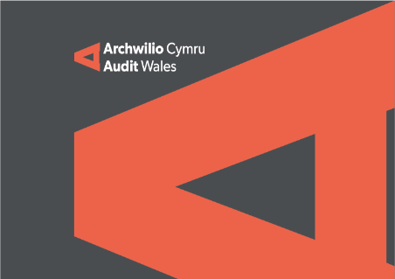
Audit Wales
The Draft Statement of Accounts for 2021/2022 were presented to the Governance & Audit Committee on 16th November 2022. The principal reason for the delay in submission of the accounts related to the resolution of a significant issue identified by Audit Wales. As part of their audit of accounts for 2020/2021, Audit Wales identified issues in relation to errors identified within the Fixed Asset Register which resulted in a misstatement of the Capital Adjustment Account and Revaluation Reserve. Given that, Audit Wales indicated that there is a high probability for the accounts to receive a qualified opinion. This would have an adverse reputational impact on the Council in demonstrating that appropriate governance arrangements are in place to manage the reporting of its strategic financial affairs. However, in order to conclude the audit of the 2021/2022 Accounts, the Council could accept the qualification of these accounts on the understanding that the causes of this qualification are remedied for the 2022/2023 financial year, i.e., a programme of asset revaluation and re-lifting is implemented.

As it is not possible to undertake and review the revaluation of assets internally in compliance with RICS requirements, external valuers will be required to provide this service. Valuations are also required for the procurement of insurance cover, the absence of which would be a material risk for high-value assets.

Over time it is possible that the value of assets may become materially misstated, for example during periods of rapidly changing prices. In order to reduce the potential for this type of misstatement, the Council’s rolling programme of revaluations will be actioned over a period of 3 years instead of 5 years.

A procurement exercise is being undertaken to commission external valuers to provide the required asset information, including revaluations for financial accounting and insurance purposes, alongside an annual review of asset lives.

The Council is awaiting confirmation from Audit Wales that qualification of the 2021/2022 Accounts with appropriate correction in 2022/2023 is an acceptable course of action. If this is agreed, the financial audit can recommence in order to conclude the work required in relation to Property Plant and Equipment.

The work by Audit Wales and the Council to conclude the 2021/2022 Accounts combined with the timescales required for the revaluation process may have a consequential impact on production of the Statement of Accounts for 2022/2023.

