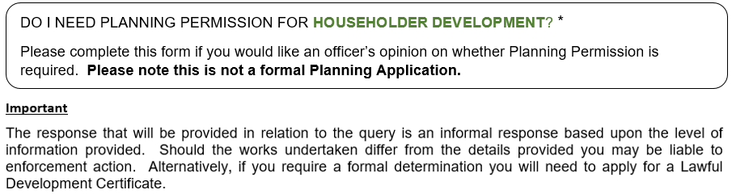

For Office Use Only | **PA** Application Form

BGCBC Ref. No.: …………………….…………………………

Receipt No.: ……………………….………………………

|  |  |  |  |  |
| --- | --- | --- | --- | --- |
| **1 Briefly describe what you want to do and provide a sketch plan/drawing overleaf (see example provided)** | | | | |
|  | | | | |
| **2 Contact Details** | | | | |
| Full Name: |  | | | |
| Full Address: |  | | | |
| POST CODE: |  | Contact Tel./Mobile Number: | |  |
| Email: |  | | | |
|  | | | | |
| **3 Details of Property of The Proposed Development / Query (if different to above contact details)** | | | | |
| Full Address: |  | | | |
| POST CODE: |  | | | |
|  | | | | |
| **4 Is the property detached, semi-detached or terraced?** | | |  | |
| NB: Planning permission is always required to extend or materially alter the external appearance of flats (apart from in some cases, installing solar panels). | | | | |
| If you have any queries in relation to completing this form please contact Development Management, Planning Division on 01495 355555 or email [planning@blaenau-gwent.gov.uk](mailto:planning@blaenau-gwent.gov.uk)  Please return the form to [planning@blaenau-gwent.gov.uk](mailto:planning@blaenau-gwent.gov.uk) or post to Development Management, General Offices, Steelworks Road, Ebbw Vale, NP23 6DN  Payment can be made online via our website home page / ‘Make a Payment’ link, a guide is available on request. | | | | |

*Any development within the curtilage of a residential property.

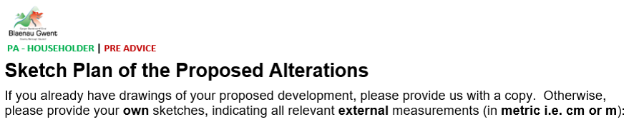

|  |  |
| --- | --- |
| **Property Address:** |  |

Please use additional sheets as required

