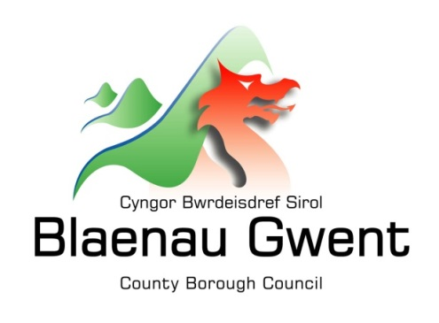

Privacy Notice –Infrastructure – Bridges and Retaining Walls

This notice is provided for clarification on what information the council needs in order to manage the public safety of bridges and retaining walls. It is necessary for the council to gather, collect, store and process personal information relating to the location of bridges and retaining walls. The council puts measures in place to protect the privacy of individuals throughout this process

Who is responsible for your information?
All personal information is held and processed by Blaenau Gwent County Borough Council in accordance with Data Protection legislation. For information on the role of the Data Controller, Data Protection Officer and Contact Details for the Council, please refer to the ‘Data Protection’ page of the Council’s website:
https://blaenau-gwent.gov.uk/en/Council/data-protection-foi/data-protection-act/

What Information do we need?
Blaenau Gwent County Borough Council may collect the following information:
- Name and address
- Contact information including email address
- Other information you might submit for us to deal with the safety of bridges and walls
We will use this information to process information to ensure public safety. We may check some of the information with other sources to ensure the information you have provided is accurate.

Why do we need your information?
We require this information to carry out our duties under the:
- Highways Act 1980

We need this information to:
- Ensure the safety of the public

Who will we share your information with?
To enable the Council to deal with your involvement in the process and comply with our legal obligations, we will share your information with partner organisations, including:

- Internally within Blaenau Gwent Council
- Your legal representatives
- SRS (Shared Resource Service Wales) – ICT service provider
- Software Consultants AMX

What is the Lawful basis for processing?
In order to comply with GDPR, personal data shall only be processed where a condition is met under article 6 of the legislation.

In this case, the lawful basis for processing is:

- a legal obligation that requires us to process your personal information;

- carrying out a public task, for instance, performing our safeguarding role, planning or waste services function.

How long do we keep your information?
The Council will only keep your information for as long as necessary. However, there may be circumstances where we may need to keep your information for longer. Full details of how long the Council retains your information can be obtained by contacting the relevant Department responsible for the services you require.
Council contact centre: info@blaenau-gwent.gov.uk / 01495 311556.

Providing accurate information
It is important that we hold accurate and up to date information about you in order to assess your needs and deliver the appropriate services. If any of your details are incorrect or incomplete, please ensure that you tell us as soon as possible so that we can update your records.

