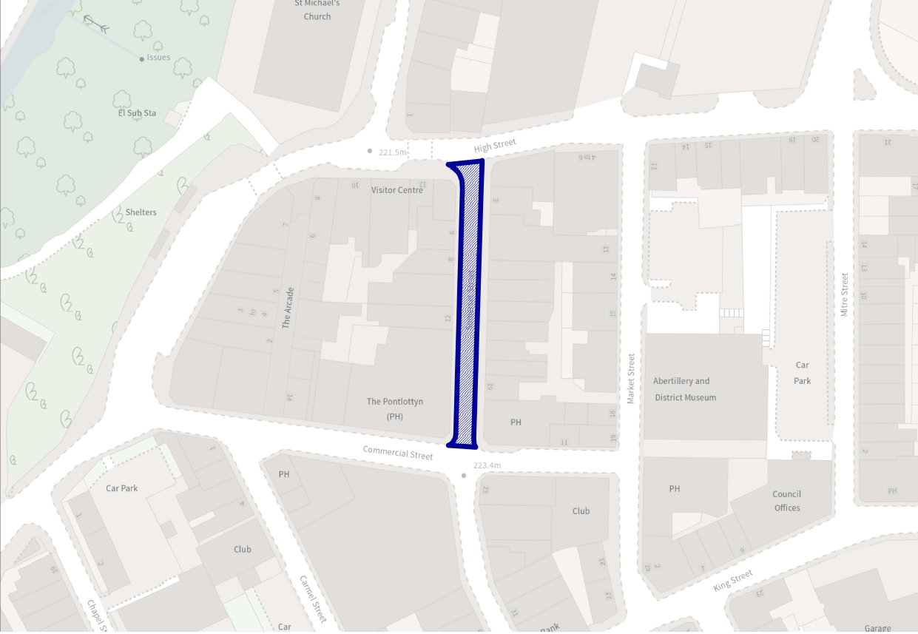
SCHEDULE 1: PROHIBITION OF DRIVING  1ST APRIL TO 30TH SEPTEMBER  MONDAY - SUNDAY  Pedestrian Zone  Somerset Street from its junction with High Street in a southerly direction to its junction with Commercial Street. |  | Somerset Street, Abertillery
 |  | Pedestrian Zone – Seasonal 01 April – 30 September

C.ROGERS B.Sc. (Hons),
C.Eng., M.I.C.E., D.M.S., Dip.M. HEAD OF COMMUNITY SERVICES ENVIRONMENT DIRECTORATE GENERAL OFFICES
STEELWORKS ROAD EBBW VALE
NP23 8UW
 |  | Drawn |  |  | Checked |  |  | Scale
 |  | Traced |  |  | Print |  |  | DRG. No. TS2245/100

