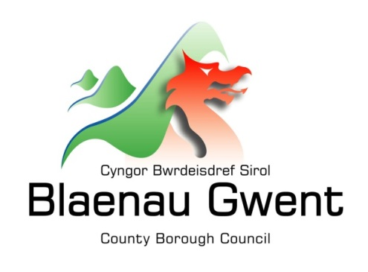

Privacy Notice – College Transport

This notice is provided for clarification on what information the council needs in order to process College Transport applications. It is necessary for the council to gather, collect, store and process personal information relating to claimants. The council puts measures in place to protect the privacy of individuals throughout this process

Who is responsible for your information?
All personal information is held and processed by Blaenau Gwent County Borough Council in accordance with Data Protection legislation. For information on the role of the Data Controller, Data Protection Officer and Contact Details for the Council, please refer to the ‘Data Protection’ page of the Council’s website:
https://blaenau-gwent.gov.uk/en/Council/data-protection-foi/data-protection-act/

What Information do we need?
Blaenau Gwent County Borough Council will require the following personal information about you:
- Name and address
- Contact information including email address
- Date of birth
- Where provided Bank Account Details
- Other relevant information needed to process your claim, such as proof of eligibility;

We will use this information to process your application. We may check some of the information with other sources to ensure the information you have provided is accurate.

Why do we need your information?
This information is required by the council in order to carry out its duties under:

• The Education (Miscellaneous Provisions) Act 1996
• The Transport Act 1985
• The Learner Travel (Wales) Measure 2008
• The Learner Travel Information (Wales) Regulation 2009
• The Safety on Learner Transport (Wales) Measure 2011
• The Learner Travel Statutory Provision & Operational Guidance 2014
• The Travel Behaviour Code Statutory Guidance 2009
• Special Educational Needs Code of Practice 2002
• SEN and Disability Act 2001

Who will we share your information with?
To enable the Council to process your request and comply with our legal obligations, we will share your information with partner organisations, including:

- Colleges and Schools
- Creditors
- SRS (IT)

The Council will also use the information for the purpose of performing any of its statutory enforcement duties. It will make any disclosures required by law and may also share this information with other bodies responsible for detecting/preventing fraud or auditing/administering public funds.

How long do we keep your information?
The Council will only keep your information for as long as necessary. However, there may be circumstances where we may need to keep your information for longer. Full details of how long the Council retains your information can be obtained by contacting the relevant Department responsible for the services you require.
Council contact centre: info@blaenau-gwent.gov.uk / 01495 311556.

Providing accurate information
It is important that we hold accurate and up to date information about you in order to assess your needs and deliver the appropriate services. If any of your details have changed, or change in the future, please ensure that you tell us as soon as possible so that we can update your records.

Automated Decision Making
Some decisions are computer-based as the Council uses automated systems to support its services. If your personal data is processed by automated means, you will be notified of the outcomes and a summary of the criteria used in this process. The results are subject to a final decision by the relevant service manager.

