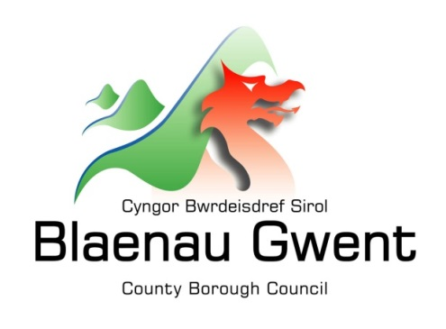

Privacy Notice – Infrastructure – Street Naming and Numbering

This notice is provided for clarification on what information the council needs in order to process street naming and numbering applications. It is necessary for the council to gather, collect, store and process personal information. The council puts measures in place to protect the privacy of individuals throughout this process

Who is responsible for your information?
All personal information is held and processed by Blaenau Gwent County Borough Council in accordance with Data Protection legislation. For information on the role of the Data Controller, Data Protection Officer and Contact Details for the Council, please refer to the ‘Data Protection’ page of the Council’s website:
https://blaenau-gwent.gov.uk/en/Council/data-protection-foi/data-protection-act/

What Information do we need?
Blaenau Gwent County Borough Council will collect personal information about you, and if necessary, your family and other parties. This information will include:
- Details about you, such as, your name, address, telephone number, email address;
- Other relevant information needed to process your claim, such as confirmation of property ownership;

We will use this information to process your application. We may check some of the information with other sources to ensure the information you have provided is accurate.

Why do we need your information?
This information is required by the council in order to carry out its duties under the Local Government Act 1972. By section 180(3) it is laid down that this section also applies to The Public Health Act 1875 to 1925.

We need this information to process your application. If this information is not provided it may affect our ability to process your enquiry.

Who will we share your information with?
To enable the Council to process your request and comply with our legal obligations, we will share your information with partner organisations, including:

- Internally within Blaenau Gwent County Council
- Royal Mail
- SRS (Shared Resource Service Wales) – ICT service provider, Software Consultants Geoplace.

The Council will also use the information for the purpose of performing any of its statutory enforcement duties.

What is the Lawful basis for processing?
In order to comply with GDPR, personal data shall only be processed where a condition is met under article 6 of the legislation.

In this case, the lawful basis for processing is:

- a legal obligation that requires us to process your personal information.

How long do we keep your information?
The Council will only keep your information for as long as necessary. However, there may be circumstances where we may need to keep your information for longer. Full details of how long the Council retains your information can be obtained by contacting the relevant Department responsible for the services you require.
Council contact centre: info@blaenau-gwent.gov.uk / 01495 311556.

Providing accurate information
It is important that we hold accurate and up to date information about you in order to assess your needs and deliver the appropriate services. If any of your details have changed, or change in the future, please ensure that you tell us as soon as possible so that we can update your records.

Automated Decision Making
Some decisions are computer-based as the Council uses automated systems to support its services. If your personal data is processed by automated means, you will be notified of the outcomes and a summary of the criteria used in this process. The results are subject to a final decision by the relevant service manager.

