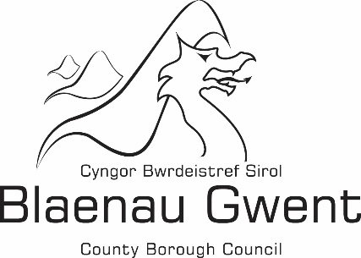

Financial Statement -

Building Regulations Chargeable and Non-Chargeable Account

Financial Statement 2018/2019

Blaenau Gwent County Borough Council's financial statement for 2018/19 is shown below:

 | Chargeable |  | Non-Chargeable |  | Total
 | £ |  | £ |  | £
Expenditure
Employee Expenses | 275,459 |  | 66,846 |  | 342,305
Transport | 7,445 |  | 0 |  | 7,445
Supplies and Services | 9,029 |  | 158,514 |  | 167,542
Third Party Payments | 1,091 |  | 0 |  | 1,091
Central and support service charges | 113,810 |  | 0 |  | 113,810
Total Expenditure | 406,833 |  | 225,360 |  | 632,193
Income
Building Regulations Charges | 134,009 |  | 0 |  | 134,009
Miscellaneous Income | 0 |  | 87,304 |  | 87,304
Total Income | 134,009 |  | 87,304 |  | 221,313
(Deficit)/Surplus for the year | (272,824) |  | (138,056) |  | (410,880)

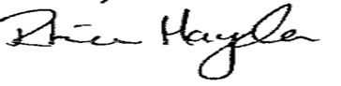
Approved by: …………………………………………………………………………………… (Section 151 Officer)

Date: -------------------------------------------------------------------------------------------------------------------

