
THIS DRAWING SHALL NOT BE REPRODUCED IN WHOLE OR IN PART WITHOUT THE EXPRESS PERMISSION OF THE INFRASTRUCTURE SERVICES DEPARTMENT
©Hawlfraint y Goron a hawliau cronfa ddata 2013 Arolwyg Ordnans LA 09002L



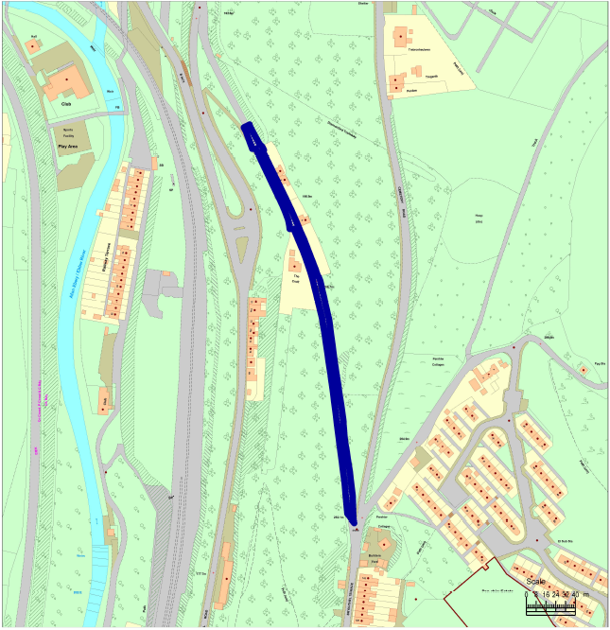
© Crown copyright and database rights 2013 Ordnance Survey LA 09002L
Proposed section of road for 20mph speed limit order
Job title  Church Road, Aberbeeg, NP13 2AA |  | Drawing title  20mph Speed Limit Order
 | Infrastructure Services  Mr. C Rogers B.Sc (Hons), C.Eng.,M.I.C.E.,D.M.S., Dip.M.  Head of Community Services Regeneration & Community Services Directorate  General Offices Steel Works Road Ebbw Vale  NP23 6DN |  |  | Date | Drawn |  | Checked
 |  |  |  | Scale  Illustrative use only |  | Drawing No.

