Tredegar & The Sirhowy Valley Pride in Place
Chairperson Recruitment Process
We, the Tredegar & Sirhowy Valley Pride in Place Working Group, are seeking applications for a chairperson, to lead the Tredegar Pride in Place Programme and recruit the neighbourhood board.
Pride in Place Neighbourhood Stakeholder Board is led by local partners, including GAVO, Aneirin Health Board and Tai Calon, councillors, Member of Parliament (MP) and Member of Senedd for Blaenau Gwent County Borough Council.
Anyone can apply for the role who lives, works or has a strong connection to the geographical area below:
Sirhowy Area
Population: 14,683
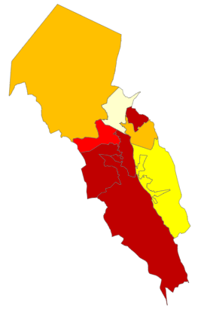

Ways You Can Apply
- You can apply yourself
- You can be nominated by someone from geographical area above.
If a person is being nominated, they must have agreed to being nominated before the application is submitted.
Submitting Your Application
- You will need to submit your name, address, postcode and contact details.
- You can submit a written application of up to 500 words showing how you will be a great chair and meet the requirements set out in the job description – please keep to the word count.
- Instead of a written application we will accept an audio file or video, no more than three minutes long, telling us how you will be a great chair and meet the requirements set out in the job description.
All applications to be sent to
BSInfoandData@blaenau-gwent.gov.uk
Timelines and Other Information
- Closing date 17th April Midnight
- We will not accept late applications.
- Shortlisting and Interviews will be completed by a residents panel with Karin Smyth MP and a Senior representative from BGCBC.
- Interviews will be held on Friday 24th April 2026
In the Pride and Place Guidance it states no active politicians can apply for the role which includes MP’s and local councillors.
This is a voluntary role but as a chairperson you will be supported to make the role a success. We are committed to supporting the role through reasonable expenses and any additional support costs such as personal assistance and/or childcare.
Checklist on What do I Need to Send
- Name, address, postcode and your contact details including telephone number and email address.
- 500 word written application or nomination or voice note or video explaining how you meet the requirements of the job description. Please send your applications or if you have any questions contact our team:
  - BSInfoandData@blaenau-gwent.gov.uk

