Introduction
The Local Government and Elections (Wales) Act 2021, requires councils to keep their performance under review through self-assessment, with the need to publish a report setting out the conclusions of the self-assessment once every financial year.

This is the second annual self-assessment report of Blaenau Gwent County Borough Council covering the year 2022/23. The focus of the self-assessment is the Council’s Corporate Plan priorities, known as Well-being Objectives, and providing an assessment of how well the Council feels it has achieved these and where further improvement is required. The Corporate Plan 2022/27 Well-being Objectives are:

- Maximise learning and skills for all to create a prosperous, thriving, resilient Blaenau Gwent;
- Respond to the nature and climate crisis and enable connected communities;
- An ambitious and innovative council delivering quality services at the right time and in the right place; and
- Empowering and supporting communities to be safe, independent and resilient.
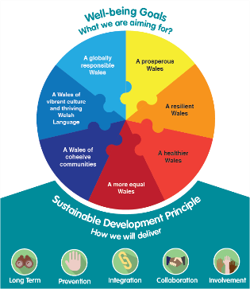
To align to the requirements of the Well-being of Future Generations (Wales) Act 2015, the Council has also provided an assessment against the:
- Sustainable development principle;
- Seven corporate areas of planning; and
- Well-being goals.

Throughout all sections of the self-assessment the Council has considered:
- How well are we doing? Narrative of the activity that has taken place;
- How do we know? Qualitative and quantitative evidence provided; and
- What and how can we do better? Actions to implement over the coming years.

This self-assessment has been developed at a point in time and includes the information available at that time. The Council’s approach to self-assessment is an ongoing and fluid process of review, and the assessment will be updated as and when more information becomes available. The Council also recognises that the self-assessment process will evolve over time to meet the requirements of the Local Government and Elections (Wales) Act 2021 and the arrangements will be amended, as appropriate moving forward, so that there is an effective programme of review and evaluation in place to challenge the effectiveness of the services provided. As part of this process, the Council actively promotes and partakes in participation and engagement activities with various groups and the community, however, further work will be undertaken throughout the year to enhance our reach and to promote transparency aligned to our new Engagement and Participation Strategy due for approval in early 2024.

As a council we work to a ‘One Council’ approach, and this is seen throughout the document with various examples and evidence of activity fitting under a number of the strategic priorities and themes. Progress and challenges are also identified throughout the document.

The Council welcome any feedback you might have about the Self-assessment 2022/23. Your views are important to us, and we want to know what information you would like to see and how you would like to see it reported. Please contact the team on the details below if you would like to give feedback on the Assessment or if you require this document in a different format e.g. large print, Braille, audio version, etc.

Corporate Performance Team  Blaenau Gwent County Borough Council  General Offices  Steel Works Road  Ebbw Vale  NP23 6AA | Email: pps@blaenau-gwent.gov.uk | 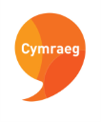  Mae’r ddogfen hon ar goel yn Gymraeg  This document is available in Welsh.

