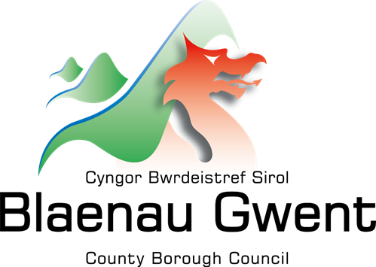
Blaenau Gwent Strategic Equality Plan
Annual Report
2025-2026

Blaenau Gwent County Borough Council

Strategic Equality Plan
Annual Monitoring Report
April 2025 – March 2026

“Blaenau Gwent – a place that is fair, open, and welcoming to all by working with and for our communities”

If you do require this document in a different format, e.g., large print, Braille, audio version, etc. please contact:
Email: pps@blaenau-gwent.gov.uk

Contents | Pages
Foreword | 1-2
Introduction | 3
Equality Objective 1 – We will be a fair and equitable organisation. | 4-12
Equality Objective 2 - We will be a workplace that champions diversity and inclusion. | 13-19
Equality Objective 3 - We will create a fair and inclusive learning culture for all children and young people with a focus on equality, diversity, and inclusion. | 20-25
Equality Objective 4 - We will promote and support inclusive, safe and cohesive communities. | 26-31
Equality Objective 5 - We will ensure effective engagement and participation for people with protected characteristics. | 32-35
Equality Objective 6 - We will strive to reduce inequality caused by poverty. | 36-39
Next Steps | 40
Workforce Data Summary 2024/25 | 41-45

Foreword
We are pleased to present the annual report on our progress in delivering Blaenau Gwent County Borough Council’s Strategic Equality Plan (SEP) 2024–28 for 2025–26. This report reflects the collective commitment across the organisation to addressing inequality, strengthening inclusion, and improving outcomes for the people of Blaenau Gwent.
Equality, diversity, and inclusion remain central to our vision for the county. We want Blaenau Gwent to be a place where every individual—whether living, working, studying, or visiting—can access opportunities, enjoy a good quality of life, and feel valued and supported.
Over the past year we have made real progress in strengthening our federated model with Torfaen County Borough Council. The Joint Chief Executive arrangement has developed into a more coordinated and collaborative approach, helping both councils share expertise, improve resilience and explore new ways of working together for the benefit of our communities.
We have also advanced work on the Blaenau Gwent Deal, a long‑term commitment to reducing inequalities by applying the Marmot Principles across local priorities, services and community partnerships. This year we have focused on building the evidence base, identifying priority areas for action and shaping how the Deal will support fairer outcomes across the county.
In doing so, the Deal is being aligned with our five missions:
- Early Years – Building Bright Futures: invest early, invest smart.
- Lifelong Learning and Resilience: skills are the new social contract.
- Wellbeing Through Community Leadership: health is created in communities, not hospitals.
- Thriving Economy and Vibrant Places: growth with purpose, not growth for its own sake.
- Empowered Communities – Shared Power and Success: from consumers of services to co-creators of change.
The missions seek to ensure that our approach to tackling inequalities is coherent, place‑based and centred on what matters most to people in Blaenau Gwent.
We have also advanced work on the a long‑term commitment to reducing inequalities by applying the Marmot Principals across local priorities, services and community partnerships. This year we have focused on building the evidence base, identifying priority areas for action and shaping how the Deal will support fairer outcomes across the county.
This report summarises our progress against our six equality objectives for 2025-26, including leadership and governance, workforce diversity, community involvement, community cohesion and tackling inequalities linked to deprivation.
Our work continues to align closely with Welsh Government’s national plans and strategies, which remain in a state of ongoing development and refinement. These include the:
- Anti-Racist Wales Action Plan (2024)
- LGBTQ+ Action Plan for Wales (2023)
- Age friendly Wales Strategy (2021)
- Violence against women, domestic abuse and sexual violence: Strategy 2022 to 2026
- Children and Young People’s Plan. (2023)
- The Socio-economic Duty (2021)

As these national policies evolve, we will continue to adapt our approach to ensure local delivery remains responsive and relevant.

We would like to thank our staff, councillors, partners and communities for their ongoing support and involvement. Together, we remain committed to building a fairer and more inclusive Blaenau Gwent for all.
  Councillor Stephen Thomas  Leader,  Cabinet Member Corporate Resources |   Councillor Chris Smith  Presiding Member  Equality Member Champion

Introduction
Our annual report highlights how we are meeting the Public Sector Equality Duty (the ‘general duty’) or (PSED) by ensuring we are supporting a fairer society through advancing equality and fostering good relationships.
We do this this by delivering policies and services on a day-to-day basis that support and value diversity, in order to:
- Eliminate unlawful discrimination, harassment and victimisation and other conduct that is prohibited by the Act.
- Advance equality of opportunity between people who share a relevant protected characteristic and those who do not.
- Foster good relations between people who share a protected characteristic and those who do not.
The Annual Report is presented into six sections. Each section corresponds with each of the current equality objectives and provides the following:
- Overview of the Objective
- Summary progress against Equality Objectives 2025-26
- Identified next steps for Equality Objectives 2026-28
The report concludes with the council’s workforce data for 2024-25.

Equality Objective 1
We will be a fair and equitable organisation.

Overview
We recognise that every individual is entitled to dignity, respect, and the ability to live and work free from prejudice. These are fundamental rights that apply to everyone, regardless of background, identity, or lived experience.
Equality is both a legal obligation and a moral responsibility. To be a fair and equitable organisation, we must demonstrate strong political and professional leadership that sets clear expectations, models inclusive behaviour, and promotes a culture built on respect, accountability, and collaboration.
We are committed to meeting our equality duties as a public body and ensuring that our policies, practices, and services are consistently fair, inclusive, and responsive to the diverse needs of our communities and workforce. This requires listening to people’s experiences, acting on evidence, and removing barriers that can prevent individuals from thriving.
Our Strategic Equality Plan is recognised as a key policy driver in achieving this goal alongside ambitions set within our Corporate Plan 2022-2027.
Summary of progress - Objective 1
Over the past year, we have continued to demonstrate our commitment to becoming a fair and equitable organisation by further embedding equality, diversity and inclusion across all areas of our work.
The Strategic Oversight and Delivery Group has matured in its role, meeting quarterly to provide challenge, support and scrutiny around delivery of the year two action plan. The group has strengthened its monitoring arrangements by introducing clearer reporting mechanisms, improved alignment with service business plans, and more consistent tracking of outcomes. This has enabled a more robust understanding of progress, barriers, and opportunities for improvement.
Chaired by Councillor Chris Smith, our Equality Member Champion and Presiding Member, the group continues to benefit from strong political leadership and representation. Councillor Smith also continues to represent the Council on the Welsh Local Government Association (WLGA) Members Equality Network, ensuring that our local work reflects national priorities and that learning from across Wales is incorporated into our approach.
Through these strengthened governance arrangements and ongoing collaboration across services, we have made steady progress in embedding fairness, accountability and transparency in the way we operate, supporting our aim of becoming a more equitable organisation for both our workforce and the communities we serve.
Training
We have strengthened our organisational commitment to fairness and equity through improvements in awareness, training, and engagement across both the workforce and Elected Members.
Our Leadership Team approved the rollout of a Equality E‑Learning Modules, developed by the West Gwent Cohesion Team and embedded within the council’s new learning platform, Thinqi. Managers were briefed on the rollout, and staff have been consistently informed throughout the year of the importance of completing the training. Completion rates have been regularly monitored through our business planning and reported throughout 2025–26, ensuring accountability and visibility of progress. At the end of the quarter 3 reporting period 67% of the workforce had completed the module.
The Equality Member Champion also completed the module and actively encouraged all Elected Members to undertake the training, reinforcing the expectation that equality knowledge and awareness should be embedded at every level of leadership.
Elected Members have additionally benefited from a series of Member Briefing sessions covering key equality themes, including the Social Model of Disability. These sessions have supported Members to better understand the diverse needs of communities and to strengthen equality considerations within decision‑making.
Together, these actions have contributed to stronger organisational understanding of equality issues, helping ensure that fairness, respect, and inclusivity remain at the core of how we work and how we serve our communities.
Networking
Blaenau Gwent Council continues to be represented at the Regional Equality Network as well as other National/Regional Networks to share best practice, learning opportunities and to work collaboratively, this includes being a part of the Proud Councils Network and WLGA Equality Officers Network.

Integrated Impact Assessment
We have strengthened our Integrated Impact Assessment (IIA) process to improve consistency, accountability and strategic alignment across the Council. The assessment has now been moved onto the SNAP survey platform, making it more streamlined and ensuring all completed IIAs are automatically shared with the Policy Team for monitoring and quality assurance. A new online training module is also being rolled out to build staff confidence and understanding.
We are introducing a clearer Federated Approach, where responsibility for completing IIA’s sits with service areas while the Policy Team provides central coordination and quality oversight. This ensures more consistent application and earlier engagement with subject experts.
The IIA is now better aligned to the Strategic Policy Framework, ensuring decisions are tested against corporate priorities, long‑term goals and statutory duties.
Work programming within Democratic Services is also being strengthened, with improved tracking of IIA requirements, clearer ownership, and integration into forward work programmes to support informed decision‑making by Members.
Finally, Blaenau Gwent contributed to national work led by the Equality and Human Rights Commission, helping shape the development of PSED monitoring in Wales and supporting improved consistency and quality of equality impact assessments across the public sector.
International Campaigns
Throughout this reporting period, Blaenau Gwent County Borough Council has continued to actively recognise, support and promote a wide range of national and international equality‑focused campaigns. Since April 2025, we have strengthened our visibility and engagement across the organisation and our communities by marking key awareness events including:
World Breastfeeding Week (August 2025):
During World Breastfeeding Week 2025, the Council’s Early Years Team hosted a week of events including a community picnic and buggy walk at Bedwellty House and Park, which provided a friendly and inclusive space for families to celebrate their breastfeeding journeys and access support. The weeks celebrations formed part of Blaenau Gwent’s broader programme to improve breastfeeding rates and reduce infant health inequalities. Over the past year, local monitoring data has shown encouraging progress, including a reported increase in breastfeeding continuation at 6–8 weeks and higher engagement with early‑years support services. Peer‑support groups have grown steadily, with attendance rising month‑on‑month, and more parents accessing targeted antenatal and postnatal education sessions. Together, these improvements demonstrate Blaenau Gwent’s continued commitment to creating a supportive and informed environment where families feel confident and empowered to breastfeed.
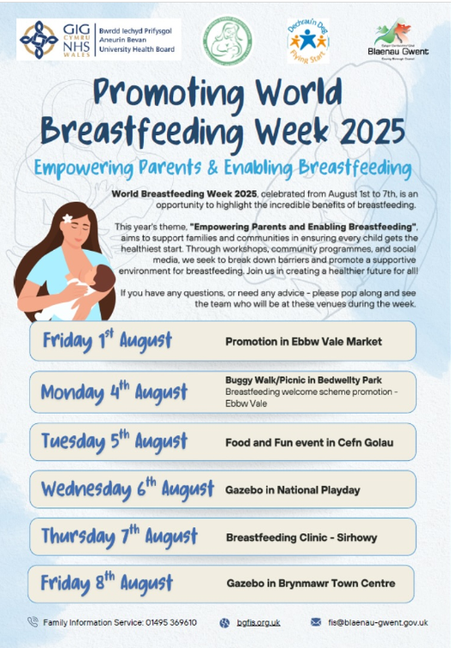
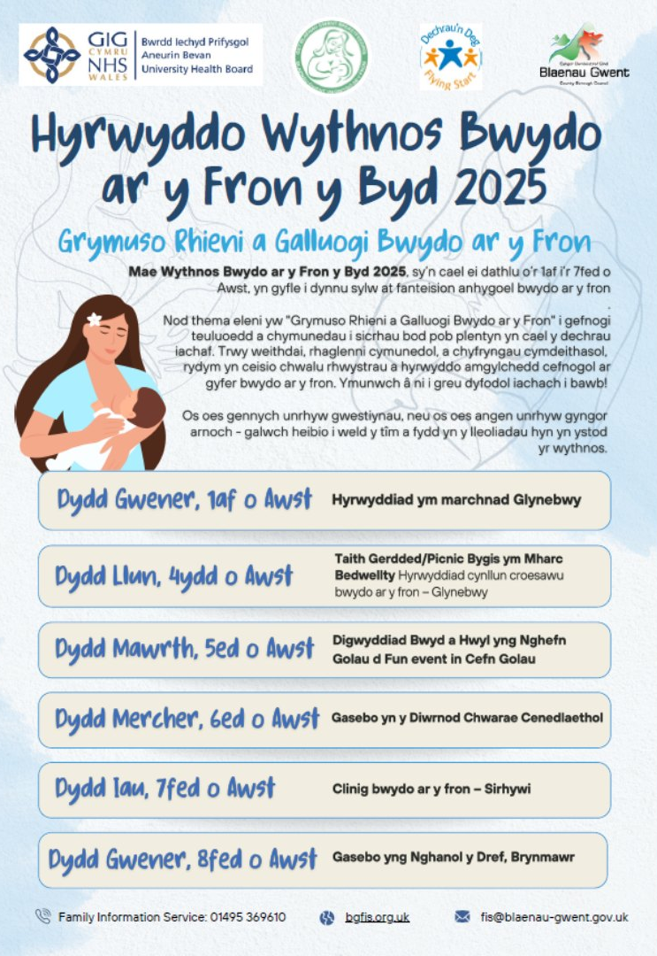

International Day of Disabled People (December 2025)
Blaenau Gwent Council came together with communities around the world to mark the International Day of Disabled People—a moment to pause, reflect, and reaffirm our commitment to inclusion, accessibility, and equality.
One of the highlights we reflected on this year was our progress within the Disability Confident scheme. Achieving Level 2: Disability Confident Employer status was an important milestone—evidence of our commitment to recruiting, supporting, and developing disabled people and those with health conditions.
But it’s also a step on a much bigger journey. Our sights are now set on achieving Level 3: Disability Confident Leader status. This means not only embedding inclusive practices within our organisation but also championing them across sectors, sharing learning, and leading by example.
Blaenau Gwent's Community Options/Trailblazers team, in partnership with People First and Barnardo’s ACT, celebrated International Day of Persons with Disabilities with an engaging event in Brynmawr. The day featured an Employment & Volunteering Creative Hackathon, where people with learning disabilities shared their ideas, talents, and experiences in a supportive environment. The event concluded with a musical performance that captured reflections and insights from participants, making it a meaningful celebration of creativity and community spirit. The post also extends thanks to all the organisations involved and encourages residents to look out for future initiatives.
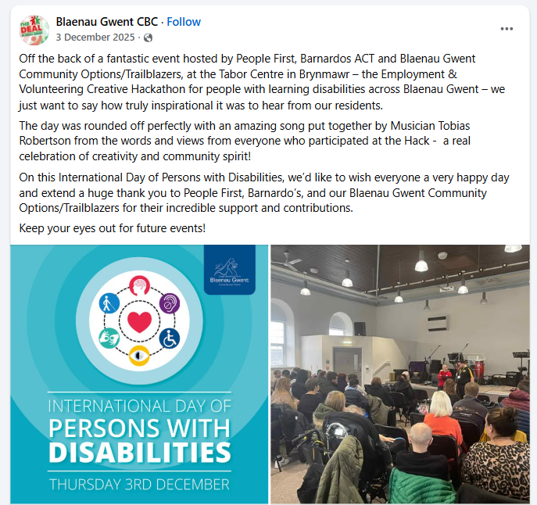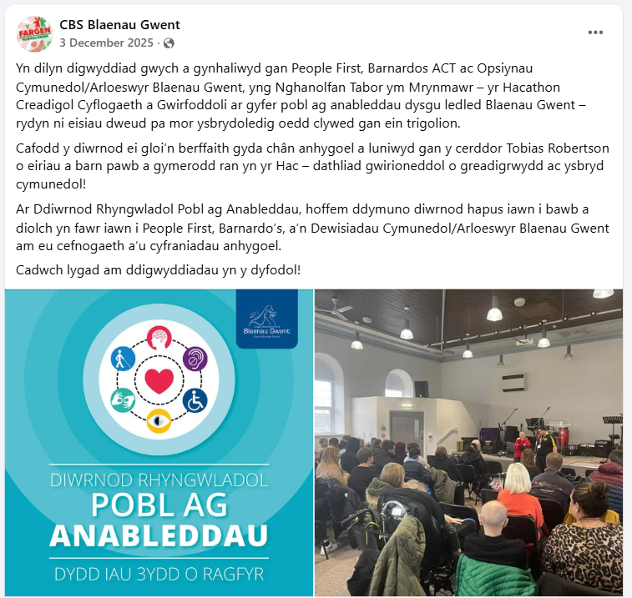

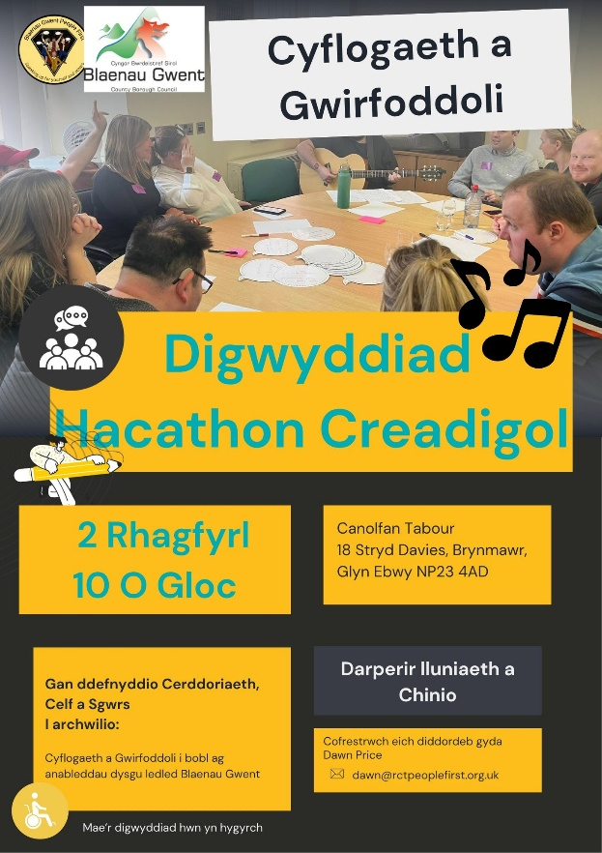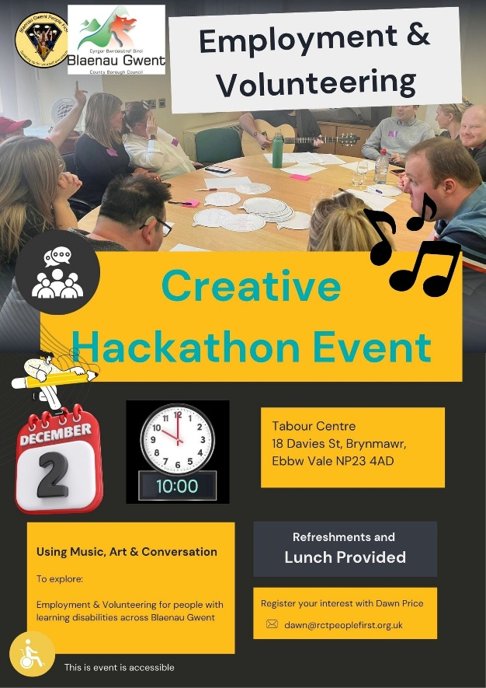

International Day of the Older People (October 2025)
The Council and community groups came together at Blaina Community Sports Club to recognise and honour local people who are committed to making our communities stronger, kinder, happier and more connected.
From lifelong volunteers to everyday heroes, we recognised and celebrated these community champions for their outstanding contributions towards making Blaenau Gwent an age-friendly community.
Nominations for the awards were received for people from across the borough via our partner organisations, community groups, and age-friendly networks who continue to work together to help make our communities age-friendly places to live and work.
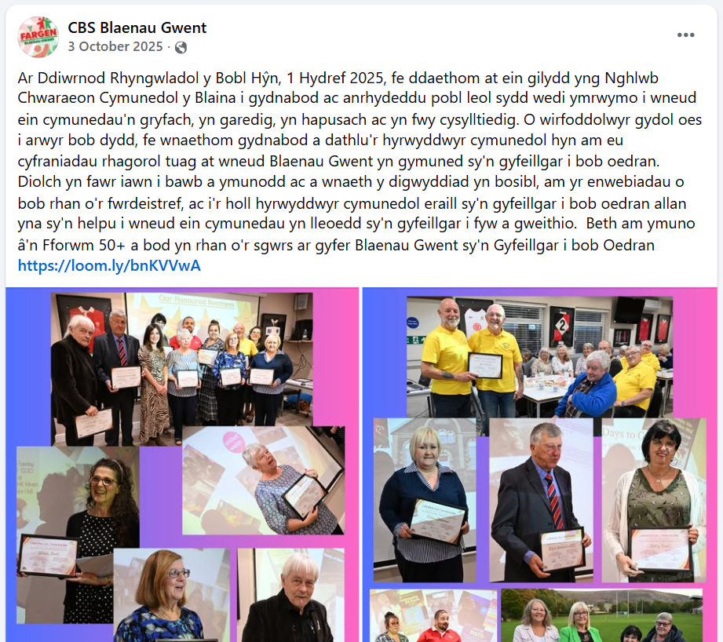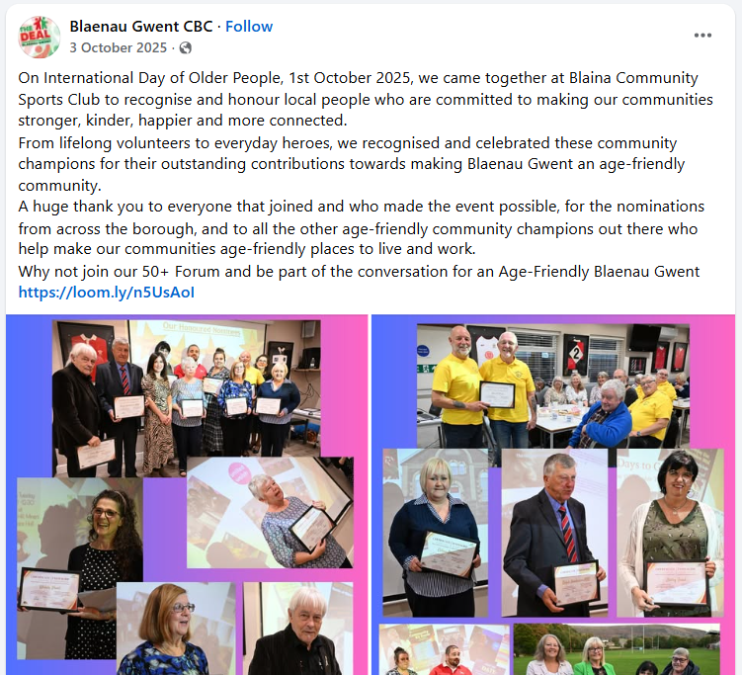
Holocaust Memorial Day (January 2026)
The theme for Holocaust Memorial Day 2026 is Bridging Generations — a call to action that reminds us that the responsibility of remembrance does not end with survivors, but continues through their children, their grandchildren, and through all of us. This theme highlights the importance of intergenerational learning, preserving memory, and carrying the lessons of the Holocaust forward into the future. It encourages us to listen, to learn, and to build connections between past and present so that the reality of what happened is never forgotten.
This year, Blaenau Gwent Council marked Holocaust Memorial Day through a series of activities across the borough, providing opportunities for reflection, learning and remembrance:
- Reflection Space at Tredegar Library providing a dedicated reflection space which offered visitors the opportunity to learn, reflect, and engage with this year’s theme of Bridging Generations.
- Born Survivor – Testimony of Eva Clarke. Copies of Born Survivor, sharing the remarkable story of Holocaust survivor and Freeman of Blaenau Gwent Eva Clarke, were made available in all Blaenau Gwent libraries, supporting the transmission of survivor testimony across generations.
- Lighting of the General Offices On the evening of 27th January, the General Offices building was illuminated purple as a visible symbol of remembrance and solidarity.

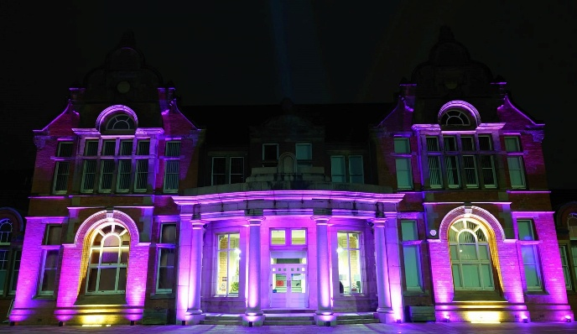

LBGT+ History Month (February 2026)
Each February, LGBT+ History Month invites us to recognise the diversity, resilience and achievements of LGBT+ people across society. This year, we embraced the 2026 theme of Science & Innovation, celebrating the many LGBT+ individuals whose creativity and ingenuity have shaped the world we know today.
At Blaenau Gwent Council, the month also provided an important opportunity to honour one of our own local trailblazers: Victor Spinetti, born in Cwm, Ebbw Vale. Spinetti became a prominent figure in theatre and film, breaking barriers and living openly at a time when doing so required extraordinary courage. His legacy continues to inspire, reminding us of the importance of visibility, representation and challenging norms with both creativity and compassion.
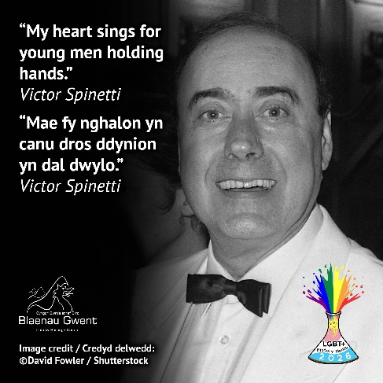
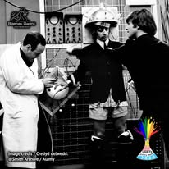

Throughout the month, we reflected on the lives and bravery of individuals like Spinetti—people who pushed boundaries and paved the way for many of the rights and freedoms we now recognise. Their stories reinforce our ongoing commitment to ensuring that Blaenau Gwent is a place where everyone feels safe, seen and celebrated, not only during LGBT+ History Month but all year round.
To further support understanding and inclusion, the West Gwent Community Cohesion Team launched a new LGBTQ+ E-Learning module in February 2026 which has been made available on the Thinqi platform. This training enables colleagues to:
- Explore key milestones in LGBTQ+ history and the movements that shaped equality.
- Gain insight into the ongoing challenges faced by LGBTQ+ communities.
- Learn practical ways to foster inclusion, support LGBTQ+ colleagues and promote positive, everyday actions in the workplace.
By engaging with this module, staff can deepen their knowledge and help strengthen our shared commitment to challenging discrimination, promoting equality, and creating welcoming, inclusive environments where every individual—regardless of sexual orientation, gender identity or expression—feels valued and supported.
Identified next steps - Objective 1
For the 2026-27 period, our key actions will include:
- Strengthen our strategic policy framework for equality and diversity, as part of our federation with Torfaen Council through our transformation plan for 26/27, including aligned Integrated Impact Assessments processes, policy planning, reporting and monitoring.
- Prepare for upcoming changes to the Public Sector Equality Duty in Wales.
- On-going promotion to support the completion and uptake of equality training, including new specialist modules.
- Expand Elected Member learning and embed equality into future induction programmes and member development forward work programmes.
- Complete an action plan for achieving Disability Confident Leader (Level 3) status.

Equality Objective 2
We will be a workplace that champions diversity and inclusion
Overview
As the largest employer in the area, we remain committed to ensuring that all staff feel valued, respected, and safe within their workplace. We recognise the importance of creating an inclusive and diverse organisational culture—one that enables individuals and teams to thrive, collaborate effectively, and experience high levels of job satisfaction.
Our ambition is to foster a workplace where diversity is celebrated, inclusion is embedded in everyday practice, and everyone feels a genuine sense of belonging. We strive to be an employer of choice that attracts, develops, and retains a workforce reflective of the communities we serve, inclusive of all backgrounds, identities, and lived experiences.
This year, the implementation of the new federated model with Torfaen has strengthened our ability to champion equality, diversity, and inclusion. Working in closer partnership has provided meaningful opportunities to learn from each other’s approaches, share best practice, align policies, and benefit from enriched collective expertise. This collaboration has enhanced our capacity to support staff more effectively and continue improving the inclusivity of our workplace culture.
To achieve our equality ambitions, it is essential that staff at all levels are supported with up‑to‑date guidance, learning, and development on key issues including Anti‑Racism, LGBTQ+ inclusion, Disability, Gender, Age, and other protected characteristics. We remain focused on ensuring that our workforce is equipped with the knowledge and confidence needed to foster positive and respectful working environments.
The Council’s Workforce Strategy 2021–26 continues to demonstrate our commitment to investing in our people. We want staff to feel engaged, motivated, and empowered so that together we can deliver the highest-quality services for the residents of Blaenau Gwent. Our ongoing efforts within this strategy—and through strengthened collaboration via the federated model—support our goal of being a workplace that truly champions diversity and inclusion.

Summary of progress - Objective 2
We have continued to provide a wide range of resources and initiatives to support our employees and to foster an inclusive and supportive workplace. These resources are designed to help staff access advice on specific issues, as well as to increase awareness, understanding, and learning around equality and diversity.
There has been a renewed focus on the distribution of staff news, with dedicated sections on equality and inclusion now embedded within our regular staff communications. These newsletters frequently include equality‑focused features, highlighting key topics, updates, campaigns, and resources to support staff across the organisation.
We have also continued to promote our calendar of key equality and diversity dates throughout the year. This calendar provides staff with a useful reference point to learn about, recognise, and celebrate different groups and communities, raise awareness of important issues, and demonstrate allyship and support.
We have worked closely with Organisational Development to draft an overarching Equality Policy for the organisation. This policy has been presented to the Equality and Diversity Oversight and Delivery Group for initial consultation and feedback. We have now reached the end of this phase in a position to undertake wider consultation. Alignment with Torfaen remains an essential element of the policy’s development and approval, and work is ongoing to progress through the necessary governance and approval processes to support this.
Blaenau Gwent Leadership Team approved for the establishment of a designated multi‑faith and reflection room within the General Offices. This space will provide an inclusive, quiet environment for prayer, reflection, or personal wellbeing, recognising and respecting the diverse beliefs, backgrounds, and needs of our workforce.
In addition, we are proud to have become a Breastfeeding Friendly organisation. This reflects our commitment to supporting parents and carers at work and ensuring staff have access to appropriate facilities and a supportive working environment.
We also led a targeted campaign encouraging staff to complete and update their iTrent equality data. This initiative aims to ensure that sensitive information is accurate and up to date, enabling us to better understand the protected characteristics of our workforce, including age, gender, ethnicity, and disability.
Having accurate and comprehensive data supports evidence‑based decision‑making and helps us to tailor policies, initiatives, and support to meet the diverse needs of our staff, contributing to a more inclusive, fair, and supportive workplace.
Training
Over the past year (2025–26), a comprehensive programme of training has been delivered to support staff understanding of equality, diversity, and inclusion, and to strengthen inclusive practice across the organisation.
A range of targeted training sessions centred the Social Model of Disability have been delivered, including:
- Neurodiversity;
- Social Model of Disability Training, supporting a shift towards removing barriers rather than focusing on impairment; and
- Reasonable Adjustment Training, equipping staff and managers with the knowledge and confidence to identify, implement, and review appropriate workplace adjustments.
In addition to facilitated sessions, e‑learning modules on Equality and Hate Crime continue to be available to all staff, ensuring flexible access to essential learning regardless of role or working pattern. During the year, the Equality module was added to the essential learning element of Thinqi, enabling organisational completion rates to be monitored on a quarterly basis through business planning reporting. This approach allows us to track compliance at an organisational level, identify training gaps, and target specific departments where further support or intervention may be required. Together, these modules are designed to increase awareness of legal responsibilities, promote best practice, and support the development of an inclusive and respectful workplace culture.
During the year, new Thinqi e‑learning modules were developed by and in partnership with the West Gwent Community Cohesion team and introduced to further strengthen organisational learning. These include:
- LGBTQ+ Awareness, supporting inclusive behaviours and understanding of sexual orientation and gender identity; and
- Integrated Impact Assessment, providing staff with practical guidance on assessing the potential impacts of decisions and policies on different groups, and embedding equality considerations into decision‑making processes.
Together, these training initiatives demonstrate our ongoing commitment to building staff capability, embedding the principles of equality and inclusion, and creating safe, inclusive environments for both employees and the wider community.
Lived Experiences Network (LEN)
We have strengthened our approach to lived experience and staff engagement by broadening the remit of our Lived Experience Network (LEN) and actively championing collaborative working across the region.
The LEN continues to provide a safe and supportive space for staff with shared protected characteristics to share their experiences, challenges, and achievements. This insight plays an important role in informing the delivery of the Blaenau Gwent Strategic Equality Plan 2024–28, ensuring that our work is shaped by real lived experience and supports meaningful inclusion.
Over the past year, we have also championed and supported the Diverse Minds group, established by Torfaen, and worked collaboratively to enable Blaenau Gwent staff to become part of this network. As a result, Blaenau Gwent now has staff who regularly attend, contributing to discussions and sharing their feedback within the group.
Staff attending Diverse Minds have reported that the group provides a safe and valued space to share their experiences, feel heard and seen, and put forward ideas to improve inclusion and wellbeing. Feedback highlights the positive impact of having a supportive forum that promotes understanding, peer support, and confidence to influence change.
Staff from the LEN continue to engage with the Equality and Diversity Oversight and Delivery Group, helping to shape our understanding of how we can further foster a truly inclusive and supportive working environment. Together, these networks strengthen our organisational learning, amplify staff voices, and support continuous improvement in equality, diversity, and inclusion.

Staff Wellbeing
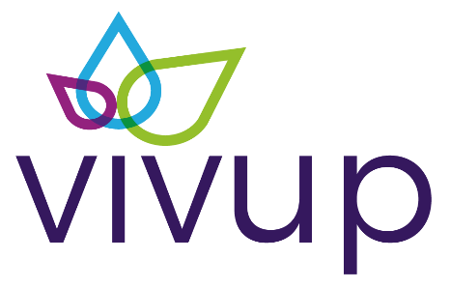
We continue to offer a range of employee benefits from our health and wellbeing partner ‘Vivup’ via their Employee Assistance Programme (EAP). These benefits are designed to improve mental, physical, and financial wellbeing. Vivup are an independent, leading provider of professional employee support services who employ professionally qualified Counsellors and Information Specialists, to support people to deal with all kinds of practical and emotional issues such as:
- Anxiety;
- Bereavement;
- Stress;
- Depression;
- Workplace Issues;
- Trauma;
- Relationships;
- Finances; and
- Family Difficulties.
The service is available 24/7, confidential and free of charge for staff to use.
In addition to the Vivup service, the council sends out a ‘Wellbeing Wednesday’ newsletter to all email users. This newsletter is designed to provide valuable information and resources related to health and wellbeing. It includes various support options that staff can access to improve their physical and mental health.
Disability Confident Leader Scheme
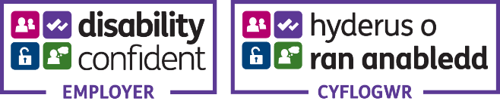
Following our successful assessment in April 2025, which saw the Council progress to Level 2 Disability Confident Employer, we have continued to strengthen disability‑inclusive practice across the organisation. Informed by the Welsh Government Disability Employment Champions, we have further embedded the Social Model of Disability, focusing on removing barriers and improving the consistency of reasonable adjustments. We are now working closely with Torfaen to share learning and align approaches as we progress towards Disability Confident Leader status. We continue to promote training opportunities on the social model, along with the Diverse Minds group internally as we acknowledge that lasting and meaningful change depends on the ongoing commitment of our entire workforce.

Cultural Competency Scheme
We made significant progress in advancing Blaenau Gwent County Borough Council’s commitment to cultural competence and the wider ambitions of the Welsh Government’s Anti-Racist Wales Action Plan. The Cultural Competence Certification Scheme, funded by Welsh Government, provides a structured framework to help organisations strengthen their cultural awareness, challenge bias, and embed more equitable practices by 2030.
The scheme aims to support organisations in developing culturally informed and inclusive service delivery. Its core objectives are to:
- Increase awareness and understanding of cultural disparities, unconscious bias, and culturally competent practices across the workforce;
- Support staff in reflecting on their own biases and enhancing their cultural awareness to improve day-to-day professional interactions; and
- Provide a clear, structured pathway for evaluating cultural competence and setting meaningful, achievable goals for continued improvement.
The scheme consists of two key components:
- Cultural Competency Awareness Sessions, delivered to build staff knowledge and confidence.
- The Self-Assessment Evidence Workbook, enabling organisations to evaluate their current position and evidence progress.
Upon assessment, organisations are awarded a gold, silver, or bronze attainment level based on their demonstrated achievements.
This year, we initiated this work in partnership with our Adult Services team, who have played a central role in driving the first phase of implementation. As part of the scheme’s requirements, we successfully completed and submitted our Self-Assessment Evidence Workbook in February 2026, demonstrating the actions taken to date and our ongoing journey toward improved cultural competence. We look forward to receiving our assessment result and continuing to build on the strong foundations laid this year.
Gender Pay Gap
As an employer, we are required by law to carry out Gender Pay Gap reporting under the Equality Act 2010 (Gender Pay Gap Information) Regulations 2017. According to the most recent Office for National Statistics data, the UK gender pay gaps for all employees stood at 13.1% in April 2024.
Within Blaenau Gwent men and women are paid equally for doing equivalent jobs across the business. The gender pay gap shows that the workforce is predominantly female with women occupying a high percentage of jobs across all four pay quartiles. The pay gap in Blaenau Gwent continues to be significantly lower than the national average Pay Policy Statement.
Identified next steps - Objective 2
For the 2026-27 period, our key actions will include:
- Agree a corporate way forward that enables us to achieve Disability Confident Leader status and ensure our processes are aligned to the Social Model of Disability.
- Use of Organisational Development Data to monitor the diversity of the workforce and proactively target the Equality Programme.
- Consult and agree an overarching Equality Policy for the federated organisations.
- Undertake research to consider options to meet legal requirements to publish gender pay data, and to report on disability and ethnicity pay gaps.
- Consider Cultural Competency Scheme for broader organisational learning.

Equality Objective 3
We will create a fair and inclusive learning culture for all children and young people with a focus on equality, diversity, and inclusion
Overview
Supporting the development of learner identity is fundamental to high‑quality education, wellbeing, and lifelong learning. Beginning in the early years and continuing throughout life, identity shapes engagement, attainment, and progression. In 2025/26, this work directly supported the Blaenau Gwent Deal mission Early Years – Building Bright Futures, recognising that investing early and investing smart is essential to reducing inequality and improving long‑term outcomes.
Addressing inequality across education and learning settings has remained a strategic priority. Learner experiences and outcomes are influenced by factors such as disadvantage, additional learning needs, language, health, and lived experience. Removing barriers to learning is central to delivering the council’s Mission of Lifelong Learning and Resilience, ensuring that all learners are supported to develop the skills, confidence, and adaptability required for future learning and employment.
Fair and inclusive learning cultures underpin this approach. Creating and sustaining these environments requires clear leadership, shared accountability, and collaboration across education, families, and partners to ensure that every learner can access high‑quality learning opportunities and achieve their full potential.
Summary of progress - Objective 3
School Support & Guidance
In 2025, schools engaged positively with Council‑led equality initiatives and resources, demonstrating how local authority support translates into meaningful learner and community impact.
Using dedicated the UK Government’s Shared Prosperity Fund (SPF) for equality work, the Council funded the Active Bystander Project “Step In, Speak Up” across all secondary schools in March 2026. The project focused on promoting respect and consent, challenging harmful gender stereotypes, and addressing peer‑on‑peer abuse. It encouraged learners to reflect on the impact of language, behaviour, and attitudes, while empowering them to intervene safely as active bystanders. The programme reinforced the importance of mutual respect and highlighted that preventing violence and abuse, including violence against women and girls, is a shared responsibility.
A large part of the West Gwent Cohesion Team focuses on helping children and young people understand equality, diversity and respectful behaviour. Over the year they have delivered a wide range of workshops and assemblies in both primary and secondary schools, covering topics such as protected characteristics, identity, challenging stereotypes, refugee awareness, misogyny and unconscious bias. These sessions took place in schools right across the borough supporting the learning of over 1,000 pupils.

- Anti-Discrimination Workshops:

School | Number | Date
Glyncoed Primary School | 58 pupils | April 2025
St Josephs Catholic School | 60 pupils | June 2025
Ystruth Primary School | 80 pupils | April 2025
St Illtyds Primary School | 45 pupils | Jan 2025
St Mary RC Primary School | 70 pupils | March 2025
Brynmawr Comprehensive school | 60 Pupils | April 2025
Brynmawr Comprehensive school | 60 Pupils | June 2025

- Bespoke sessions
Ramadan Assembly:
St Illtyds Primary School, 150 pupils, March 2025.

Refugee Awareness Assembly
Ebbw Fawr Comprehensive School, 500 pupils, June 2025.

Pupil feedback has been consistently positive. Schools reported clear improvements in pupils’ awareness, attitudes and confidence to challenge discrimination. All four of our evaluation measures showed progress, and several schools asked the Council to return for further sessions later in the year. The team have also delivered large whole-school assemblies for Refugee Awareness Week, reaching over 500 pupils.

Together, these examples demonstrate how Council advice and resources support schools to address equality issues in ways that are educational, preventative, and rooted in real‑world contexts, while strengthening learner voice, community awareness, and inclusive school cultures.
School Equality Plans
During 2025, Blaenau Gwent Council took a proactive and strategic approach to supporting schools in strengthening their Equality Plans, recognising both the statutory importance of these documents and their role in embedding inclusive practice. In response to national findings from the Equality and Human Rights Commission, highlighting inconsistency across Wales, the Council provided clear leadership through updated templates, practical guidance, a simplified audit and monitoring approach, and regular engagement with schools. This was complemented by tailored support where needed, improved communication, and a dedicated headteachers’ session to reinforce expectations and share good practice. As a result of this collaborative and supportive approach, all schools in Blaenau Gwent now have an Equality Plan in place, demonstrating a shared commitment to placing equality, inclusion, and fairness at the heart of school leadership, culture, and improvement planning.
Children and Young Peoples Participation
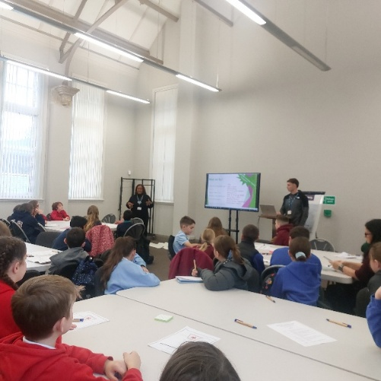
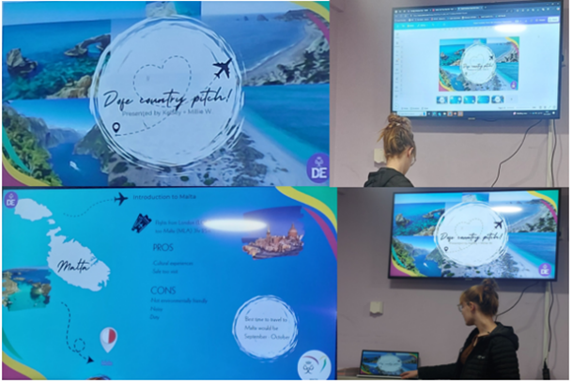
Blaenau Gwent Youth Service has strengthened equality and inclusion by delivering a wide range of targeted and universal support for young people with diverse needs and protected characteristics. The Marginalised and Accreditation Team, EOTAS provision, and 11–16 Youth Work have ensured that electively home-educated pupils, GRT young people and those at risk of exclusion can access accreditation, emotional wellbeing support and tailored education pathways.
The Youth Forum and Children’s Grand Council have championed youth voice—addressing mental health, digital safety, democratic participation and children’s rights—while international and national initiatives such as Taith and the Street Child World Cup have expanded opportunities for underrepresented young people.
Universal youth clubs, detached youth work and the 16–25, Homelessness & Wellbeing and Positive Futures teams have continued to remove barriers linked to socio-economic disadvantage, disability, NEET risk, housing insecurity and wellbeing. The counselling and play therapy service has supported emotional health for children and young people facing a range of challenges, while the Duke of Edinburgh Award has remained accessible to participants of all backgrounds.
Across all provision, participation is embedded through consultation, co-production, accreditation, and staff training on Welsh Government participation modules, with equality, diversity and inclusion underpinning every professional practice.
LGBTQ+ Support Groups
Groups across Blaenau Gwent offer support to Young People who identify as LGBTQ+. These are spaces where they feel accepted and have an opportunity to share and express their emotions, as well as a chance to celebrate and promote diversity. Young people in partnership with the Youth Service and BG Arts team came together to create art which was used in the first PRIDE event in Blaenau Gwent.
Ten sessions were delivered across school settings, community settings, as well as the Children’s Grand Council. This work supported the young people to express, learn and understand themselves as well as contribute to the celebration of LGBTQ+.
This work was able to take place through the successful funding bid submitted by Blaenau Gwent Youth Forum. The purpose of the bid was to show young people what could be created using recycled items, which was part of the Youth Mayor’s priority around pre-loved items.

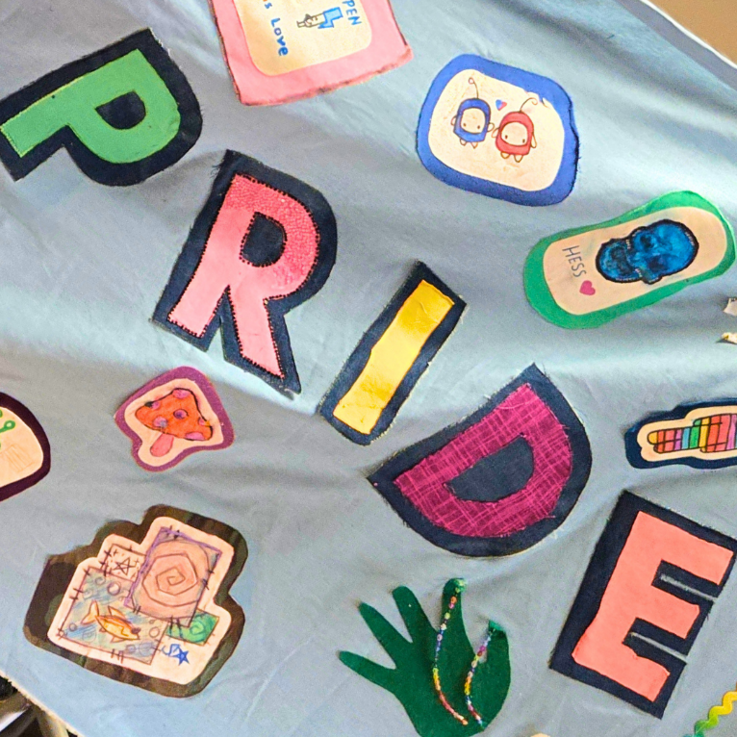
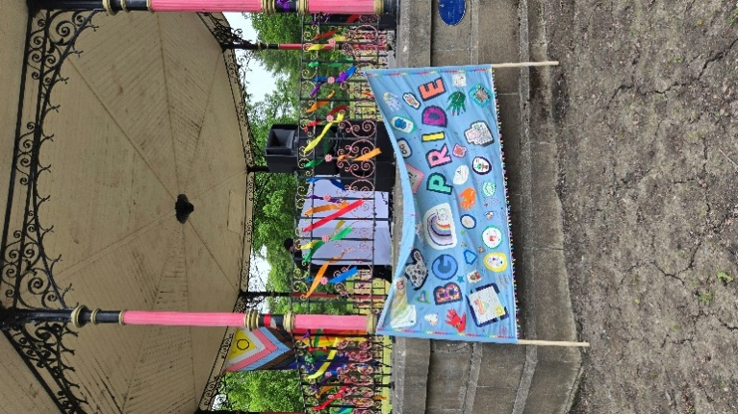
Play Activity Co-ordination and Term Time Play Provision
Dedicated engagement sessions were delivered in schools and after‑school clubs to provide opportunities to discuss out of school play provision and to gather detailed insight into the needs of our children and young people, helping to inform and influence future plans for play provision in Blaenau Gwent. A series of focus groups ensured inclusive representation, including Welsh‑language speakers, children with disabilities, young carers, children looked after, Gypsy and Traveller children, LGBTQ+ children and young people, asylum seekers, those from ethnic minority backgrounds, and children living in more rural areas.
Aspire Mentor Programme
Throughout the last year, the Aspire programme has continued to play a vital role in supporting young people in Blaenau Gwent who are, or have been, looked after, through a dedicated mentorship and employability pathway. Building on its strong foundations as the Council’s shared apprenticeship programme, Aspire provides tailored one‑to‑one mentoring, practical workplace experience, and sustained support to help care‑experienced young people overcome barriers to employment and progress into education, training, or work.
The programme focuses on building confidence, developing essential workplace skills, and offering consistent, trusted relationships with mentors who support young people to identify their strengths, aspirations, and career goals. By working in partnership with Council services, local employers, and Welsh Government, Aspire ensures participants receive coordinated, wrap‑around support that responds to their individual needs.
Since its inception, Aspire has supported over 200 apprentices across Blaenau Gwent. In 2025, its targeted mentorship for looked‑after and care‑experienced young people reinforces the Council’s commitment to improving life chances, promoting equality of opportunity, and supporting positive transitions into adulthood.
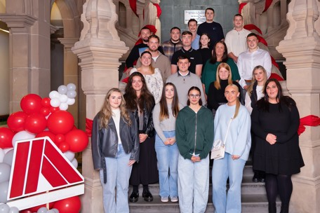

Identified next steps - Objective 3
For the 2026-27 period, our key actions will include:
- Increase representation Asian, Black and other ethnically diverse people on the youth forum.
- Recommend to School Governors to appoint anti-racism leads.

Equality Objective 4
We will promote and support inclusive, safe and cohesive communities
Overview
Creating communities where people feel safe, valued and included is fundamental to the social, economic and cultural well‑being of Blaenau Gwent. Ensuring that everyone who lives and works in the county borough feels a sense of belonging remains central to our commitment to equality, inclusion and long‑term community resilience, and reflects our ongoing duties under the Well‑being of Future Generations (Wales) Act.
Over the last year, our work has aligned closely with Mission 3 (Wellbeing through Community Leadership) of the Blaenau Gwent Deal, building on this foundation by strengthening the capacity, assets and connections within our communities to support inclusive, safe and cohesive places. Through partnership working with local communities, voluntary organisations and public services, the Deal has helped shape programmes and initiatives that raise awareness and understanding of equality issues, celebrate diversity, and bring people together. In doing so, the approach directly supports the national well‑being goals of a More Equal Wales and a Wales of Cohesive Communities, enabling communities to play an active role in shaping positive and inclusive futures across Blaenau Gwent.
Summary of progress - Objective 4
Special Recognition Awards
Blaenau Gwent’s Special Recognition Awards continue to play a valuable role in celebrating individuals, groups and organisations who make a meaningful difference to communities across the borough. Over the last year, the awards have brought people together to recognise achievements that reflect shared values of equality, inclusion, kindness and community pride.
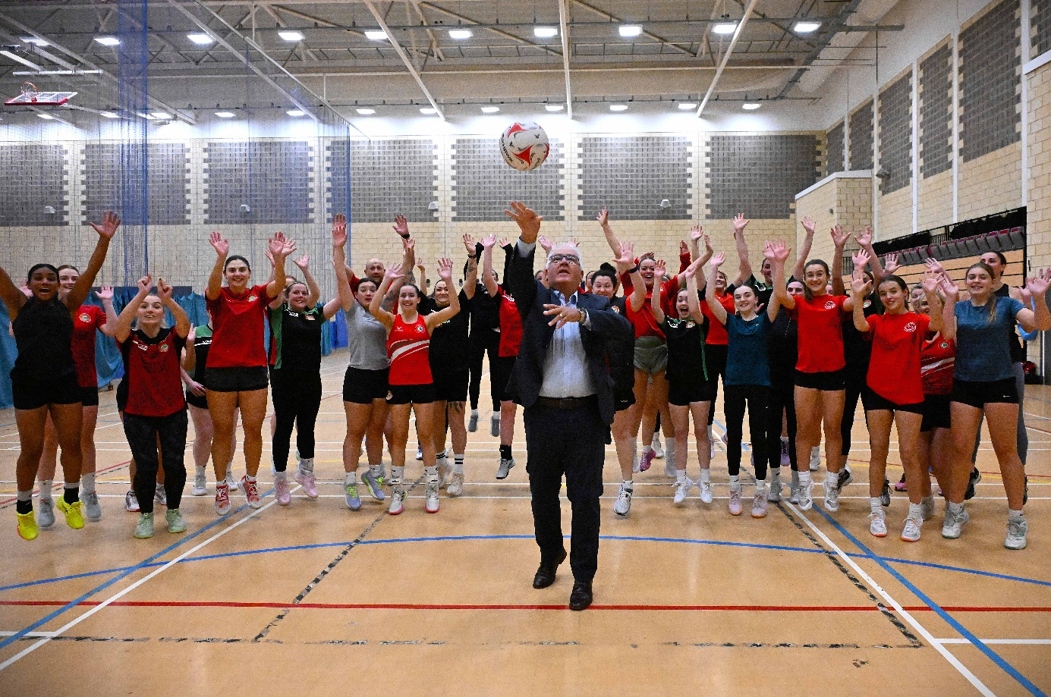
Recent Special Recognition Awards have celebrated a diverse range of contributions. Cymric Netball was recognised for its commitment to inclusion and community engagement, providing opportunities for people of all ages to participate, develop confidence and feel a sense of belonging through sport.
One Life Autism Support received recognition for its dedicated work supporting autistic individuals and their families, helping to reduce isolation, improve understanding, and promote acceptance and equality within communities.
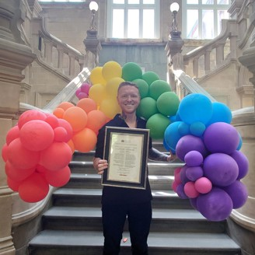
Nathan Wyburn was recognised for his positive representation of Blaenau Gwent and his work to raise awareness of social issues, using creativity to inspire pride, challenge perceptions and promote inclusive messages. By publicly recognising these achievements, the Special Recognition Awards celebrate the everyday impact of those who champion equality, support vulnerable residents and strengthen community connections. The initiative highlights positive role models, encourages civic pride and helps to build more inclusive, safe and cohesive communities by valuing the contributions of those who go above and beyond for others.
Over the last year, the Special Recognition Awards have reinforced Blaenau Gwent’s commitment to identifying, acknowledging and celebrating the people and organisations that help make the area a fairer, more welcoming place to live and work.

The West Gwent Community Cohesion Team
The Community Cohesion Team has strengthened inclusion and resilience across West Gwent by bringing people together through accessible community events and small‑grant projects, working closely with grassroots leaders to build trust, and supporting newly arrived and marginalised communities through coordinated resettlement work, new orientation models and volunteering pathways. Alongside this, the team played a key role in monitoring emerging risks through multi‑agency structures, providing intelligence and coordinated responses to issues such as the online ‘outing’ of Registered Sex Offenders, while also addressing incidents of bullying, extremist graffiti and safeguarding concerns. Extensive reassurance and engagement—such as work around Traveller funerals—helped reduce fear and manage community tensions. The team also contributed to regional and national learning networks and strengthened internal systems through improved hate crime policy, LGBTQ+ e‑learning and no recourse to public funds (NRPF) guidance. Overall, their work has increased community connection, improved confidence in addressing equality issues, enabled early intervention on tensions, supported new communities to settle safely, empowered grassroots action, and contributed meaningfully to the Strategic Equality Plan and the wider goal of building inclusive, welcoming and resilient communities.
Early Years Support
Over the last year, Blaenau Gwent has strengthened maternity and early years support, with a particular focus on improving breastfeeding outcomes and ensuring parents feel supported and confident throughout their feeding journey. Working in partnership with health services and community organisations, the Council has taken a proactive role in promoting a positive, inclusive breastfeeding culture.
Central to this work has been the Council‑led ‘Get Blaenau Gwent Breastfeeding’ campaign, which has raised awareness of breastfeeding, helped normalise feeding in public spaces, and encouraged breastfeeding‑friendly environments. Through targeted engagement, practical resources and positive messaging, the campaign has contributed to improving local breastfeeding rates to 68% an increase of over 28% from the start of the ‘Get Blaenau Gwent Breastfeeding’ campaign launched in 2024.
Over the last year, breastfeeding awareness events, community‑based initiatives, promotion of breastfeeding‑friendly venues and celebrations linked to World Breastfeeding Week have helped recognise and celebrate mothers’ experiences. Together, these activities have strengthened local support networks, reduced isolation, and empowered mothers to feel supported and encouraged in their feeding journey.
This work continues to support positive early years outcomes while building healthier, more connected communities across Blaenau Gwent.
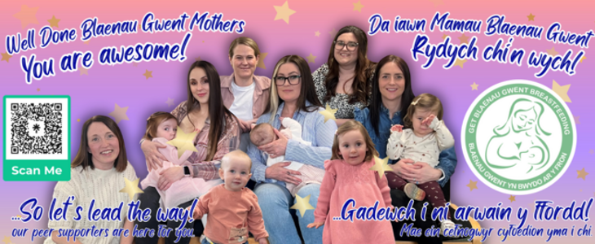

Support for the LGBTQ+ Community
The delivery of Blaenau Gwent’s first Pride event marked a significant milestone in the borough’s journey towards greater inclusion, visibility and allyship for LGBTQ+ communities. As a landmark moment, the event represented an important step in acknowledging and celebrating diversity, while demonstrating a clear commitment to equality, respect and belonging for all residents.
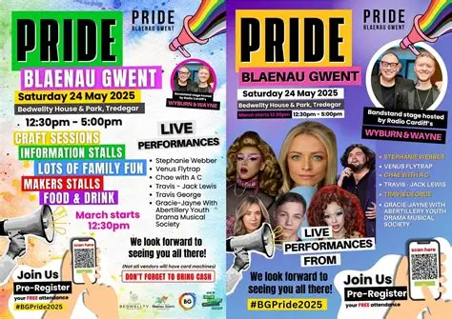
The Pride event brought communities together to celebrate identity, raise awareness and promote understanding, creating a welcoming and safe space for people to come together as allies. It provided an opportunity to amplify LGBTQ+ voices, challenge stigma and reinforce the message that Blaenau Gwent is a place where everyone should feel valued, supported and free to be themselves.
Beyond the celebration itself, the event reflected the growth of Blaenau Gwent as an inclusive community and highlighted the importance of visible leadership and partnership working in advancing equality. By supporting and delivering the first Pride event, the Council and its partners demonstrated active allyship and a commitment to building inclusive, cohesive communities where diversity is celebrated as a strength.
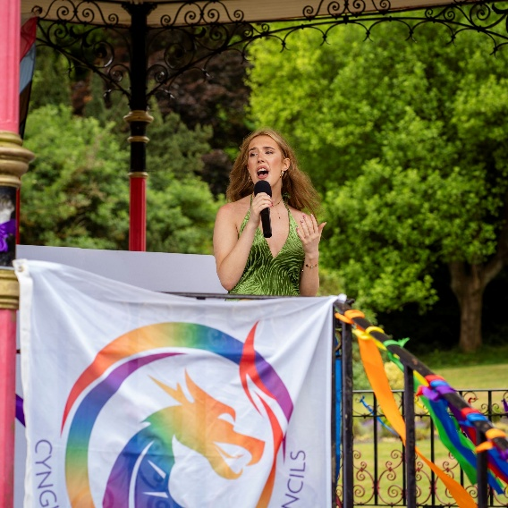
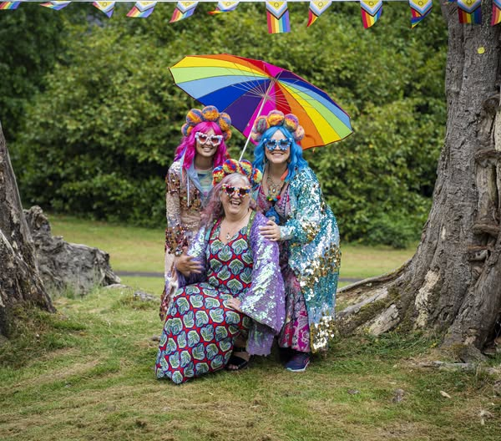
The success of the event has laid strong foundations for future activity, helping to embed Pride as a meaningful expression of community solidarity and ongoing commitment to equality across Blaenau Gwent.

Identified next steps - Objective 4
For the 2026-27 period, our key actions will include:
- Identify champions for equality, diversity and inclusion across service areas.
- Embrace the ethos of The Deal to support the creation of cohesive communities.
- Work with GAVO to recruit community members to deliver future Pride Celebrations

Equality Objective 5
We will ensure effective engagement and participation for people with protected characteristics.
Overview
We have continued to embed our new federated model with Torfaen and begun aligning our work with the Blaenau Gwent Missions. As a result, our approach to engaging with communities is evolving. This new landscape strengthens opportunities for collaboration, shared insight, and consistent, inclusive practice across the region.
Our commitment remains the same: everyone should be able to help shape our vision and influence meaningful change. This includes ensuring that under‑represented people, particularly those with protected characteristics, can fully participate in decisions that affect their lives. We also recognise that intersecting identities shape people’s experiences of discrimination, disadvantage, and privilege, and this understanding will continue to guide our work.
Our current Engagement and Participation Strategy—developed in line with the Equality Act 2010 and the Well-being of Future Generations (Wales) Act 2015—ensures that intersectionality and long‑term impact remain central. In line with our federated approach, we will make flexible use of a wide range of engagement methods, from in‑person and community‑led activities to digital tools, online platforms, and formal consultations.
Through these approaches, we will ensure engagement remains accessible, representative, and supportive of meaningful participation from residents with protected characteristics across both councils

Summary of Progress – Objective 5 (2025–26)
We have strengthened our engagement approach across Blaenau Gwent by building on learning from last year’s activities and deepening our understanding of community experiences. Our work has continued to support the delivery of the Strategic Equality Plan 2024–2028 and ensure that people from protected characteristic groups can meaningfully shape local priorities.
A key part of this has been our ongoing work with the Community Lived Experiences Network, which has enabled residents to share personal experiences that help us understand the real impact of inequality and shape our approach more effectively. We also celebrated and promoted diversity through the Member-led Special Recognition Awards, which highlight and value the contributions of individuals and groups who champion equality in the community.
This year we also focused on delivering the Blaenau Gwent Deal, using a range of consultation methods, including surveys and Citizens’ Assemblies to ensure broad and inclusive participation. These assemblies were designed to secure strong representation across protected characteristics and have played a central role in shaping the Deal. Through open conversation and collaborative problem-solving, residents, partners, and the Council explored how we create lasting change by building trust, fostering shared responsibility, and encouraging innovation.

Community Lived Experiences Network –
Over the past year, the Community Lived Experiences Network has continued to highlight powerful personal stories that help shape more inclusive policies and services across Blaenau Gwent. These lived experiences give us deeper insight into the barriers people face and strengthen our work under the Strategic Equality Plan.
This year, three standout contributions included:
- 80-year-old catering assistant, who works in one of our Primary Schools challenged age-related assumptions by sharing her passion for work and showing that age is no barrier to contribution. Her story reinforces our commitment to age-inclusive practice;
- The founder of One Life Autism, whose experiences supporting autistic individuals and families emphasised the need for accessible, community-led support and greater understanding of neurodiversity; and
- Celebrating Welsh artist and LGBTQ+ advocate, who hosted a question-and-answer session with school learners, speaking openly about his experiences growing up as a gay man and the challenges he faced. His honesty helped promote visibility, understanding, and a more supportive environment for young people;
These stories strengthen the Network’s role in ensuring lived experience directly informs our equality work and shapes long-term ambitions as a federated organisation.
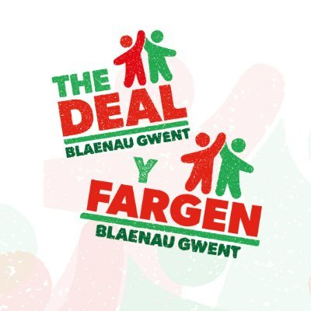
Blaenau Gwent Deal – Citizen Engagement
The Blaenau Gwent Deal sets out our long‑term ambition for the county, bringing together residents, partners, and the Council to shape a shared vision for a fairer and more prosperous future. The Deal focuses on creating lasting change by improving opportunities, strengthening communities, and supporting wellbeing across all neighbourhoods. Central to its development is a commitment to working with our citizens—ensuring local people influence decisions, shape priorities, and guide how we deliver the Deal over time.
Over the last year, we have significantly expanded how we engage residents, with a clear focus on ensuring that voices across all protected characteristics are represented. Our approach reflects our federated model and commitment to accessible, inclusive, and meaningful engagement.
How Citizens Have Shaped the Blaenau Gwent Deal
To ensure the Deal reflects the lived realities of our communities, we used a range of methods to gather insight, encourage discussion, and support co‑production. These included:
1. A Public Survey
Residents were invited to share their views on local priorities, challenges, and ambitions for the future. The survey gathered broad community insight and ensured that people who may not attend events could still contribute in meaningful ways.
2. Three Citizens’ Assemblies
We delivered a series of three Citizens’ Assemblies, designed to bring together a diverse cross‑section of local people—including representation from across protected characteristics—to explore the themes and challenges underpinning the Deal.
Across the assemblies, participants discussed what lasting change should look like in Blaenau Gwent and how we can build trust, strengthen shared responsibility, and foster innovation through strong collaboration between the Council, residents, and partners. The assemblies produced clear community‑driven recommendations, which directly informed the shaping of the Deal’s priorities and delivery approach.
3. Targeted and Community‑Led Engagement
In addition to formal engagement, community groups, partners, and representative organisations helped us facilitate small‑group conversations with residents whose voices are often under‑represented in strategic decision‑making.
Through these approaches, residents have:
- Shaped the priorities and themes of the Blaenau Gwent Deal;
- Highlighted inequalities that the Deal must address;
- Helped identify communities and groups that need targeted support; and
- Influenced how the Council and partners work together to deliver long‑term change.
Our engagement this year demonstrates our commitment to transparency, co‑production, and building a Deal that reflects the aspirations, values, and lived experiences of the people of Blaenau Gwent. This partnership approach will continue as we refine the Deal and move into delivery.

Identified next steps - Objective 5
For the 2026-27 period, our key actions will include:
- Re-align the Engagement and Participation Strategy with the Blaenau Gwent Deal, working in partnership with Torfaen to develop a shared approach, ensuring residents with protected characteristics are represented.
- Integrate the Citizens Panel with Torfaen’s Get Involved platform to support a consistent, federated approach to citizen engagement aligned to The Deal.
- Improve representation and participation in council activities and decision-making from young people, disabled people, LGBTQ+ people and people from minority ethnic groups.
Equality Objective 6
We will strive to reduce inequality caused by poverty
Overview
Inequality affects people with protected characteristics disproportionately, and poverty is both a key cause and a consequence of this inequality. It also has specific and unequal impacts across different groups. Tackling inequality for people with protected characteristics who are affected by poverty requires a holistic, preventative and targeted approach—one that addresses both the root causes of poverty and its everyday manifestations. As an organisation, we have long been committed to supporting those within our communities who most need help, advice and guidance, and this commitment remains central to our work.
Building on this, during 2025–26 we have continued to strengthen our approach to equality, diversity and inclusion, informed by the work of the Equality and Human Rights Commission (EHRC) to improve implementation of the Public Sector Equality Duty (PSED) in Wales. As part of their project focused on ongoing monitoring and targeted interventions, the EHRC conducted a desk‑based monitoring exercise during Summer and Autumn 2024 to assess compliance with the PSED, with particular attention to Wales‑specific equality duties.
We welcomed the EHRC’s feedback, especially their recognition of our clear objective addressing the Socio‑economic Duty. We remain fully committed to meeting our responsibilities under the Public Sector Equality Duty, including the requirement to tackle inequality driven by poverty. We will continue to facilitate that people experiencing poverty, or living in less favourable socioeconomic circumstances, are meaningfully considered in all decision‑making processes related to the services we provide.
Our work in 2025–26 maintained a strong focus on reducing inequality, removing barriers and improving outcomes for the people and communities we serve. We will continue to build on the progress already made, strengthen our processes further, and continue to offer accessible, responsive support for those who need our services most.

Summary of progress - Objective 6
Trailblazer
The Trailblazer programme, funded by the UK Government, targets economically inactive people of working age who are disabled and/or have health conditions, or caring responsibilities by providing tailored interventions including one-to-one mentoring, counselling services, wellbeing provision, and specialist support for those with health conditions.
The Blaenau Gwent Trailblazer Programme continues to build a rich picture of the 297 people it has supported to date, with recent data showing engagement from a diverse range of residents—slightly more women than men, a small number of ethnic minority and migrant participants. The cohort is largely young, with two‑thirds aged 15–39, and many facing complex forms of economic inactivity, as nearly half are not working and not seeking work. The most significant barriers to employment, education, and training include childcare, health issues, transport challenges, confidence, and caring responsibilities, health—particularly mental health—is a major theme, with over a third reporting mental health conditions and many more experiencing long‑term health impairments. These insights reinforce the need for joined‑up, person‑centred approaches that address structural, emotional, and practical obstacles.
Corporate Parenting Strategy
Blaenau Gwent Council has approved a new Corporate Parenting Strategy 2025/2030 - a bold and forward-thinking plan that places care experienced children and young people at the heart of decision-making.
Accompanying the strategy is a comprehensive Action Plan designed to deliver real, lasting change.
Co-produced with care experienced children and young people, staff, elected members, and a wide range of partners, the strategy sets out 11 core principles and 9 promises, aligned to the Welsh Government’s Corporate Parenting Charter – A Promise for Wales (2023), which was endorsed in August 2024 by the Cabinet Member for People and Social Services and the Council’s Chief Executive.
The strategy was officially launched by the young people themselves at a Winter Wonderland event in Blaenau Gwent in December 2025.
Corporate Parenting is a legal duty for councils and their partners to act as any responsible and loving parent would. Blaenau Gwent’s new Strategy raises the bar — not only meeting statutory obligations but going further to create a culture of high aspiration, emotional support and opportunity.
UK Shared Prosperity Fund Community Food Development Grant Scheme
Throughout 2025/26, the Blaenau Gwent Food Partnership delivered a small grants scheme focused on food activities for people with protected characteristics. The £15,000 fund, provided by Welsh Government, aimed to ensure community food initiatives reached diverse and underserved populations in line with the Equality Act 2010.
Thirteen organisations received funding to deliver a broad range of activities, including:-
  - food growing and slow cooker sessions for older people;
  - cooking skills workshops for primary school children;
  - a cultural food festival for secondary school pupils;
  - life skills booklet development for neurodiverse residents;
  - cooking activities for young people with disabilities; and
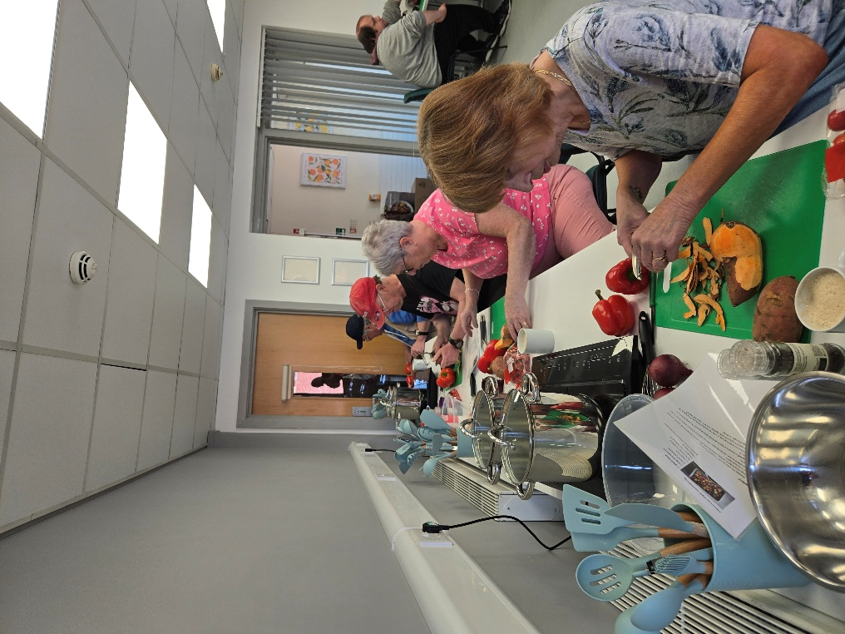
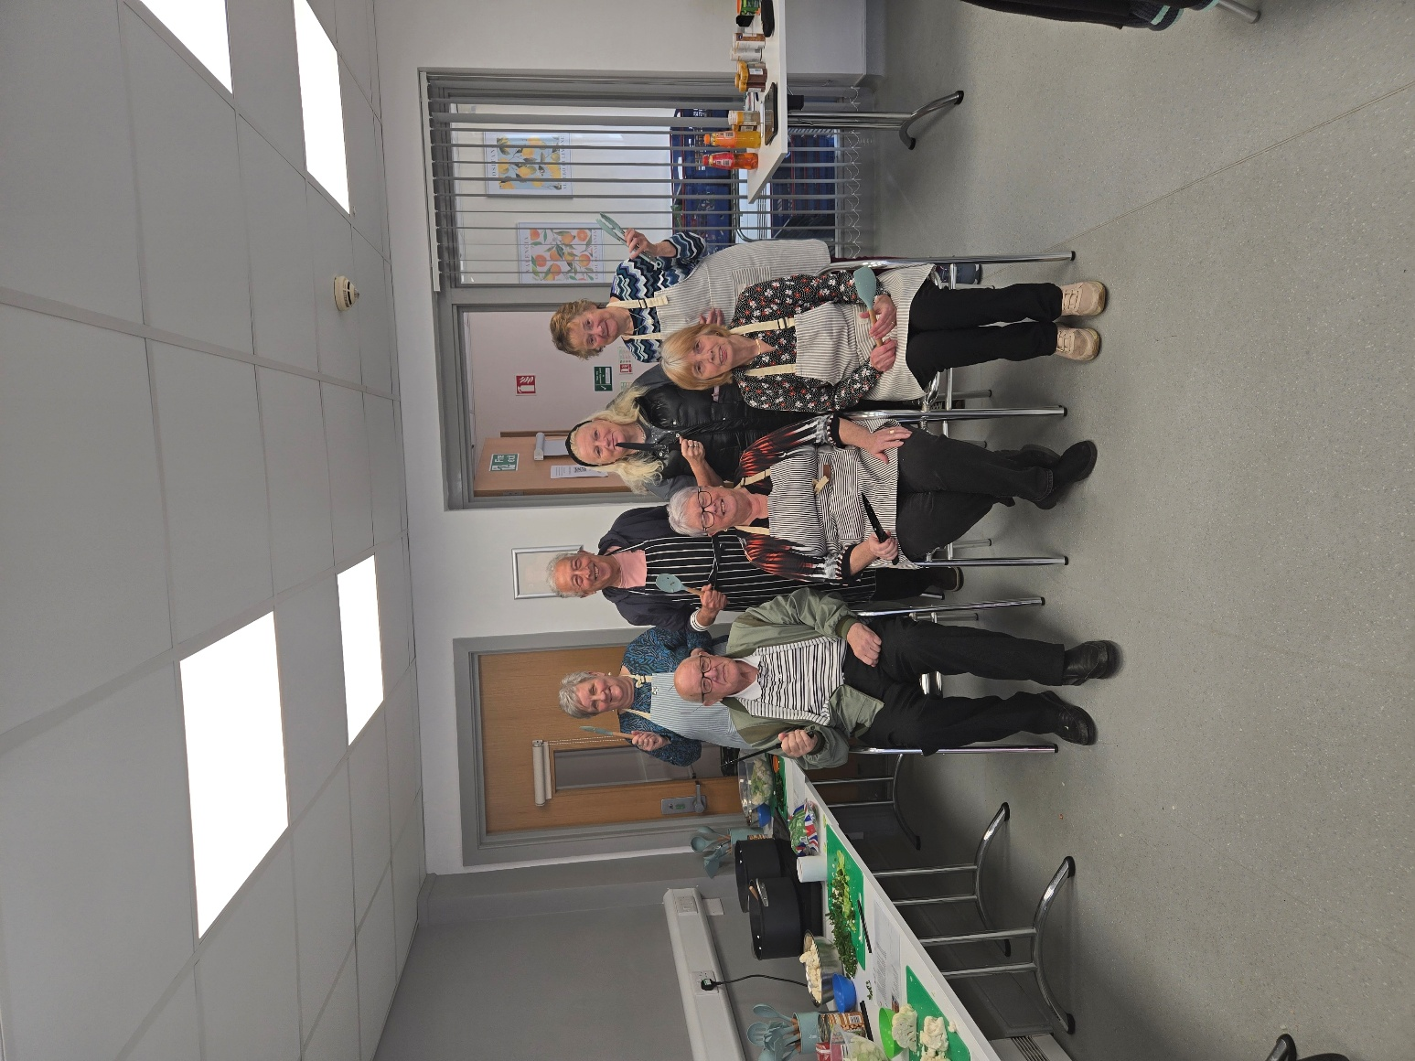
  - a meal kit service for families with children under four.

The grant scheme demonstrated drive locally for targeted food activities among groups who may face greater inequality. By delivering these activities we have seen a supported strengthening food resilience where it was most needed.
Identified next steps - Objective 6
For the 2026-27 period, our key actions will include:
- Create structured ways for people affected by poverty to shape services, establish lived‑experience panels linked to:
    - Trailblazer;
    - Corporate Parenting; and
    - Community food initiatives.
    - Review Integrated Impact Assessment (IIA) to ensure that poverty‑related impacts are assessed consistently and with lived‑experience evidence.
    - Work closely with EHRC guidance and implement recommendations from the EHRC’s 2024 desk‑based monitoring review.

Next Steps and Action Planning 2026–2028
Our annual report outlines the continued progress we are making in fulfilling our Public Sector Equality Duty and highlights key examples of our achievements against the Strategic Equality Plan Objectives 2024–2028. Through this work, we continue to strengthen and embed awareness of equality across our organisation.
While we have made meaningful progress, we recognise that further work is required. This report reflects our understanding that many areas of activity will need to be carried forward into the third year of the 2024–28 plan and will form the basis of the next action plan.
This plan will include clear commitments to deliver on the Welsh Government’s Strategic Action Plans for Equality, including the Anti-Racist Wales Action Plan and the LGBTQ+ Action Plan for Wales.
We remain committed to advancing equality and look forward to driving further progress in the year ahead.

Blaenau Gwent Workforce Equality Data
The charts below provide a consolidated overview of the organisation’s self-declared protected characteristics, as recorded in our Human Resources portal. Unlike in previous years, departmental breakdowns have been removed to ensure a higher level of anonymity and data protection.

Age Profile Summary
The age profile of the workforce shows a strong concentration of employees aged 36 to 55, indicating a predominantly mid-career demographic. Representation declines at both extremes of the age spectrum, with comparatively fewer employees aged 16–25 or over 65. This pattern suggests a stable, experienced workforce, though it may also highlight opportunities to further encourage younger entrants and support older employees approaching retirement.

Disability Summary
Disability data indicates that the majority of the workforce report no disability, with only a small proportion identifying as disabled. A notable number of individuals either left the question blank or selected ‘Not Known’, which may suggest hesitancy or uncertainty in disclosure. This highlights the potential value of continued awareness-raising about the purpose of data monitoring and assurances around confidentiality.

Marital Status Summary
The marital status breakdown shows that employees who are married make up the largest group, followed by those who identify as single. Other categories—including civil partnerships, separated and widowed individuals—represent much smaller proportions. This distribution is broadly consistent with national demographic trends but may also reflect the age profile of the workforce.

Ethnicity Summary
The workforce is predominantly composed of employees who identify as British or Welsh, with very limited representation across minority ethnic communities. Several categories record very small numbers. This pattern reflects low ethnic diversity within the organisation and may signal opportunities for targeted inclusion and outreach efforts, particularly during recruitment.

Religion Summary
The religious profile shows that employees most commonly identify with No Religion or Christianity. Other religious groups represent only a small fraction of the workforce. A modest number of employees chose not to state their religion, suggesting some preference for non-disclosure. Overall, the data reflects a relatively low level of religious diversity.

Gender Summary
The gender distribution shows a significantly higher proportion of female employees, who make up the majority of the workforce. Male representation is notably smaller. This imbalance may reflect the gendered nature of certain occupational roles within the public sector, such as social care and education, which traditionally attract higher numbers of women.

Sexual Orientation Summary
Most employees identify as heterosexual, with only small numbers reporting other sexual orientations such as gay, lesbian, bisexual, or asexual. A considerable number of individuals either left the field blank or selected ‘Prefer not to say’, which suggests that some employees may still be cautious about disclosing sexual orientation information. This underlines the continued importance of fostering a supportive culture where individuals feel confident to self-report.

