Empowering and supporting communities to be safe, independent and resilient
Evaluation Rating 4:  Good | Evaluation Narrative:  The Council continues to strengthen its approach to empower communities supporting them to becoming more resilient and independent. Working in partnership with the West Gwent Community Cohesion Programme and local Community Safety Partnership, the Council continues to deliver a range of projects and initiatives which promote increased awareness and understanding; encourages and celebrates diversity; and brings people and local communities together to strengthen community spirit and resilience. Since 2016, Blaenau Gwent Council has supported the UK’s Resettlement Scheme Programme, working in partnership with a wide range of public, third sector and private sector organisations, to deliver a holistic package of support for those requiring resettlement. The Council has supported this approach whilst maintaining positive community cohesion across the borough. Preventative service delivery continues to be a priority for the authority and our Social Services Directorate in particular works preventatively to support independence and safeguarding to our communities. Recruitment and retention in social services continues to be a challenge which is similar to the national picture. Workforce strategies have been developed to address these challenges and an officer has been recruited to promote career development opportunities to our social work staff. In Children’s Services two residential properties have been purchased to provide residential care for children with more complex needs so they can be looked after closer to home as opposed to outside of Blaenau Gwent and even Wales. Although our safeguarding performance is good, due to the pandemic, there has been a delay in fully addressing recommendations made by Audit Wales. Directorates across the authority will undertake the implementation of the recommendations which will be reported in the next self-assessment.

Why This Is Important as an Area of Focus:
The Council wants to encourage and support people to make healthy lifestyle choices to enable children, young people and families to thrive. Research has proven people demonstrating positive health behaviours from birth throughout their life will lead to greater independence, and people being free from complicated health conditions later in life. This in turn could reduce demand on services and ensure the services that are provided are high quality, efficient and responsive to local people’s needs. With reduced funding and increasing demand on services the Council can no longer do everything it has done in the past. The focus must be on those actions that will have the greatest impact. Safeguarding the most vulnerable people in the community continues to be a top priority for the Council alongside transforming the aspirations of residents and valuing fairness and equality in everything we do.

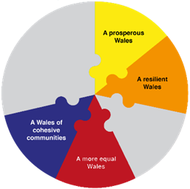
Identified Need:
- Promote awareness and understanding and encourage and celebrate diversity;
- Strengthen community spirit and resilience;
- Community Safety;
- Blaenau Gwent: Is a welcoming, diverse and thriving place to live and visit; and
- Creating volunteering opportunities to empower residents to have control over their own communities.

What We Aim to Achieve - An increase in the resilience of communities, where everyone is welcome and safe and which minimises dependency and maximises independence.

How Well We Are Doing and How Do We Know:
Information Advice and Assistance
The Social Services Directorate continues to have dedicated Information Advice and Assistance (IIA) Teams for both Children and Adult Social Services. These teams are the first point of contact for the pubic who wish to access advice and support and for professionals making referrals. The teams take a preventative approach to ensure needs are met at the earliest opportunity, by providing the right services to prevent needs from escalating. In relation to Adult Services this also includes contacts for some health functions. A range of other professional’s work within these teams.

The Children’s IAA Team is funded by a mixture of core and grant funding which is a risk if future grant funding is removed. However, the new Adult Services IAA structure went live in April 2022 and is no longer reliant on grant funding creating a more sustainable service.

Preventative service delivery continues to be a priority across all services. Children’s Service’s IAA teams have seen a significant rise in referrals, but, despite this, all referrals have been dealt with within statutory timescales. All contacts across both Adult and Children’s Services take an outcome based approach by establishing ‘what matters’ to the customer and the number of referrals being allocated continues to be stable, evidencing that the preventative work, undertaken at the ‘front door’, continues to be successful.

Adults Services IAA received 4,610 enquires at the 'front door'. The number of referrals resolved at IAA was 2,767 (made up of those enquiries signposted, closed down before progressing to assessment, and those that led to an IAA). The remainder 1,843 went to the Safeguarding Team, Community Resource Team or the Unpaid Carers Team. Children’s Services IAA received 6,755 referrals with 772 of them being referred to preventative services (Families First).

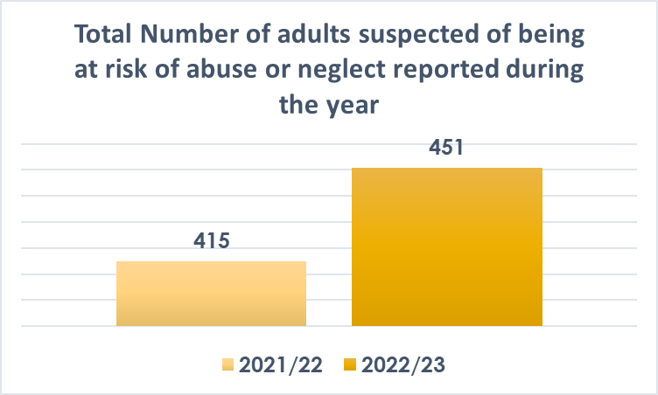
Safeguarding
The Department recognises the importance of having a robust and sustainable Safeguarding Teams across both Adult and Children’s Services to ensure we not only meet our legislative requirements, but that we are also able to protect our most vulnerable citizens. All safeguarding referrals continue to be managed in line with the Wales Safeguarding Procedures and statutory requirements. Adult Services has implemented a new adult safeguarding staffing structure which is now operational and working effectively. An additional senior practitioner for safeguarding has been created to create additional capacity and also provide decision making resilience. The service has seen an increase in numbers of referrals of safeguarding during 2022/23 compared to 2021/22.
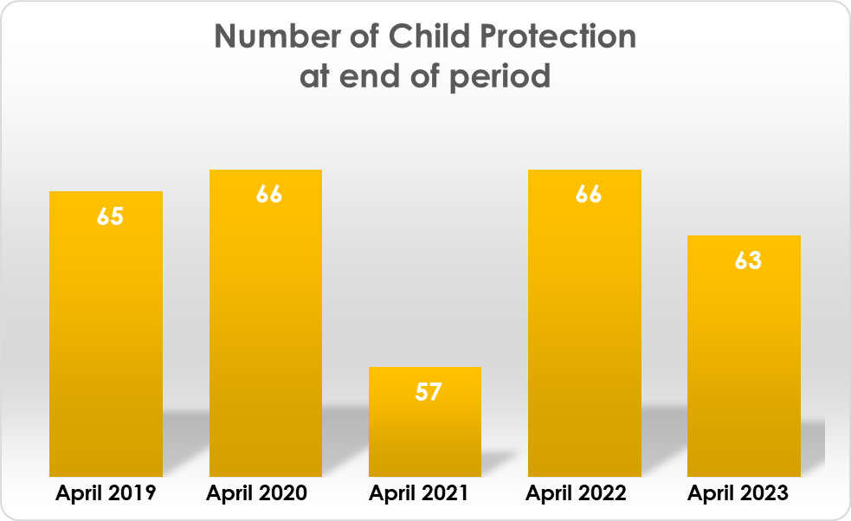
Safeguarding performance is good. Child Protection conferences have been held within statutory timescales as have all Child Protection statutory visits for children on the register.
The graph shows the number of children on the Child Protection Register at the end of each year since 2019.

Having a suitably qualified and skilled workforce is paramount when ensuring that vulnerable people are safeguarded. The department has developed a workforce strategy to ensure that we recruit and retain staff across Adult, Children and Provider Services and also support their development, progression and well-being. To assist in the delivery of the workforce strategy the department has successfully recruited a lead officer to support managers in progressing and promoting the opportunities that we can offer staff in Blaenau Gwent.

Staff safeguarding training is ongoing with different models of learning offered to different staff groups. Refresher training has been provided to Provider Services which has included commissioned sessions from the Workforce Development Team and also bespoke learning sessions provided by our Safeguarding Team.

The Early Years Child Protection Training programme is created annually and checked monthly to ensure that it is up to date. Safeguarding is always a standing item in the Network Meetings and six monthly meetings are held with the Safeguarding Lead and the Early Years Child Protection Manager.

All new Council staff are informed of the Council’s safeguarding arrangements as part of their induction programme. All staff within teams have completed the relevant level of safeguarding training. Within the Children’s IAA team all Safeguarding referrals must be responded to within 24 hours and we are continuing to respond accordingly. All safeguarding concerns are responded to with appropriate decision making and all strategy discussions are usually held within 24 hours. The issue with Police meeting this timescale remains an issue when they deem it 'non-urgent' they will arrange for this to be held out of this timescale.

We continue to be a key partner of the Gwent Safeguarding Strategic Board and relevant operational sub groups. As a partner of the Gwent Deprivation of Liberty Safeguards (DoLS) Board we continue to prepare for the implementation of the Liberty Protection Safeguards legislation (LPS) and, during the year, have contributed to the consultation on the long-awaited codes of practice. As a partnership, we have submitted a Welsh Government Regional (Gwent) bid to support capacity for the development of LPS in order to provide important rights and protections for people who lack the mental capacity to agree to care, support, or treatment arrangements, where these arrangements amount to a deprivation of liberty. In addition to this, a new Social Work senior practitioner with responsibility for Mental Capacity Act support and DoLS has been recruited and due to start in July 2023. The number of people waiting for a DoLS assessment within Blaenau Gwent has reduced considerably during 2022/23 as a direct result of the local monitoring and as a result of coordinated resource to address the back log via both the Gwent DoLS team and externally commissioned assessments.

In 2022 Audit Wales undertook a follow up review of the Council’s Safeguarding Arrangements, following reviews undertaken in 2014 and 2019. In November 2022 the Council received the outcome of the report. Audit Wales found that, ‘the pandemic further delayed the Council’s response to the 2019 report. Although it has taken recent action to strengthen its corporate safeguarding arrangements, the Council has not yet fully addressed our previous recommendations. The Council recognises the need to strengthen corporate safeguarding arrangements beyond the Social Services and Education directorates. The Council developed an action plan to address the outstanding recommendations but, due to the pandemic, most of the planned work did not begin until early 2022’. From this, a further two recommendations were received for implementation.

The Audit Wales Safeguarding report was presented to Governance and Audit Committee on 8th March 2023. The Strategic Safeguarding Leads Group, chaired by the Interim Head of Children’s Services, with representation from each directorate across the Council, will undertake implementation of the recommendations identified by Audit Wales. An internal audit has also taken place in relation to safeguarding processes across the directorate and reasonable assurance was given.

Working in Partnership
The council ensures that it provides a varied range and level of preventative services. To ensure that the correct services are in place, a population needs assessment was completed for 2022/23. Extensive consultation took place when undertaking this assessment, and based on the data, priorities were set for each part of the population including children and young people, older people, including those with Dementia, people with physical disabilities and sensory impartment, people with leaning difficulties, people with Autism, people with mental health issues and carers in need of support. A regional action plan has now been developed to meet the needs identified for each population group. The RPB has agreed an Area Plan 2023/28 which sets out the response of the RPB to the findings of the regional Population Needs Assessment and has been prepared to meet the requirements of the statutory guidance in relation to Area Plans under section 14A of the Social Services and Well-being (Wales) Act 2014. The Plan will align to other strategic drivers such as the Gwent Public Service Board Well-being Plan, Aneurin Bevan University Health Boards Integrated Medium Term Plan and supporting Integrated Service Partnership Board plans.

The Supporting Change Team has been working collaboratively with the Youth Service to run a small trauma informed, activity based group for some of the hardest to reach young people open to the team. This includes the establishment of a sports session and the continuation of the Carers Support Group. The team has also concluded a group work project working in partnership and alongside a targeted group of young girls looking at raising aspirations, self-esteem, and self-worth. The project has been very well evaluated and the team are looking into how they can run further projects.

Workforce
Staff are supported with access to training on ‘what matters’. New staff have also attended training sessions on Collaborative Communication and accessed other learning opportunities available in order to support outcome focused practice, and deliver interventions based on an outcomes/strengths based approach. Monthly reflective practice sessions continue in each of the service areas and refresher training is available to all staff through Workforce Development.

Adult Service staff have been undertaking learning and development opportunities in collaboration with colleagues from Aneurin Bevan University Health Board (ABUHB) as part of a project facilitated by Social Care Wales (SCW) and there has been a strong emphasis on focussing on changing the conversation with patients during assessments within our acute and community settings. This work was evaluated by Social Care Wales in the Autumn of 2022, the outcome of which will be presented to the Gwent Adult Strategic Partnership Board as part of showcasing across the RPB.

Having a skilled and motivated workforce is essential in order to provide high quality services. As part of this, the Council has a Joint Workforce Development Team with Caerphilly County Borough Council with responsibility for delivering a training and development strategy that supports development opportunities for staff at all levels in Social Services.

A full programme of learning is provided for the whole social care sector. All statutory, legislative, and registration linked requirements are planned and accounted for. The offer includes developmental opportunities for the workforce and support for resilience and well-being.

The challenges for the workforce to fully embrace learning opportunities remain high. The current recruitment environment has a major impact on the sector and forces harsh choices that without doubt impact on the capacity available to fully embrace development opportunities beyond the essentials.

The first half of the year continued its support for the registration of residential workers ahead of October. The Social Work Strategy continues to deliver qualified professionals, and at a rate above the national norm.

The way the workforce wants to learn has changed, they expect choice and flexibility. Various initiatives within the organisation are in place to support improving digital confidence and access to digital learning. The authority underpins its approach with the recognition of barriers that exist for parts of the social care workforce, so the offer includes the traditional classroom route.

Classroom activities use digital devices to provide safe space learning with facilitator and peer support:
- The authority has co led the All-Wales project on securing an organisational level, fit for purpose, future proof, digital learning platform that will meet the needs of the whole sector, communities and volunteers. The authority, one of four in the first phase, are demonstrating nationally to others the benefits to the workforce of sharing across boundaries
- The power of social media is used to engage and communicate with the sector
- The learning delivery model, currently blended learning approaches and a choice of digital or face to face, will shortly include hybrid delivery – the required investment in technology having been funded by a successful bid to Social Care Wales

The engagement from the workforce with new ways of learning is exceptional and they continue to reward the community with their ongoing resilience and determination.

Disability Services
A Worcester University Evaluation of the 0 -25 Disability Service has been undertaken. The Evaluation evidences good use of the disability index and the disability Facebook page and these services continue to be offered within the team.

This year, Augusta House requested registration from our regulator CIW to provide respite support to young children in addition to adults which was agreed. This has now enabled the Disability Team to have access to a residential respite provision which is proving successful for children with a disability and supporting the needs of their parents and carers, as well as outcomes for the young people.

Work-based services within our Community Options and Day Activities teams have continued throughout the year with students returning to placements within our catering enterprise in partnership with Vison 21. As part of our employment and training opportunities for people with a Learning Disability or living with poor mental health, we continue to scope new opportunities for development including the development of additional catering enterprises including a new community café.

Adult Services
There have been ongoing reviews of the care management waiting lists due to capacity demands and reduced availability of domiciliary care to support people safely at home. We have proactively utilised the DASH emergency domiciliary care service to cover unplaced packages of care and this has ensured that no citizens have been without their domiciliary care packages and that they are safely supported at home.

The council has contributed to a regional Winter Plan with the aim of preventing people entering hospital, and when in hospital, facilitating discharge as soon as possible. Work has also taken place with providers of residential care to enable early discharge from hospital for those with short term nursing needs.

A Gwent Dementia Action Plan has been developed and aligns to the 20 All Wales Dementia Pathway of Standards which will also include performance measures. Work stream subgroups have been developed to take forward this programme of work. Discussions continue with the Alzheimer’s society regarding dementia advisors for the dementia reablement programme in line with the Dementia action plan and this new service is due to commence in April 2023.

We have continued to see increasing demands placed on the Health and Social Care system including at our community and acute hospital sites. We have been working with our Gwent Local Authority colleagues and ABUHB to revise current models of support to enable patients who are ready for discharge to either safely return back to their own homes or to utilise alternative accommodation, on a temporary basis, whilst waiting for support to enable them to return home. We are using current partnership Regional Integrated Fund (RIF) grant funding to develop a menu of support services including, increasing the use of Step Closer to Home beds to reduce the dependency on hospital stays and reduce length of stays, providing additional care home capacity as well as additional capacity within our assessment teams in order to address both the current and future demand. Alongside this, a review of the Hospital Social work team has created additional capacity to support patients to avoid unnecessary lengthy stays in hospital. This team works closely with the hospital ward staff, discharge assistants and therapists to ensure that patients can return home as quickly as possible. The team also supports family unpaid carers through the discharge process and provides statutory carers assessments to enable carers to maintain their caring role alongside their work, health, leisure and family commitments.

The reduction in Covid restrictions has enabled our residential care homes, supported living services, and Augusta Respite Centre to re-engage with wider community activities and welcome visitors back to support our residents. Cwrt Mytton has welcomed learners from a number of our schools as part of our intergenerational work streams.

Respite is an important part of maintaining caring responsibilities. The department is currently working with our neighbouring authorities to develop enhanced respite offers alongside the more traditional offers of care home placements, Augusta House Respite Centre and Day Opportunities. The new scheme is due to be launched in Summer 2023 and is a partnership arrangement with NEWCIS, a large North Wales provider of carer services. The Augusta PODS were completed in March 2023 and will give people with learning difficulties the opportunity to develop their independence skills in a purpose built supported environment.

We continue to aim for the delivery of modern flexible and responsive services that enable older people to maximise their independence and live with appropriate support within their communities. The development of our SMART flat will assist this by further promoting assistive technology to professionals, individuals, and their families/carers. The Service Manager for Preventative Services and the Supporting People Team Manager have delivered presentations on the SMART flat to a number of organisations. We are continuing to add to the TEC equipment at the Smart Flat to ensure we continue to broaden awareness and knowledge of TEC services.

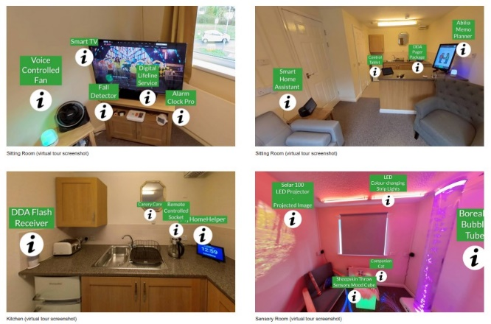
The Local Authority has utilised equipment purchased as part of the Welsh Government Promoting Independence Grant to provide the latest equipment (beds / hoists/ standing aids) to support the ethos of single handed care. The CARIAD (Collaborative Assessment Reducing Interventions, Admissions and Delayed transfers of care) bariatric flat was completed in September 2022 and now forms part of the Blaenau Gwent CARIAD offer. The coordination and monitoring will be facilitated by our Community Resource Team as part of the review of the functions and to ensure that we have a reablement and promote independence for our most vulnerable people.

Our Better Care / Single Handed care project continues to promote people’s independence and reduce their reliance on staff for manual handling and personal care tasks. The Better Care Team have developed a comprehensive training and support package for all staff across the Blaenau Gwent Health and Social Care community who provide frontline care.

Children’s Services
The South East Wales Adoption Service (SEWAS) is supporting the review and implementation of the National Adoption Service 2025 plan in respect of building capacity for access to records, and ensuring that Welsh Government investment monies promote multi agency work. ‘Understanding the Child’ Days are taking place for all children referred to the service from 18 months old, and transitions continue to follow the good practice guides to ensure all care plans are outcome based. Support workers are in the process of being recruited to support delivery of the objective in respect of trauma nurture timelines and adoption support check ins. The SEWAS Contact Worker continues to promote sibling contact which involves speaking to child care social workers at an earlier date with regards to sibling contact arrangements and reviewing existing arrangements. One off birth parent meetings are increasing.

SEWAS are working with the National Adoption service central team and other regions to ensure marketing is targeted to increase the number of adopters for more complex children. We have been able to provide in house adopters for a number of siblings in a timelier manner. At present, the number of children waiting for placements is decreasing as is the rate of referrals from prospective adopters. This could be linked to the cost of living crisis and will need to be monitored more closely moving forward.

The Life Journey Work Coordinator is rolling out training to childcare social workers. Improvements have also been made to the quality of materials provided to adoptive parents. The understanding of child days and trauma nurture timelines are completed for children aged 18 months + and this provides adoptive families with enhanced analysis of the impact a child's early years.

A special guardianship order (SGO) is a way of providing stability for a child who cannot return to live with their birth parent and for whom adoption is not appropriate. It is a legal way of giving the person caring for the child, clear, long-term responsibilities for the child's upbringing. As at 31st March 2023, there were 145 children subject of SGO living in 107 families open to the service.

In April 2022, Blaenau Gwent established its own MyST (My Support Team) to provide greater capacity within the service. Since this time, staff from MyST have been attending News and Networking events and meeting mentors in order to embed the service fully within Blaenau Gwent. Positively, the service is now working with children, under each of the operational teams, suggesting that the service is being utilised by all. MyST are operating at full capacity providing support to 15 children and young people as well some additional bespoke pieces of work. The MyST service also continue to work with a number of young people in residential care on a 'step-down' basis as well as working with a number of young people who are at risk of entering residential care on a preventative basis. In order to improve the service, offer discussions have taken place between the MyST and Placement Team in order to work collaboratively and have joint marketing going forward.

A formal consultation process for foster carers has been implemented with the deadline for submission of the survey 31st March 2023, the outcome of the consultation will be processed and reported going forward. Teams continue to practice in an outcome focused way where we identify family options early in the intervention process, which we prioritise if children have to be admitted into the care of the Local Authority. However, there are situations when appropriate placements are not available locally leading us to access Independent Fostering Agency placements and residential care for young children. Supervision is used consistently to review the plans of Children Looked After (CLA) and consider opportunities for discharging the Care Orders. Regular review of care planning for these children is a priority and for those with a high level of needs referrals to the MyST are considered and prioritised.

Work has taken place to ensure that mandatory safeguarding training for foster carers is being delivered on a face-to-face basis rather than virtually. The training needs of foster carers continue to be monitored and promoted during annual reviews, appraisals and supervision sessions, a programme of training/reflective sessions for foster carers commenced in January 2023 and is being delivered by the MyST.

A Circle of Security Parenting Programme has been delivered to a small number of parents with young children, in collaboration with the Psychologist and Support Worker. Additionally, Circle of Security has been delivered to a cohort of foster carers, helping to stabilise children in care and preventing a risk of breakdown in placement. Feedback is that they have found the parenting programme to be very beneficial and are adapting their parenting styles accordingly.

There continues to be a slow but steady reduction in the number of CLA. New children are still coming into care, but we are also progressing with discharging Care Orders for children living at home or with kinship carers.

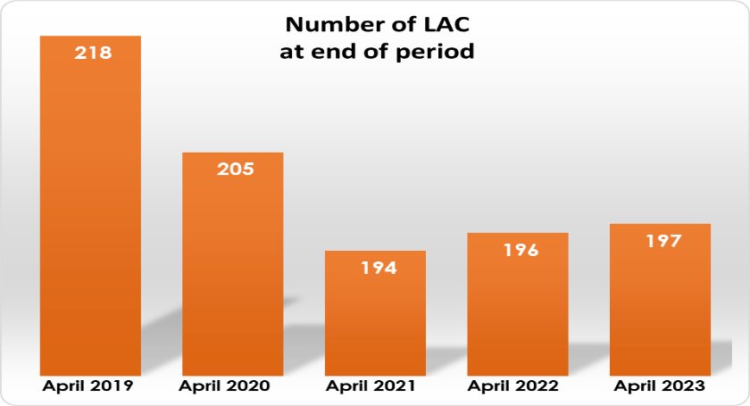
We are now part of the National Transfer Scheme and responsible for a cohort of Unaccompanied Asylum Seeking Children who are CLA. We currently have 8 children placed, mostly in England. The team is learning to develop their skills in working with this group as this is very new to Blaenau Gwent.
Number of CLA at end of period

The Welsh Government has continued to provide funding for a set number of children to participate in the Letterbox Club each year. The Letterbox Club encourages reading for pleasure and learning at home. It helps to improve the educational outlook for children who are looked after. Parcels have continued to be distributed to our children on a monthly basis between October and May, with an additional festive parcel provided in December.

This year, two residential properties have been purchased to provide residential care for children with more complex needs so they can be looked after closer to home as opposed to outside of Blaenau Gwent and even Wales.

Support to our unpaid carers including our Young Carers, have benefited from the development of a new scheme that supports them with the impact of the cost of living crisis. The department has implemented a series of information opportunities, along with a carers grant scheme, with funding provided by Welsh Government and the Carers Trust for 2022/23 and 2023/24. The coordination of this project has been collaboratively led by officers from both Children and Adult Services to ensure that we provide equitable opportunities to both our young and adult carers.

The service continually monitors and reviews the way in which services operate and to decide if a change is necessary in order to manage demand and workload. As a result of this, as of January 2023, a new pilot commenced with the Children Services Locality Teams which will run over a 12-month period. Within this pilot, three new operational care planning teams were established with the 4th becoming the Statutory Assessment Team. Early indications are that the change is impacting positively on capacity and outcomes for the child and family. The Statutory Assessment Team has also eased the work pressure on the Locality Teams. The pilot is reviewed regularly to ensure that the staff complement is appropriate and that the new model is working well. Caseloads continue to be monitored and all staff and team managers are ensuring caseloads are accurate to ensure they are manageable.

Flying Start services were involved in the Estyn inspection that was undertaken in November 2022 on Blaenau Gwent Education Services and came out as an area of excellence in verbal feedback.

Families First continue to work intensively to prevent cases escalation into statutory services with:
- 330 cases active at the end of March 2023;
- 237 cases being discussed at Wellbeing panels in the last quarter; and
- A variety of group, community work and events being delivered throughout the year.

A pathway for Antenatal support supported by Families First has been developed, which will mean every pregnant woman in Blaenau Gwent will be able to access the appropriate Antenatal support until the child is 1-year-old.

Housing
A review has recently been undertaken to understand the number of empty properties across the borough. There are approximately 761 privately owned empty properties in Blaenau Gwent, with 33 empty properties (46 units) brought back into use 2022-2023 via direct action.

Work continues to identify and prioritise future housing opportunities (mix of tenure) working with Tai Calon and partners to identify schemes. Tai Calon now have one new residential development under construction, with another about to be submitted for planning, with the aim to formulate an ongoing future programme of development. Constant review with all Registered Social Landlord partners is undertaken to ensure a pipeline of residential development is identified and brought forward.

61 Disabled Facilities Grants (DFGs) have been delivered this year. This work provides major home adaptations for disabled people for the purpose of providing access into and around their homes. The average number of calendar days taken to deliver a DFG in private homes to support independent living this year was 334 days.

A Local Housing Market Assessment is underway in order to inform a revised Housing Strategy and Local Development Plan. A cross cutting Housing Strategy Group has recently been set up to take forward the revised Housing Strategy.

The City Deal Housing Viability Gap Fund is a targeted funding programme to bring forward new homes on key strategic housing sites across South East Wales. Blaenau Gwent made a successful submission to the fund as it was identified that there is a viability gap which required grant input to support development to go ahead. £1.7M has recently been secured in order to remediate a site in Ashvale, Tredegar. The site will bring much needed homes, to the area, comprising of 54 open market and 6 affordable homes.

Homelessness
During the reporting period, 288 households met the threshold for being threatened with homelessness. Of these, 183 were successfully prevented from losing their accommodation - 64%. This high prevention rate has been achieved by targeting early intervention initiatives to prevent homelessness at a very early stage.

The likelihood for homelessness presentations is likely to increase which will put pressure on temporary accommodation, this situation is likely to be further impacted by the cost of living crisis. Therefore, the service is looking at the following in order to plan ahead and prepare:
- Move to Rapid Re-Housing Approach – Changing the Culture;
- Work with social and private rented sector landlords to develop schemes and to sustain tenancies and increase access to housing;
- Increase prevention work to maximise successful outcomes;
- Reduce the number of ‘repeat presenters’ and rough sleeping;
- Maximise access to a range of support;
- Utilise Welsh Government Funding Streams (Homelessness Prevention Grant);
- More Affordable Housing (Including 1 property per new housing development specifically for Housing First Scheme);
- Staff Training – Technologies opened up new opportunities that were previously impracticable / unaffordable; and
- Raise awareness of homelessness and services, encouraging self-help and resilience.

A change in legislation has led to a high number of new homelessness presentations in Blaenau Gwent and this is further impacted a lack of available temporary accommodation. The current data shows:

Current Placements:
  - Bed & Breakfast - 29
  - Ty Parc (Homeless Hostel) - 19
Total Placements since April 2020 – Present:
  - Bed & Breakfast accommodation - 322
  - Homelessness Hostel - 81
Total ‘Live’ Homelessness Applications– Present:
  - 278
Total Cost of Temporary Accommodation (Funded by WG)
  - Bed and Breakfasts - £800,000+
  - Security (due to number of incidents) - £570,000+
The current number placed in Bed and Breakfast accommodation is – 29

There continues to be an improvement in the number of affordable and private homes being delivered across Blaenau Gwent with high numbers of homes accessing funding for making them more energy efficient. Alongside this, the early intervention for homelessness means 63.5% of potentially homeless households were prevented from becoming homeless.

Our Transitional Capital Funding Programme involves working with Registered Social Landlords to identify properties for homelessness/resettlement schemes. During the year, 8 additional properties have been included and a further 3 properties have been identified in partnership with Tai Calon for inclusion in the scheme for which a bid was submitted to Welsh Government for funding.

The Youth and Community Team continue to support young people to prevent youth homelessness and to support mental health and well-being. The team has continued to support individuals on a one to one basis, along with groups and community projects. These young people are often in precarious housing situations, and support is based around navigating appropriate information, advice and guidance from other services to help provide some stability and to enable them to improve their housing situation. This has continued to develop, with ongoing relationships with partners growing and becoming more efficient and effective. During the last academic year, 34 young people were supported on a one to one basis.

Environmental Health
Blaenau Gwent’s Food Hygiene Service continues to deliver interventions at food businesses within the Borough. During 2022/23, a total of 218 interventions were completed at high risk premises meeting one of the challenging targets that was set in the Food Standards Agency recovery plan. This work has been completed alongside our other continuing programmed and reactive workload. We still have a significant backlog of food hygiene interventions to deliver which are a legacy of the impact of the Covid pandemic. At present, we have a backlog of 225 D and E rated premises that are overdue an inspection. We are currently considering options to address this backlog. This figure does not include new businesses. During 2022/23, 98 new food businesses opened across the Borough. We continue to prioritise for inspection those that are likely to present a higher risk in terms of food safety in-line with guidance from the Food Standards Agency. Of those that opened during and prior to the 31st March 2023, we still have 46 new businesses which require inspection.

At the close of the reporting year 2022/23, 92.6% of food premises were broadly complaint with food hygiene standards with an increase in the number of re-rating requests.
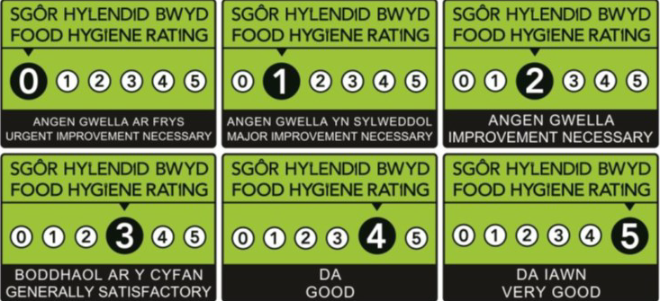

Challenges the Council have experienced throughout the year

Workforce
Workforce stability is a key consideration within Social Services as some teams are facing staffing shortages, however, it is acknowledged that this is a Wales wide position and there is no simple solution. The department as a whole has been working hard to look at innovative ways of managing the workload within teams as well as developing recruitment and retention strategies to address workforce pressures. Despite these significant pressures the existing staff and providers of services have continued to ensure children and adults needs are met, risks are managed, and safeguarding issues dealt with.

Social Services are working closely with Organisational Development to establish a Strategic Workforce Plan to support capacity concerns in the short, medium and longer-term as well as considering the opportunity to collaborate on a regional basis. The workforce in Social Services has been identified as a critical risk and has therefore been included on the Council’s Corporate Risk Register.

Child Protection Conferences
Safeguarding performance is good although child protection conferences are still slow to bring back to face to face arrangements. This is an area that will require further development. The rise in residential placements for older children is also a concern.

Foster Care
It has proven to be extremely difficult to recruit foster carers and interest in fostering at this current time is very low, despite efforts to increase awareness via social media and recruitment activity. Close working relationships with the Foster Wales Manager and the promotion of the Foster Wales brand continues. Demand for foster placements has increased and there has been a greater reliance on Independent Fostering Agency placements (IFA).

Challenges remain regarding the availability of ‘step down’ accommodation from residential care into foster care which is largely dependent on the availability of ‘step-down’ foster placements. With the demand on placements, and the difficulties with recruitment of foster carers, it has not been possible to reduce the population of young people in residential care further.

Budget
During 2019/20, 2020/21 and 2021/22, the Council incurred costs of around £2m per annum (£2.5M, £2M & £1.8M) respectively) on residential placements for Children Looked After. Costs have been reducing as a result of lower numbers of children requiring residential provision, however, the local authority will always need to provide residential care for some children. To address these high costs, in September 2022, it was agreed to proceed with the development of a business case to deliver local authority residential placements for children looked after.

What Evidence is Available
- Children Looked After Strategy
- Corporate Safeguarding Policy
- Prevention and Early Intervention Strategy
- Performance Data
- Auditor Reports
- Service Business Plans
Agendas and Recordings of Democratic meetings all available on the Council Website - https://democracy.blaenau-gwent.gov.uk/ieDocHome.aspx?Categories=

