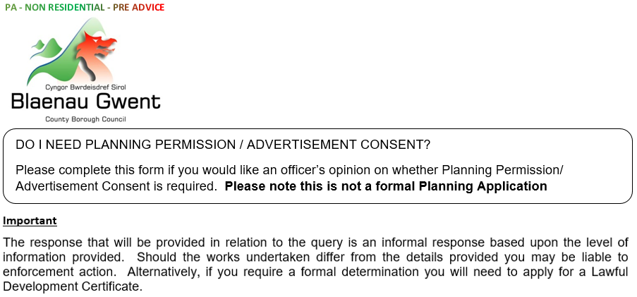

For Office Use Only | **PA** Application Form

BGCBC Ref. No.: ……………………….………………………

Receipt No.: ……………………….………………………

|  |  |  |  |  |
| --- | --- | --- | --- | --- |
| **1 Briefly describe the proposed development / query and provide a sketch plan overleaf**. If you already have detailed drawings, please attach them. | | | | |
|  | | | | |
| **2 Contact Details** | | | | |
| Full Name: | |  | | |
| Company Name: (if applicable) | |  | | |
| Full Address: | |  | | |
| POST CODE: | |  | Contact Tel./Mobile Number: |  |
| Email: | |  | | |
|  | | | | |
| **3 Details of property/site of the proposed development / query** (If the land is not easily identifiable by a known address please include a *Site Location Plan* outlining the site in red). | | | | |
| Full Address: |  | | | |
| POST CODE: |  | | | |
|  | | | | |
| If you have any queries in relation to completing this form please contact Development Management, Planning Division on 01495 355555 or email [planning@blaenau-gwent.gov.uk](mailto:planning@blaenau-gwent.gov.uk)  Please return the form to [planning@blaenau-gwent.gov.uk](mailto:planning@blaenau-gwent.gov.uk) or post to Development Management, Planning Division, General Offices, Steelworks Road, Ebbw Vale, NP23 6DN  Payment can be made online via our website home page / ‘Make a Payment’ link, a guide is available on request. | | | | |



**Sketch Plan of the Proposed Development**

|  |
| --- |
|  |

