BLAENAU GWENT COUNTY BOROUGH COUNCIL

Ethics and Standards Committee
Annual Report 2023

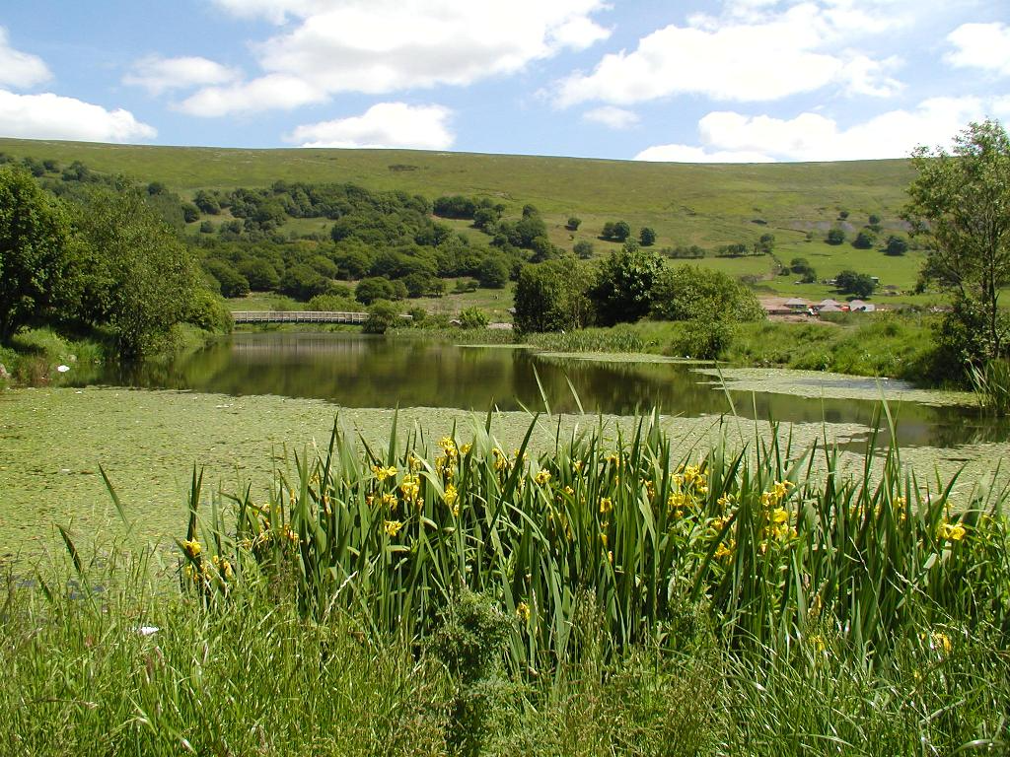
Blaina – Cwmcelyn Pond

THE TEN PRINCIPLES OF PUBLIC LIFE

Selflessness – Members should serve only the public interest and should nev-er Improperly confer an advantage or disadvantage on any person. | Personal judgement – Members may take account of the views of others, in-cluding their political groups, but should reach their own conclusions on the is-sues before them and act in accordance with those conclusions.
Honesty and integrity – Members should not place themselves in situa-tions where their honesty and integrity may be questioned, should not behave improperly, and should on all occasions avoid the appearance of such behaviour. | Respect for others – Members should promote equality by not discriminating unlawfully against any person, and by treating people with respect, regardless of their race, age, religion, gender, sexu-al orientation or disability. They should respect the impartiality and integrity of the authority’s statutory officers and its other employees.
Objectivity – Members should make decisions on merit, including when mak-ing appointments, awarding contracts, or recommending individuals for re-wards or benefit. | Duty to uphold the law – Members should uphold the law and, on all occa-sions, act in accordance with the trust that the public is entitled to place in them.
Accountability – Members should be accountable to the public for their ac-tions and the manner in which they car-ry out their responsibilities, and should co-operate fully and honestly with any scrutiny appropriate to their particular office. | Stewardship – Members should do whatever they are able to do to ensure that their authorities use their resources prudently, and in accordance with the law.
Openness – Members should be as open as possible about their actions and those oftheir authority, and should be prepared to give reasons for those ac-tions. | Leadership – Members should promote and support these principles by leader-ship, and by example, and should act in a way that secures or preserves public confidence.

FOREWARD BY THE CHAIR
I am pleased to present this Annual Report of the Ethics and Standards Committee for 2022/2023. The Annual Report provides information to the Council about the work carried out by the Committee in promoting and maintaining high standards of conduct by elected Members and co-opted Members during the past 12 months and identifies specific issues that have arisen.
Standards Committees are required by virtue of Section 63 of the Local Government and Elections (Wales) Act 2021 and Part 3 of the Local Government Act 2000 to make an annual report after the end of each financial year and for full Council to consider that report within 3 months. This statutory report must describe how the Committee's functions have been discharged during the previous year and must include specific reference to any reports, actions or recommendations made or assigned to the Committee. This is the first year that the report includes formal reference to the work of the Group Leaders on promotion of high standards within their Groups. We thank them for their important work in this area. Copies of this Annual Report must also be sent to the Public Services Ombudsman for Wales and to all local community councils.
The Ethics and Standards Committee is committed to promoting high standards of ethical conduct among elected Members, co-opted Members and officers in order to maintain public confidence in local government. The Committee has, and will continue, to proactively review all ethical standards policies and procedures as part of their important forward work programme. In this reporting period, there were no referrals to the Ethics and Standards Committee under the Local Resolution Protocol. There was a conduct complaint in relation to an Elected Member that was taken to investigation by the Public Service Ombudsman for Wales (PSOW). In addition, the PSOW made two completed investigation referrals to the Ethics and Standards Committee. Further detail is provided later in this report at page 5. It is essential that the good standards are maintained in the future and the Ethics and Standards Committee needs to monitor against any possible drift towards complacency or reduction of ethical values.
The training requirements for County Borough Councillors will continue to be monitored as part of the Committee’s forward work programme. It is a continued commitment to ensure that all mandatory training has been completed and that all declarations of acceptance of office and registers of members’ interests have been completed where appropriate.
The Ethics and Standards Committee continues to benefit from the expertise of Councillors Lisa Winnett, Jacqueline Thomas and Malcolm Cross. Following the sad demise of the previous Town Councillor, we are pleased to welcome Town Councillor J Rawcliffe to the Ethics and Standards Committee. This appointment took effect in November 2023.
Finally, I would like to thank all Members of the Committee and Council officers for their invaluable advice and support throughout the last 12 months.
Ronnie Alexander

1. Introduction
The Local Government Act 2000 requires Councils to establish a Standards Committee to promote and maintain high standards of conduct and probity in the conduct of Councillors. Blaenau Gwent County Borough Council established a Standards Committee in October 2000.
The Local Government & Elections (Wales) Act 2021 introduced a mandatory requirement for Standards Committees to present an annual report to full Council. This statutory report must describe how the Committee has discharged its functions during the previous year and must include a summary of any reports, actions or recommendations made or referred to the Committee. In addition, it should be noted each year’s Annual Report should include an assessment of the extent to which leaders of political groups on the Council have complied with their new duties to promote and maintain high standards of conduct within their groups.
The current terms of reference for the Ethics and Standards Committee is appended to this report.
This Ethics and Standards Committee Annual Report covers the period from 31st December 2022 to 31st December 2023.
2. Membership of the Ethics and Standards Committee (9 Members)
The Standards Committees (Wales) Regulations 2001 sets out the statutory framework which determines the size and composition of Standards Committee Membership. It should be noted that Regulation 12 of those Regulations specifies that the rules of political proportionality do not apply to those elected representatives/ members who are nominated y the County Borough Council to sit on the Standards Committee. At least half of the Committee members shall be independent (lay) members with no affiliation (within the specified rules) to the Council for whom they are appointed. Five of the nine members of Blaenau Gwent’s Standards Committee are independent (lay) thus satisfying the composition requirements.
The Blaenau Gwent County Borough Council Ethics and Standards Committee is comprised of the following members:
- Mr R Alexander (Chair)
- Miss J White
- Mr S Williams (Vice Chair from July 2022 to present)
- Mr FR Lynch
- Mrs S Rosser
- Councillor L Winnett
- Councillor M Cross
- Councillor J Thomas
- Town Councillor J Rawcliffe (appointed Nov 2023, post vacant prior to this)
During 2023 the previous Town Councillor sadly passed away and created a vacancy. Following a period of consultancy with the relevant Town Council where responsibility to provide a member currently sits Cllr J Rawcliffe was appointed in November 2023.

3. Term of Office - Independent Members of the Ethics and Standards Committee
Regulations 18 – 21 of the Standards Committees (Wales) Regulations 2001 sets out the detailed rules in relation to the permitted terms of office of members of a Standards Committee. The term of office for an independent member of the Standards Committee is for an initial term of between 4 and 6 years. The independent member can be reappointed for a second term of no more than 4 years.
Below is a table which sets out the current position in connection with individual terms of office.
 | Appointment Date | Term Time (Yrs) | End Date
1. Cllr Jacqueline Thomas | 22/02/2018 | 4 | 02/05/2026
2. Mr Francis ROY Lynch | 23/07/2020 | 6 | 22/07/2026
3. Mr. Stephen Williams | 28/02/2019 | 6 | 27/02/2025
4. Miss Jenny White | 26/01/2023 | 6 | 25/01/2029
5. Sarah Rosser | 26/11/2020 | 6 | 26/11/2026
6. Mr Ronnie Alexander | 01/05/2016 | 10 | 30/04/2026
7. Cllr M Cross | 01/06/2022 | 4 | 01/06/2026
8. Cllr L Winnett | 01/06/2022 | 4 | 01/06/2026
9. Town/Community Cllr Roger Clark | 10/11/2023 | 4 | 01/07/2026*
*Cllr Rawcliffe’s end date for his term takes into consideration that some of the term allocated to Abertillery and Llanhilleth Town Council has already been served by his predecessor.
4. Term of Office - Community / Town Council Member of the Ethics and Standards
Committee
The term of office for a Community/Town Council Member of the Standards Committee shall be no more than 4 years or the period until ordinary elections for the community council on which the member sits, whichever is the shorter.
A member may be reappointed for a further consecutive term upon consultation with other community councils within the area.
A Community/Town Council Member shall cease to be a member of the Standards Committee if that member ceases to be a member of the Community/Town Council.

5. Meetings of the Ethics and Standards Committee
In the period between 31st December 2021 and 31st December 2022 the Blaenau Gwent County Borough Council Ethics and Standards Committee met a total of 3 times on the following dates:
• 24th January 2023
• 2nd March 2023
• 21st September 2023
6. Detail of the Work undertaken by the Ethics and Standards Committee
The following paragraphs set out the work carried out by the Ethics and Standards Committee during the reporting period:
- No applications for dispensations were made to the Ethics and Standards Committee. In certain circumstances Councillors may be granted a dispensation by the Standards Committee which enables them to take part in Council business where this would otherwise be prohibited because they have a personal interest as defined by the Members’ Code of Conduct. Provided Councillors act within the terms of their dispensation there is deemed to be no breach of the Code of Conduct or the law.
- During the period the Committee considered the Annual Report of the Public Services Ombudsman for Wales (PSOW). This report did not raise any conduct issues for Blaenau Gwent but did report on each Local Authority’s performance on code of conduct issues and it was noted that Blaenau Gwent were shown to have an excellent record with the fewest complaints referred to PSOW. This low figure was largely attributed to the Council’s successful early resolution and prevention process using its Local Resolution Policy.
- No referrals were made to the Ethics and Standard’s Committee under the Council’s Local Resolution Protocol (LRP). The LRP is set out in the Council’s Constitution and is a mechanism for encouraging early resolution of internal Member Conduct complaints without the need to engage the PSOW’s office.
- Complaints of Breach of the Code of Conduct: One conduct complaint in relation to an Elected member of Blaenau Gwent was taken to investigation by the Public Services Ombudsman for Wales during the relevant period, and in addition the PSOW made two completed investigation referrals to the Ethics and Standard’s Committee for determination during this period.
- The first referral made to the Ethics and Standards Committee during this period was considered by the Committee between September and October of this period. Following a thorough review and hearing which took place on 26th October 2023 involving all relevant parties it was determined that a Community Councillor had failed to comply with paragraphs 6(1)(a)(disrepute), 7(a) and 7(b) i), ii), iii) (misuse of position and resources) and 11(1), 11(2)(b), 14(1)(a)(i), 14(1),(a),(ii) and 14(1)(c) (which relate to interests) of the Members’ Code of Conduct. The Committee decided that the appropriate action was to censure the defendant and included a recommendation that further training be undertaken on the Member’s Code of Conduct.
- The second referral made to the Ethics and Standards Committee during this period was considered between September and December of this period. Following a thorough review and hearing which took place on 21st December 2023 it was determined that the defendant had not breached the Member’s Code of Conduct. Whilst the Community Councillor had placed his signature on one document it was determined that it had been reasonable for him at that time to have relied upon assurances provided by others and it was not his conduct in isolation which gave rise to financial loss or brought the Community Council into disrepute.
- A decision was reached in March 2023, that was later ratified by full Council, to rename the committee from the Standards Committee to the Ethics and Standards Committee.
- Other work relating to training considerations, composition of the Committee and recruitment have also been reported and/or considered during this period.
7. Annual Meeting with Political Group Leaders
Section 62 of the Local Government and Elections (Wales) Act imposes new duties on Leaders of political groups and they must take reasonable steps to promote and maintain high standards of conduct by the members of their group. In addition, the changes to the legislation also provide the Standards Committee with additional functions to ensure that group leaders have access to advice and training to support these new duties and to monitor their compliance with them.
The Ethics and Standards Committee met with the Group Leaders of Blaenau Gwent in October 2022 to discuss the changes in legislation where it was agreed to work together on matters of standards, ethics and the code of conduct. It was agreed that Group Leaders would continue to meet with the Ethics and Standards Committee on an annual basis and also extend an invite to all Committee meetings with a view to promoting a good working relationship. Due to the scheduling of meetings in this period, the Committee has not met with the Group Leaders. However, a meeting with the Leaders has now been scheduled for March 2024.

Addendum – April 2024
At a meeting of the Ethics and Standards Committee on 13th March 2024, it was agreed that future reports for the Committee would include information on members that had taken up the Personal Development Review (PDR) process. This would also be included retrospectively for this year.
According to the records provided by the Democratic Services, for the year 2022/2023, 12 Labour members and 2 Independent members signed up to partake in the PDR process. The PDR process is a voluntary scheme that aims to help members identify their learning and development needs and plan their activities accordingly. The Ethics and Standards Committee commends the members who have participated in the PDR process and encourages all members to take advantage of this opportunity to enhance their skills and knowledge.

