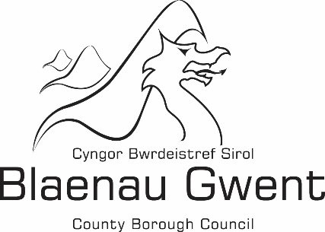

Financial Statement -

Building Regulations Chargeable and Non-Chargeable Account

Financial Statement 2020/2021

Blaenau Gwent County Borough Council's financial statement for 2020/21 is shown below:

 | Chargeable |  | Non-Chargeable |  | Total
 | £ |  | £ |  | £
Expenditure
Employee Expenses | 317,590 |  | 26,166 |  | 343,756
Transport | 3,882 |  | 0 |  | 3,882
Supplies and Services | 6,434 |  | 1,946 |  | 8,381
Third Party Payments | 1,124 |  | 0 |  | 1,124
Central and support service charges | 63,249 |  | 0 |  | 63,249
Total Expenditure | 392,279 |  | 28,112 |  | 420,391
Income
Building Regulations Charges | 109,390 |  | 0 |  | 109,390
Miscellaneous Income | 0 |  | 109 |  | 109
Total Income | 109,390 |  | 109 |  | 109,499
(Deficit)/Surplus for the year | (282,889) |  | (28,003) |  | (310,892)

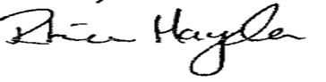
Approved by: …………………………………………………………………………………… (Section 151 Officer)

Date: -------------------------------------------------------------------------------------------------------------------

