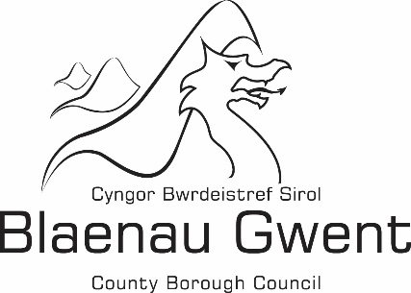

Financial Statement -

Building Regulations Chargeable and Non-Chargeable Account

Financial Statement 2017/2018

Blaenau Gwent County Borough Council's financial statement for 2017/18 is shown below:

 | Chargeable |  | Non-Chargeable |  | Total
 | £ |  | £ |  | £
Expenditure
Employee Expenses | 268,062 |  | 64,275 |  | 332,337
Transport | 7,499 |  | 0 |  | 7,499
Supplies and Services | 6,244 |  | 11,010 |  | 17,254
Third Party Payments | 841 |  | 0 |  | 841
Central and support service charges | 90,462 |  | 0 |  | 90,462
Total Expenditure | 373,108 |  | 75,285 |  | 448,393
Income
Building Regulations Charges | 134,009 |  | 0 |  | 134,009
Miscellaneous Income | 0 |  | 10,922 |  | 10,922
Total Income | 134,009 |  | 10,922 |  | 144,931
(Deficit)/Surplus for the year | (239,099) |  | (64,362) |  | (303,461)

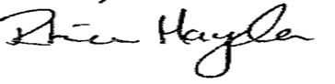
Approved by: …………………………………………………………………………………… (Section 151 Officer)

Date: -------------------------------------------------------------------------------------------------------------------

