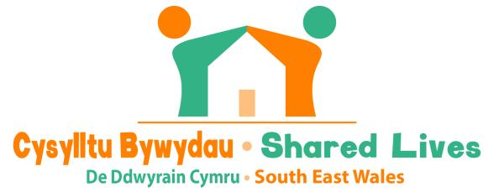

Sharing home, family and community life

The South East Wales Shared Lives Scheme offers a unique community based service for adults who need care and support in Blaenau Gwent, Caerphilly, Merthyr Tydfil, Monmouthshire, Newport and Torfaen. Individuals are matched with compatible Shared Lives carers who offer to share their home, family and community lives.

Shared Lives carers are carefully selected, assessed, trained and supported by the scheme. They come from all walks of life and choose to care for a wide variety of reasons. Shared Lives carers are united through their enthusiasm, commitment, and positive motivation to make a real difference in people’s lives.

The flexibility of Shared Lives means that carers can provide support for lots of different people in a wide range of situations. Individuals supported in Shared Lives may have learning or physical disabilities; they may be older people some who are frail or living with dementia, or people with mental health problems.

Shared Lives carers are self-employed and provide arrangements in their own homes, with the option of providing long term arrangements, respite or day support.

Shared Lives carers can also provide arrangements which may prevent people being admitted into hospital, and people can be discharged from hospital into a Shared Lives setting for a period of recovery and assessment before returning home.

The Scheme is currently recruiting carers in all areas.
If after reading the job description you feel this rewarding opportunity is for you, then please complete an application form via the team on the telephone number below or follow the link below to make your request by email

If you are interested in making a difference to someone's life by becoming a Shared Lives carer, contact the South East Wales Shared Lives Scheme on 01443 864784, email adultp@caerphilly.gov.uk or visit the website www.caerphilly.gov.uk/sharedlives

