****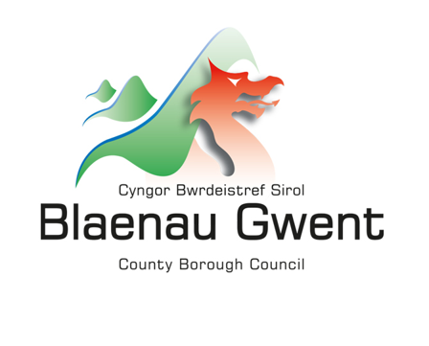

**Shared Prosperity Fund People and Skills Grant Application Guidance**

The application form:

**Applicant information:** This is the name of the person completing the application on behalf of the organisation. Address and contact details should be for the organisation, not personal data.

**Value Being Requested:** Total amount that the applicant is requesting from the Shared Prosperity Fund People and Skills grant scheme. The People and Skills Grant is open to bids up to £250,000 over a 1-year period (April 2024 – April 2025).

Projects of smaller values can be supported by umbrella organisations who wish to apply to fund multiple smaller initiatives. The umbrella organisation will have full responsibility for the administration, payment and monitoring of smaller projects. Umbrella organisations will be held to the same scrutiny as single project holders.

**What intervention does your proposal correspond to:** Blaenau Gwent CBC are committed to addressing all interventions. Where your project aligns with more than one intervention please indicate with a percentage measure e.g.

50% - W40: Green skills courses targeted around ensuring we have the skilled workforce to achieve the government's net zero and wider environmental ambitions.

50% - W41: Retraining and upskilling support for those in high carbon sectors, with a particular focus on transitioning to green, and Industry 4.0 and 5.0 jobs.

**Project Summary:**

Provide describe the project as simply as possible. Do not use technical terms, explain any acronyms. If an assessor cannot understand the project it cannot be assessed against the selection criteria and the bid will be rejected.

**Project Name**: The name of project being proposed not the organisation name.

**Project Proposal:** Please give an overview of what the project intends to do.

**Who will deliver the activities?** **How will the activities be delivered?**

**Who will be the beneficiaries of the project? Where will the activities take place?**

Clearly explain what the project intends to do and how it will be done. Be as straightforward as possible. If it helps to use diagrams these can be inserted into the application. When reviewing your bid consider the following questions from the point of view of someone who knows nothing about the organisation or the project:

* is it clear what the project would do?

* is it clear who will deliver the activities, who is involved and their roles?

* is it clear how, when and where the project will be delivered (ie. will the project deliver one to one support, one to many events/activities, will it be delivered in a specific location, on business or personal premises)?

* is it clear which individuals and businesses will benefit from the project, is there a focus on certain groups of people or types of businesses?

* is it clear how the project activities reflect the investment priorities?

If the project will work with people or businesses, you can summarise the customer journey using a flow chart showing specific project activities. A logic model or theory of change may also help explain your proposal.

**Project dates:** Please enter the project timeframe.

**What are the key milestones for the implementation and delivery of the project?**

These key milestones must link to the proposed activities and demonstrate that the project is deliverable within the project dates. Do not include milestones relating to the approval of the bid. Consider:

* securing internal approvals for the project or any other funding

* establishing the project team

* procurement for external services/suppliers

* project launch and recruiting beneficiaries

* key points on the beneficiary journey

Projects will be monitored against these milestones.

**What experience does the organisation have of delivering this type of activity?**

It is essential that organisations can draw on relevant experience and are able to demonstrate they have access to the resources and expertise they need to deliver the project. Projects that can demonstrate a partnership approach will be scored more highly.

**What outcomes and outputs do you anticipate the project to achieve (please give numbers) and how will you evidence these?**

Provide information on project outcomes and outputs and explain how the figures have been estimated. For example, explain the relationships between the number of intended final beneficiaries and the outcomes you intend to achieve?

Projects will be required to report on the number and type of beneficiaries supported and the outcomes and outputs achieved and will be monitored against these targets.

Project Outputs:

*Number of economically inactive people engaging with keyworker support services (numerical value)*

*Number of economically inactive people supported to engage with the benefits system (numerical value)*

*Number of socially excluded people accessing support (numerical value)*

*Number of people supported to access basic skills (numerical value)*

*Number of people accessing mental and physical health support leading to employment (numerical value)*

*Number of people supported to engage in job-searching (numerical value)*

*Number of people receiving support to gain employment (numerical value)*

*Number of people receiving support to sustain employment (numerical value)*

*Effective working between keyworkers and additional services (number of engagements)*

*Number of people supported to engage in life skills (numerical value)*

*Number of people supported onto a course through providing financial support (numerical value)*

*Number of people supported to participate in education (numerical value)*

*Number of volunteering opportunities supported (numerical value)*

*Number of people taking part in work experience programmes (numerical value)*

*Number of people retraining (numerical value)*

*Number of people in employment engaging with the skills system (numerical value)*

*Number of people receiving support to gain a vocational licence (numerical value)*

*Number of people attending training sessions (numerical value)*

*Number of people supported to gain a qualification or complete a course (numerical value)*

Project Outcomes:

*Number of economically inactive individuals in receipt of benefits they are entitled to following support (numerical value)*

*Number of active or sustained participants in community groups as a result of support (numerical value)*

*Number of people reporting increased employability through development of interpersonal skills funded by UKSPF (numerical value)*

*Number of people with basic skills (English, maths, digital and ESOL) (numerical value)*

*Number of people in supported employment (numerical value)*

*Number of people engaging with mainstream healthcare services (numerical value)*

*Number of people sustaining engagement with keyworker support and additional services (numerical value)*

*Number of people engaged in job-searching following support (numerical value)*

*Number of people in employment, including self-employment, following support (numerical value)*

*Number of people sustaining employment for 6 months (numerical value)*

*Number of people in education/training (numerical value)*

*Number of people experiencing reduced structural barriers into employment and into skills provision (numerical value)*

*Number of people familiarised with employers’ expectations, including, standards of behaviour in the workplace*

*Number of people gaining a qualification or completing a course following support (numerical value)*

*Number of people gaining qualifications, licences and skills (numerical value)*

*Number of economically active individuals engaged in mainstream skills education and training (numerical value)*

*Number of people engaged in life skills support following interventions (numerical value)*

*Increased number of people gaining qualifications, licences and skills (% increase)*

*Increased number of people engaged in life skills support following interventions (% increase)*

**How does the project support the Government’s Net Zero ambitions or wider environmental considerations?**

Projects should be based on low or zero carbon best practice, adopt and support innovative clean tech where possible and support the growing skills and supply chains in support of Net Zero where possible.

**How much UK Shared Prosperity Fund investment is sought (Please give a breakdown of funding request)?**

Summarise the amount that will be spent under main areas of expenditure. The breakdown must be detailed enough to demonstrate that the funding package and budget is appropriate to the proposed activities and sufficient to deliver the project. The project will be monitored against expenditure.

**Does the funding package include any match funding? If so, how much?**

Match funding is any funding other than funding from the Shared Prosperity Fund that will be used to meet project costs. This includes from the project applicant or other organisations including income from beneficiaries. Please set out who match funding will come from, where relevant.

**When will any funding that is not in place be secured?**

If the project relies on match funding and it is not secured, explain when it is expected to be secured and what the impact would be if it is not secured.

**How has the overall budget been estimated, what has been done to test that it is accurate, how would any unexpected costs be managed?**

Describe how the figures provided were estimated. For example

* staff costs of X posts at salaries of £Y pro-rata for Z months of activity

* grants of between £X and £Y at an average of £Z per grant multiplied by the number of expected beneficiaries

* materials at a cost of £X per beneficiary multiplied by the number of expected beneficiaries

Explain what has been done to test the budget is accurate and how any unexpected costs or cost increases would be managed.

**Subsidy Control**

If the project will provide support to businesses or public / voluntary sector organisations that are operating in a commercial way there is potential for this support to represent a subsidy.

If the project would involve the award of subsidies explain how this will be managed in line with the UK’s obligations. For example, small scale awards can be managed under the threshold for Special Drawing Rights (or De Minimis where State Aid applies).

If the project provides support to businesses but you feel this does not constitute a subsidy explain why.

**Branding and Publicity**

As per UK government guidelines: The following logos must also be used when communicating in English and Welsh respectively:

 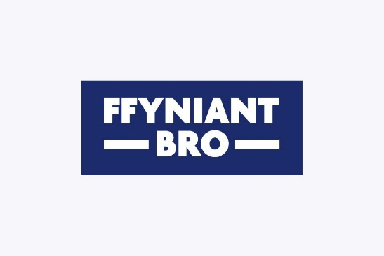

Alongside use of the appropriate UK government logos, lead local authorities and project deliverers must also ensure that websites and printed materials include a clear and prominent reference to the funding from the UKSPF. This includes any preparatory activity linked to the Fund.

We will require project deliverers to install a plaque of significant size at a location readily visible to the public, bearing the appropriate UK government logos, project name and standardised text. Plaques should be bilingual in English and Welsh in Wales.

Co-branding is only permitted with lead local authorities (or any strategic geography branding) or funders.

**Project Applicant Statement**

This section requires the acknowledgement and signature of the applicant and one other senior person within the organisation, be it the Chairperson, Vice Chair or Treasurer or Trustee.