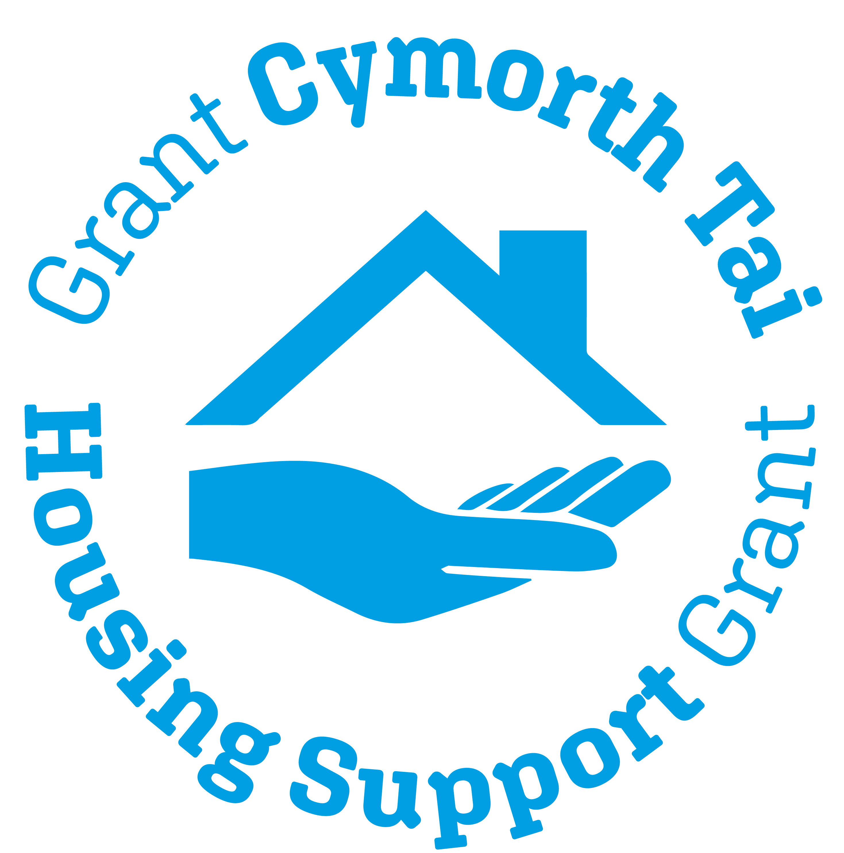
Housing Support Gwent
APril 2022
Gwent Regional Housing Support Collaborative Group
Regional Statement 2022-2023

Gwent Housing Support Grant Regional Statement 2022-2023
Introduction
The Housing Support Grant (HSG) Programme is an early intervention programme that funds a wide range of housing related support and homelessness services for people at risk of homelessness across Gwent, and supports activity to: help people stabilise their housing situation, prevent people from becoming homeless, or helps people affected by homelessness to find and keep accommodation.

The vision for the Housing Support Programme is:

“A Wales where nobody is homeless and everyone has a safe home where they can flourish and live a fulfilled, active and independent life”.
The preventative nature of the programme supports local, regional and national policy objectives that help people to live independently in the community. Housing Support Grant services help prevent homelessness, social exclusion, isolation and institutionalisation. Services also help with the reduction of crime and disorder.
The Regional Housing Support Collaborative Group provides the forum for partners to come together to discuss and agree collaborative working which is better placed to be delivered regionally. The group is committed to delivery of regional working that provides tangible outcomes that can affect change.
This statement provides oversight of the priorities of the RHSCG for the next 12 months; Service Users, providers, wider stakeholders and commissioners working together as equal partners to ensure that services continue to be, sustainable, resilient and able to meet the needs of people that need to access them, remains a key priority for Members of the RHSCG.
Strategic Priorities
The Housing Support Grant Programme is a cross cutting policy framework that links to a wide range of national, regional and local priorities and strategies. There continue to be a range of policy and legislative initiatives, that will influence the future provision, direction and delivery of housing related support and homelessness services for people in Gwent.
The following are the key drivers for the delivery of the Housing Support Grant in Gwent:
- The Well-being of Future Generations (Wales) Act 2015
- Housing (Wales) Act 2014
  - The grant programme makes a significant contribution to the implementation of Part 2 of the Housing (Wales) Act 2014, which is focused on homelessness prevention.

- Social Services & Well-being (Wales) Act 2014
- Violence against Women, Domestic Abuse and Sexual Violence (Wales) Act 2015
- Substance misuse delivery plan: 2019 to 2022
- Renting Homes (Wales) Act 2016
- Welfare Reform Act 2012
- Gwent Homelessness Strategy 2018
- Accommodating Offenders Strategy 2021 *(currently in draft)
- Transition to Rapid Rehousing

The strong links that had been formed with strategic groups and partnerships across Gwent are further strengthened through the establishment of the Regional Housing Support Collaborative Group; a group that has been established and meeting formally since September 2020. The RHSCG provides a forum for collaborative working; an overview of the strategic links the RHSCG has made with partners is provided below:
Gwent Regional Partnership Board and their Strategic Housing Partnership and Mental Health & Learning Disabilities Partnership:

- The RHSCG Chair and a Strategic LA Lead are members of the Strategic Housing Partnership.
- The nominated Health representative provides the link to the Mental Health & Learning Disabilities Partnership.

Gwent Local Authority Public Service Boards:

- RHSCG has a nominated PSB representative

Children’s & Communities Grant:

- RHSCG has a nominated CCG representative
- HSG Leads work collaboratively with their CCG colleagues at a local level

Gwent Violence against Women, Domestic Abuse and Sexual Violence Partnership Board:

- RHSCG has a nominated VAWDASV representative
- Nominated HSG representatives attend the VAWDASV Commissioning Board and VAWDASV Strategic Delivery Group and relevant sub groups
- RDC meets on a regular basis with the VAWDASV Regional Officer

Gwent Area Planning Board for Substance Misuse:

- RHSCG has a nominated Substance Misuse Representative
- RDC attends the APB Strategic Commissioning Group
- The joint Substance Misuse and Housing Sub Group has been established; this group reports to both the APB and the RHSCG
- RDC meets on a regular basis with the Substance Misuse Regional Officer
- RDC attends the DRD Panel to represent HSG and Homelessness
- RDC attends the Harm Reduction Group representing HSG and Homelessness

Criminal Offending and Gwent Safer Communities Board:

- RHSCG has a nominated Probation representative
- RHSCG has a nominated Gwent Police representative
- RHSCG has a nominated Youth Offending Service representative

Private Rented Sector:

- RHSCG has a nominated PRS representative from the National Residential Landlords Association

Public Services:
- RHSCG has nominated representatives from South Wales Fire Service and the Welsh Ambulance Service Trust

Equality & Social Justice:
- RHSCG has a nominated representative from Tai Pawb

Partnership working is fundamental to the success of delivery of the Housing Support Grant. The Gwent RHSCG established itself during 2020/2021 and agreement was sought from a wide range of partners to become members of the group. A full membership list can be found at Appendix 1.
Supply, Needs Assessment, Consultation Evidence and Service Gaps
The Housing Support Grant teams have well established local and regional planning and commissioning frameworks that:
- Create a clear picture of the supply of services and the identified housing related support needs across the localities and the region.
- Enable the planning of services to meet identified gaps in service provision
- Develop and maintain quality services that are sustainable, strategically relevant and offer value for money.
- Ensure services are citizen centred; putting the needs of service users first by conducting appropriate consultation and by providing opportunities to be involved in the planning, commissioning and review of Housing Support Grant funded services.

During 2022/2023 the Gwent inclusive and strategic needs planning process will be undertaken in line with requirements of the COVID-19 Public Health measures.
- The main elements of the strategic planning process are taken forward by the local HSG teams. Some elements including the annual stakeholder and service user engagement processes are taken forward at a regional level, by consultation developed with Planning Officers from the HSG teams and the RDC. The Gwent Housing Support website is additionally utilised as part of this process for on-line surveys: www.gwenthousingsupport.co.uk It is anticipated that engagement exercises will be developed and completed during quarter 2/3.
- A regional supply map of services is collated on an annual basis along with a regional spend plan so that oversight and analysis at a regional level can be undertaken by the RDC as required on behalf of the RHSCG and the local HSG commissioning teams. It is anticipated that the regional supply map and regional spend plan will be collated during quarter 1. A copy of the regional spend plan 2021-2022 can be found at Appendix 2. (*to be included once finalised)
- The recommendations following the research into the needs of LGBTQ+ People in Gwent to be considered once the final report is published in Quarter 2.
- Following the successful development of the virtual platform that was used to deliver an online Open Day during 2021/22. Evaluation information that was gathered from the day, will be considered for the development of future consultation events

Priorities for service development
The RHSCG will be focussed on developing its priorities across the following areas:

• Development of specialist services for which there is not a critical mass locally:

A regional on the shelf register of services is held and maintained by the Regional Development Co-ordinator; projects for this register are currently identified through the needs planning framework.

- Regional project proposals are requested from service providers and wider partners on an annual basis and prioritised using the Gwent HSG Prioritisation Matrix tool. The on the shelf register of services is updated on an annual basis. It is anticipated that this exercise will be completed during quarter 2 / 3
- Additionally, services can be identified through the 2022/2023 local authority needs assessments and planning arrangements and agreed for development by the HSG teams and relevant partners.
- Services are also identified through the consultation exercises which take place on annual basis with Service Users, support providers and wider stakeholders.
- Research projects are undertaken by the HSG Commissioning teams as needed and any recommendations are considered at HSG Leads regular meetings and with relevant partners as required.
- HSG Leads consider where extension of local services to regional provides added value or increased value for money at their regular HSG Leads meeting.
- Updates on any developments in this area provided to the RHSCG.

Consideration will also be given to this area; with work undertaken through the following groups and strategic partnerships:

- VAWDASV Regional Commissioning Board and its sub groups
- Regional Partnership Board Strategic Groups including Strategic Housing Partnership, Young People Partnership, Mental Health & Learning Disabilities Partnership and various sub groups
- Mental Health & Housing Steering Group
- Substance Misuse Strategic Joint Commissioning Group
- Gwent Homeless Prevention Task Group
- Gwent Safer Communities Board; Strategic Assessment for Crime & Disorder
- Strategic partners including Probation, OPCC, Youth Offending Service

Working in partnership with stakeholders to embed specialisms within services and to ensure clear pathways are in place to make the best use of ongoing limited resources remains a key priority for the RHSCG.

• Development of regional services where justified by economies of scale:

It remains a clear priority to assess the specific needs of small groups to which the development or commissioning of separate local services would not be justified or economical.

The local HSG teams are committed to ensuring there remains diversity across the sector in the provision of HSG services from a wide range of providers.

- Consideration is currently given to the development of regional and sub-regional services for specific groups via the regular HSG Lead Officer meeting.
- The supply map of services is collated on an annual basis and a detailed report of all services commissioned across Gwent is shared with HSG Commissioning teams to aid with future service planning.
- Learning from the hoarding pilot to be considered by the HSG Commissioning teams with a view to extending this service to include more Gwent LAs
- It will be a priority for the RHSCG to consider and support services to be developed across this area.

• Delivery of improvements to be achieved by collaboration:

The strong partnerships across Gwent have been fully utilised and further developed through the new working practices introduced due to the COVID-19 pandemic. A wide range of improvements, efficiencies and clearer pathways have been made at a local level to HSG services and wider partner services by working together. It remains a priority for all partners to ensure that collaborating to improve outcomes for people accessing services continues as we move through to recovery phases of the pandemic.

The following areas are highlighted as a priority for this regional statement:

- The strong regional governance framework for HSG with oversight through the RHSCG continues to ensure that there is collaboration and partnership working at a regional level to deliver improvements to services and raise the profile of the Housing Support Grant.
- HSG teams and the RDC will continue to work together to consider improvements that can be made to delivery of the HSG Programme both locally and regionally.
- The RHSCG will work closely with partners to collaborate and support funding bids that will add value and provide positive outcomes at a local and regional level to address homelessness and develop housing support services.
- Working closely with colleagues in the Regional Transformation team to ensure that the profile of HSG is raised across relevant Strategic Partnerships continues to be a priority for the group.
- Working closely with colleagues from other regional boards is an ongoing priority to ensure that the profile of the HSG continues to be raised.
- It was acknowledged by the RHSCG at the virtual development session in 2021 that collaboration at a policy level and the governance of funding streams remains a priority and where there are issues that need to be addressed these will be raised through the appropriate mechanisms.
- Engaging with people who use HSG services is an ongoing priority to ensure that people receiving services are involved in service design and redesign ensuring that services continue to remain relevant and accessible for those that need them in the future.
- Engaging with service providers and stakeholders is an ongoing priority and following delivery of the Virtual Gwent HSG Open Day; learning from that event to be considered in the delivery of stakeholder engagement events for 2022/23

The following bullet points provide an overview of particular areas of work and projects that will be taken forward and further developed at a regional level through 2022/23:

- Money Guiders Learning Programme:
  - In partnership with the Money Advice & Pensions Service; the pilot that was delivered during 2021/22 is going to be widened to all Gwent HSG funded services during quarter 1 providing all support workers across Gwent the opportunity to engage with the training framework to develop money guidance skills and improve consistency in this area. This programme, aims to improve the skills of staff in relation to money guidance.
  - Learning and feedback from the widening of the Gwent pilot, will be gathered by the Money & Pensions Service to inform best practice for a future role out across all HSG services in Wales.
  - Regular updates will be provided to the RHSCG on the progress of the phase 2 project.
- Substance Misuse:
  - Training Needs: It was a recommendation from the Substance Misuse and Housing Task group that the training needs of HSG Funded providers will be reviewed on an annual basis; this process, to be agreed by the HSG Teams and the substance misuse training provider GDAS will be taken forward during 2022.
  - Training: The HSG Teams to determine how best to monitor the take up of the new Substance Misuse E-Learning training package that has been developed by GDAS; offering Level 1 Introduction to Substance Misuse training for all housing workers and which is due to be rolled out during 2022.
  - Drug Related Deaths: Collaborative work will be undertaken to improve the reporting mechanisms to the DRD Panel and to develop the feedback process to housing and homelessness of any recommendations agreed by the group.
- VAWDASV:
  - IDVA: Following the recommissioning of the Regional IDVA service during 2022/23; further work will be undertaken to ensure clear pathways for referral are in place between the new regional service, once it is commissioned and the local HSG funded VAWDASV services.
  - Regional refuge provision: it was highlighted by RHSCG Members that the regional refuge is oversubscribed. HSG teams to consider the needs for refuge provision for those with complex needs
  - Perpetrator Support: consideration of the services needed to support and meet the housing needs of perpetrators of VAWDASV to be considered.
- Complex Needs: it was clear from the RHSCG session to look at future work; that developing and improving the support offer for those with complex needs needed to be reviewed in partnership with colleagues from the Health Board and with those responsible for the delivery of other funding streams such as the Regional Integration Fund.
  - A task group to be established to consider and take forward this work.
- Mental Capacity Act and the Liberty Protection Safeguards Code of Practice: work is underway with colleagues responsible for this area to deliver a session during quarter 1 to housing and homelessness colleagues to raise awareness of the changes to the Mental Capacity Act and to increase understanding of the Liberty Protection Safeguards.
- Digital Inclusion: Following on from the Service User Survey 2021: Focus on Technology;
  - A task group is to be set up to take forward the recommendations contained within the Service User Survey report.

• Collaboration with other public services:

Learning from the COVID-19 pandemic continues to highlight the wide range of collaboration undertaken to ensure that people are able to access services and support when they need it. Working collaboratively across public services continues to be a priority for the RHSCG to further strengthen the preventative approach of services commissioned by the HSG. Additionally:

- Ensuring that membership of the RHSCG is fit for purpose and includes relevant officers from other public service areas will be an ongoing priority for the RHSCG and the RHSCG Chair:
  - Still to be progressed is how we engage with wider health partners for example primary care colleagues at a regional level.
- Hospital Discharge: Following the work to improve the hospital discharge process for people receiving mental health care; ABUHB colleagues and HSG Teams to consider and review the changes made and provide updates to the RHSCG
- Continuing to work in partnership with the following groups and partners is an ongoing priority for the RHSCG:
  - VAWDASV Regional Commissioning Board and Strategic Delivery Group
  - Strategic Housing Partnership and Health Social Care & Housing Operational Group
  - Public Service Board colleagues and thematic boards and groups
  - Mental Health & Housing Steering Group
  - Substance Misuse Area Planning Board and Strategic Joint Commissioning Group
  - OPCC, Gwent Police, Probation and Youth Offending Service partners
  - CCG Partners
  - Gwent Suicide Review group: HSG Lead attends the on behalf of the five Gwent HSG teams
  - Drug Related Death Panel: RDC attends the on behalf of the five Gwent HSG teams
- Ensuring that the Housing Support Grant is well understood and providing clear communications to a range of partners will continue to be a priority for the RHSCG.

The delivery of the areas identified within this regional statement is the collective responsibility of the Regional Housing Support Collaborative Group (RHSCG).

The regional statement will be a standing agenda item at the RHSCG meetings and regular updates will be provided by members of the group at each meeting.

Oversight of this statement is the responsibility of the RHSCG Chair and the Regional Development Co-ordinator.

The work to be taken forward through this statement will be detailed in a work plan overseen by the Regional Development Co-ordinator.
Appendix 1: Membership List

Local Authority Strategic Lead Officer representatives | Blaenau Gwent | Michelle Church (Social Services)
 | Caerphilly | Viv Daye (Social Services)
 | Monmouthshire | Sharran Lloyd (Partnerships )
 | Newport | VACANT TBC following restructure
 | Torfaen | Rachael Lewis (Social Services/Housing) covering Simon Rose
Local Authority HSG Lead Officers | Blaenau Gwent | Claire Davies
 | Caerphilly | Shelly Jones
 | Monmouthshire | Lyn Webber
 | Newport | Nigel Stannard
 | Torfaen | Sophie Slade
Local Authority Homelessness Coordination Cell Leads | Blaenau Gwent | Mark Congreve
 | Caerphilly | Kerry Denman
 | Monmouthshire | Jane Oates
 | Newport | Natalie Thompson
 | Torfaen | Sheryl Thomas
Regional Partners | RPB Strategic Housing Representatives | Simon Rose  Sam Lewis
 | Public Service Boards (PSB) | Sharran Lloyd
 | Substance Misuse APB | Lisa Meredith
 | VAWDASV Commissioning Board Representative | Babs Walsh (Interim)
 | ABUHB Mental Health  Public Health | Joanne Lewis-Jones  Arif Mahmood (PH contact- no capacity to attend meetings at the moment)
 | Probation Representative | Guy Browett  Charlotte Davies
 | Gwent Police | Leigh McFarlane
 | OPCC | Sam Slater/Rosanne Davies
 | Tai Pawb | Rob Milligan
 | Youth Offending Team | Geraint Spacey
 | CCG Representative | Lyn Webber
 | South Wales Fire Service | Ieuan Dobbs
 | Welsh Ambulance Service Trust | Alison Woodyatt
Third Sector Partners | Support providers  Social Housing Landlords | Short Term: Sam Lewis (RHSCG Chair)  Long Term: Kath Deakin  Support Provider Rep: Vacant  Landlord Rep: Mark Doubler  Landlord Rep: Vacant  Landlord Deputy Rep: Vacant
Private Rented Sector | PRS representation | Gillian Owens  Deputy: Tim Thomas
Others Partners | Service User | Specific groups/forums to be arranged

Appendix 2: Local Authority HSG Award and Regional Spend Plan 2022- 2023: All Gwent Local Authorities. Total HSG Allocation: Regional Spend plan to be included in the statement once finalised

Local Authority | 2021/2022
Blaenau Gwent | £3,453,646.23
Caerphilly | £8,435,365.71
Monmouthshire | £2,783,815.10
Newport | £8,577,295.89
Torfaen | £4,639,834.97
Gwent | £27,889,957.90
Wales | £166,763,000

