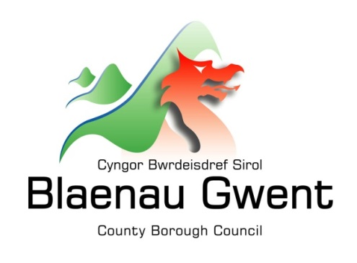

Privacy Notice – School Crossing Patrol Service

This notice is provided for clarification on what information the council needs in order to manage the School Crossing Patrol Service. It is necessary for the council to gather, collect, store and process personal information relating to school crossing patrol staff. The council puts measures in place to protect the privacy of individuals throughout this process

Who is responsible for your information?
All personal information is held and processed by Blaenau Gwent County Borough Council in accordance with Data Protection legislation. For information on the role of the Data Controller, Data Protection Officer and Contact Details for the Council, please refer to the ‘Data Protection’ page of the Council’s website:
https://blaenau-gwent.gov.uk/en/Council/data-protection-foi/data-protection-act/

What Information do we need?
Blaenau Gwent County Borough Council will collect personal information about you, and if necessary, your family and other parties. This information will include:
Details about you, such as, your
- Name and address
- Contact information such as your telephone number and email address
- Date of birth
- NI number
- Bank details
- Other relevant information needed to manage the School Crossing Patrol Service

We will use this information to process information relating to the efficient management of the School Crossing Patrol Service. We may check some of the information with other sources to ensure the information you have provided is accurate.

Why do we need your information?
This information is required by the council in order to carry out its duties under
- The School Crossing Patrol Act 1953
- Road Traffic Regulation Act 1984
- Transport Act 2000

We need this information to:
- Manage the School Crossing Patrol Service
- Process your 4 weekly payment
- Manage sickness

Who will we share your information with?
To enable the Council to manage the School Crossing Patrol Service and comply with our legal obligations, we will share your information with partner organisations, including:

- Department for Work and Pensions and other Government departments;
- Internally within Blaenau Gwent Council for business purposes;
- Gwent Police and other criminal investigation agencies;
- External Occupational Health Provider; and
- ICT provider SRS (Shared Resource Service Wales)

How long do we keep your information?
The Council will only keep your information for as long as necessary. However, there may be circumstances where we may need to keep your information for longer. Full details of how long the Council retains your information can be obtained by contacting the relevant Department responsible for the services you require.
Council contact centre: info@blaenau-gwent.gov.uk / 01495 311556.

Providing accurate information
It is important that we hold accurate and up to date information about you in order to assess your needs and deliver the appropriate services. If any of your details have changed, or change in the future, please ensure that you tell us as soon as possible so that we can update your records.

Automated Decision Making
Some decisions are computer-based as the Council uses automated systems to support its services. If your personal data is processed by automated means, you will be notified of the outcomes and a summary of the criteria used in this process. The results are subject to a final decision by the relevant service manager.

