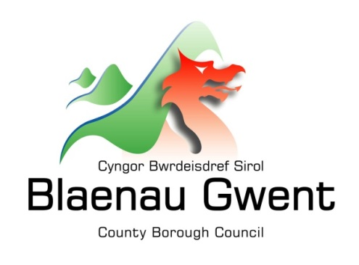

Privacy Notice – Development Services - Development Management

This notice is provided for clarification on what information the council needs in order to process pre-applications enquiries, planning applications and all other associated applications and appeals, Section 106 Agreements and enforcement complaints. It is necessary for the council to gather, collect, store and process personal information relating to applicants and people who comment on applications. The council puts measures in place to protect the privacy of individuals throughout this process

Who is responsible for your information?
All personal information is held and processed by Blaenau Gwent County Borough Council in accordance with Data Protection legislation. For information on the role of the Data Controller, Data Protection Officer and Contact Details for the Council, please refer to the ‘Data Protection’ page of the Council’s website:
https://blaenau-gwent.gov.uk/en/Council/data-protection-foi/data-protection-act/

What Information do we need?
Blaenau Gwent County Borough Council may require the following information:
- Name and address
- Contact information including email address
- Other information you might submit as part of the application process
We will use this information to process your application or comments received.

Why do we need your information?
We require this information to carry out our duties under the:
- Town & Country Planning Act 1990 and associated Regulations
- Planning (Listed Building and Conservation Areas) Act 1990
- Planning (Wales) Act 2015 amends the 1990 and 2004 Acts
- The Town and Country Planning ( Development Management Procedure) (Wales) Order 2012

We need this information to:
- process your Pre-application Advice
- process your planning applications and appeals
- prepare S106 Agreements
- deal with comments received
- deal with enforcement matters
- contact you for research purposes to enable us to improve the services we offer. We may contact you by email, phone, or email.

Who will we share your information with?
To enable the Council to deal with applications and comply with our legal obligations, we will share your information with partner organisations, including:

- Internally within Blaenau Gwent Council for business purposes only
- Your legal representative(s)
- Town or Community Councils
- Welsh Water
- NRW
- Coal Authority
- Wales and West Utilities
- Western Power
- Police
- Gwent Wildlife Trust
- Glamorgan and Gwent Archaeological Trust
- CADW
- RSPB
- Neighbouring Local Planning Authorities
- Welsh Government
- Planning Inspectorate
- SRS (Shared Resource Service Wales) – ICT service provider
- Software Consultants e.g. support for Civica, Assure, GGP and DEF

Personal details of applicants i.e. name and address are required to be made publicly available as part of the planning register.

What is the Lawful basis for processing?
In order to comply with GDPR, personal data shall only be processed where a condition is met under article 6 of the legislation.

In this case, the lawful basis for processing is:

- a legal obligation that requires us to process your personal information;

- carrying out a public task, for instance, performing our safeguarding role, planning or waste services function.

If we have your consent to use your personal information, you have the right to remove it at any time. If you want to remove your consent, please contact DataProtection@blaenau-gwent.gov.uk and tell us which service you’re using so we can deal with your request.

How long do we keep your information?
The Council will only keep your information for as long as necessary. However, there may be circumstances where we may need to keep your information for longer. Full details of how long the Council retains your information can be obtained by contacting the relevant Department responsible for the services you require.
Council contact centre: info@blaenau-gwent.gov.uk / 01495 311556.

Providing accurate information
It is important that we hold accurate and up to date information about you in order to assess your application/comments and deliver the appropriate service. If any of your details are incorrect or incomplete, please ensure that you tell us as soon as possible so that we can update your records.

