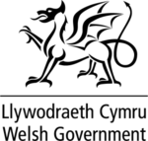
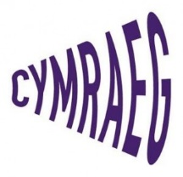
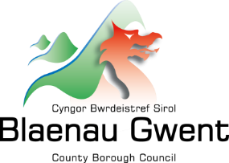

New Welsh-medium Primary School Ysgol Gymraeg Tredegar

Blaenau Gwent County Borough Council Education Transformation team have been lucky enough to secure 100% funding from Welsh Government Welsh-medium Capital Funding. This has enabled the council to build an additional Welsh-medium Primary school and increase our Welsh medium primary provision in the County Borough.
A formal consultation concluded in early 2021 which secured the Council Executive Committee approval in April 2021 to proceed with the build. The preferred site proposed for the development is situated on Chartist Way Tredegar. (See below Image)

It’s Blaenau Gwent’s plan to expand Welsh-medium education so that as a County Borough we can not only contribute to Welsh Government's vision of a million speakers by 2050 but also give the best bilingual start to your child’s education and work prospects through Welsh-medium education.
Ysgol Gymraeg Tredegar
The education offer in the town of Tredegar is about to change. For the first time, Welsh-medium education will be available on your doorstep. Up until now, Welsh-medium education for the whole of the County Borough has been provided at Ysgol Bro Helyg situated in the Brynmawr Valley. Historically pupils from Tredegar have travelled from all over Blaenau Gwent to attend this school.

Here’s what you need to know
The school building is scheduled for completion for September 2024 for 3-year groups to be admitted, this will be Nursery, Reception and Year 1 pupils, every year from 2024 the year groups will increase to include Year 2 right through to Year 6. In 2029 all year groups will be full.
However, the school Ysgol Gymraeg Tredegar will be open September 2023 and parents will be able to apply for places in Nursery and Reception places, these places will be initially located at __________ and will then move to its permanent location at Chartist Way for September 2024.
For the first few years, the school will come under the shared leadership and governing body of Ysgol Gymraeg Bro Helyg. This will enable the school to start under an established and experienced leadership team and progress confidently as more children and staff join the school in Tredegar.

It is an important reminder to parents when applying for a Nursery or Reception place for a Welsh-medium school in Blaenau Gwent, if you live closer to Tredegar, you’ll be able to apply for a Nursery and Reception places at Ysgol Gymraeg Tredegar for September 2023.

However, as a parent if you have older children that already go to Ysgol Gymraeg Bro Helyg, there would not be an option to move them over to the Ysgol Gymraeg Tredegar school as admissions would only be for the Nursery and Reception pupils in 2023 as stated above.
If you have older children in English medium schools and you would like to transfer them into a Welsh medium school, then they would be able to attend Ysgol Gymraeg Bro Helyg, which has all year groups from Nursery to Year 6.
Engagement sessions for parents
There will be a series of engagement/drop-in sessions planned from January 2023 that you will be able to attend for any new parents wanting to find out more about the offer of Welsh-medium education or Ysgol Gymraeg Tredegar.
As a parent you will be able to speak directly with Education staff, School staff representatives and agencies that support pre-school settings to get more information. Or you can call the Education Transformation team on 01495 355470 for more information on Welsh-medium education.

Design Images of Ysgol Gymraeg Tredegar

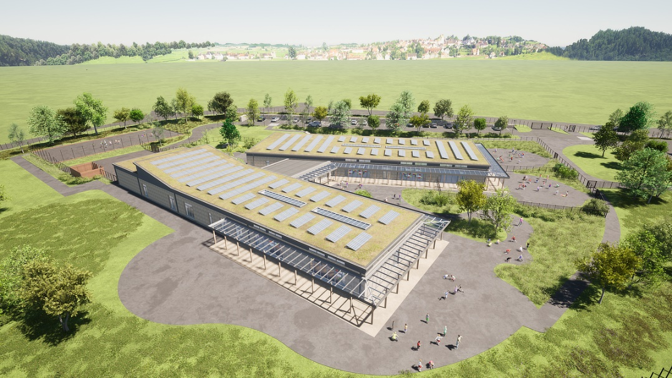

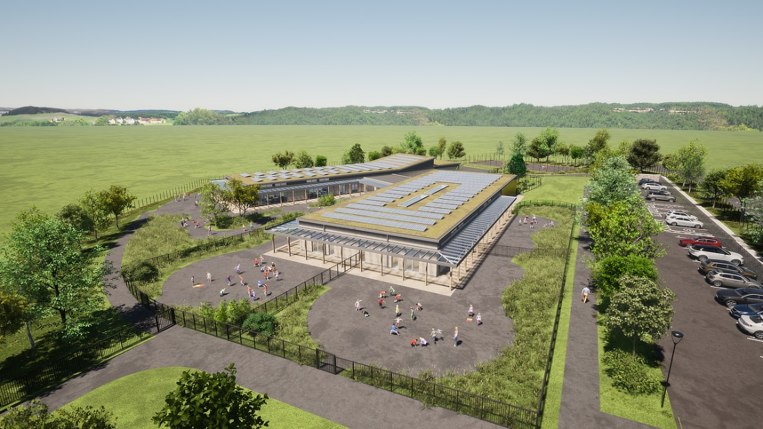

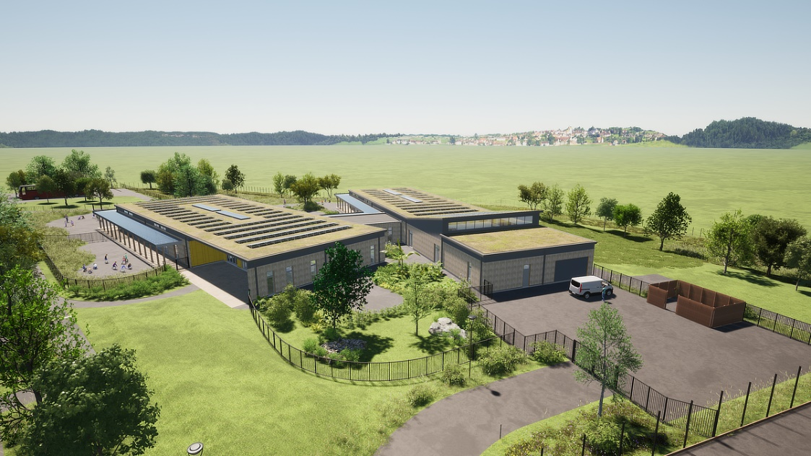

Frequently asked Questions

Frequently asked Questions
Is Welsh-medium education suitable for my child and can my child apply for a place? | Yes, and yes! In a Welsh-medium school, education is delivered in a way that at a very early age, children can speak in Welsh and English from early-years. The way we teach Welsh in a Welsh-medium school is through a method called immersion. Immersion means to surround the child completely with the Welsh language form Nursery and this will continue throughout their education. English is also taught formally from year 3 so that your child’s literacy skills in both languages are developed and progressed to an equal standard.
Does the Welsh Language have an effect on their English or other home languages? | Well, no, this method has been used for many years as a way to transfer languages from one generation to the next. In Wales, Welsh and English have equal status and more and more jobs are now looking for skills in both Welsh and English.  English or the home language is spoken at home and English is also very prominent within the community and is therefore heard and used by the child at the same time as Welsh is being learned in school!
My child has already started primary school. Can I change to a Welsh-medium school now? | Absolutely! There is a provision for any pupil that wishes to change from English-medium school to Welsh-medium school called a Latecomers Centre. Here, the pupil is given intensive language skills in Welsh in a purposely designed environment so that after a short while they will be able to join their own class in their school, in this instance the immersion unit is based in Ysgol Gymraeg Bro Helyg for any pupil/child from Year 1 upwards. This happens over a term or more if the support is needed.  In Blaenau Gwent, all pupils older than year 1 will have to attend Ysgol Bro Helyg as only pupils up to year 1 will be able to attend Ysgol Gymraeg Tredegar.
Wil there be transport provided to the Welsh-medium schools? | The Council has a Home to School Transport policy, it offers free home to school transport for any pupils that live more than 1.5 miles for under 8’s and 2 miles for over 8’s.  The council offers free home to school transport to non-statutory school age pupils (Nursery pupils) to increase the offer for Welsh-medium education.  It should be noted that free Home to School transport is only provided for pupils to their nearest catchment area school and that if you choose to send your child to the other Welsh-medium settings then it will be classed as parental choice and you may not get the free transport offer for your child

