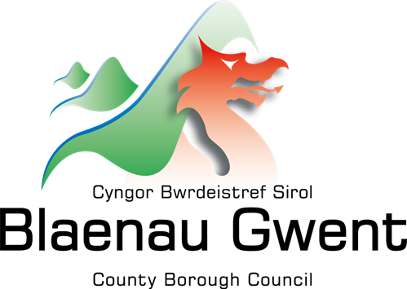
Food bank and Community food provision
Environmental health
Registration

If you are thinking of opening a food bank, community pantry, community café or similar project, this document should serve as a guide to understanding what you need to do to comply with Environmental Health standards.
For further information and up to date guidance on food safety in community food settings, please visit: https://www.food.gov.uk/safety-hygiene/food-safety-for-community-cooking-and-food-banks
If you are providing food and/or drink on a regular and organised basis or are setting up a food bank/ community operation, you will need to register first, with Blaenau Gwent County Borough Council (BGCBC). The earlier you get in touch, the better we can help guide you towards serving your community safely.
If you are an existing food business. you are required to make sure BGCBC is updated on any significant change in food activities on the premises. Significant change could include a community café previously only offering drinks and snacks now providing hot or cold meals, or a foodbank that previously only distributed low-risk, shelf stable foods now distributing high risk fresh produce or prepared meals.
If you are unsure whether you need to register due to the frequency or type of food provision you offer, further information can be found at: https://www.food.gov.uk/safety-hygiene/scenarios-where-registration-may-be-required-when-providing-food-in-the-community or alternatively contact the Environmental health commercial team for support. Additional health and safety guidance around managing risk when working with Volunteers can be found at: https://www.hse.gov.uk/voluntary/index.htm
Registration is free and is a legal requirement. A registration form should be submitted a minimum of 28 days prior to food being provided or significant changes being made to existing food offers. The current registration form can be found under Resident/Environmental Health/Food Hygiene/Food Business Registration - Starting a New Food Business, on the BGCBC website or by following this link: https://www.blaenau-gwent.gov.uk/en/resident/environmental-health/food-hygiene/food-business-registration-starting-a-new-food-business/
It is important to disclose all intended food activities during your registration so that Environmental Health can best advise you on what is required of you, in terms of food safety, before you start serving your community. Please contact the Environmental Health - Commercial Team for free advice and guidance.
Telephone Number: | 01495 357813
Address: | Public Protection – Environmental Health, General Offices, Steelworks Road, Ebbw Vale, NP23 6DN
E-mail Address: | environmental.health@blaenau-gwent.gov.uk
Environmental Health - Commercial Team
If you are unable to access any of the information linked in this document via the web, or require guidance in another format, please contact the commercial team and physical copies and/or alternative access can be provided.

