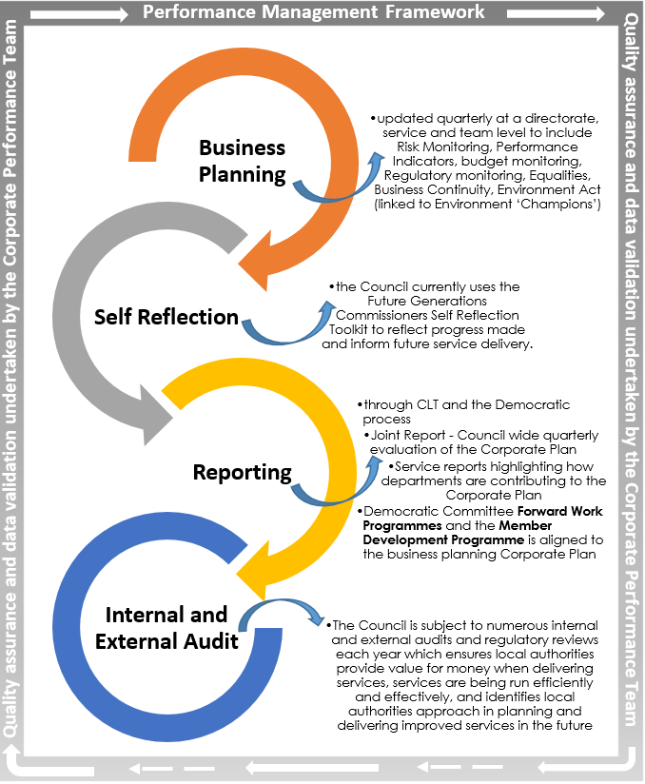

**The Corporate Plan 2020/22**

The Corporate Plan acts as the Council’s business plan and all service delivery is to be aligned to this Plan. The Outcome Statements being implemented are:

* **Protect and enhance our environment and infrastructure to benefit our communities**
* **Support a fairer sustainable economy and community**
* **To enable people to maximise their independence, develop solutions and take an active role in their communities**
* **An ambitious and innovative council delivering the quality services we know matter to our communities**

The Council’s **Performance Management Framework** has been developed to provide a shared understanding of our corporate priorities and statutory obligations as well as our individual roles and responsibilities. This framework sets out the principles, processes and procedures of performance management, linking service delivery to Council priorities.

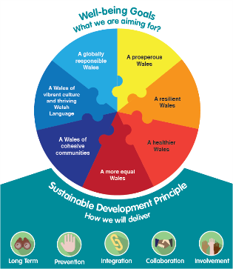

**Legislative Requirements**



In order to meet the statutory legislative requirements, the Council has implemented the following:

* **The Well-being of Future Generations (Wales) Act 2015**: the report uses the priorities within the Council’s Corporate Plan as its Well-being Objectives.
* **Local Government (Wales) Measure 2009:** the report also uses the priorities within the Council’s Corporate Plan as its Improvement Objectives.

All of these areas have supporting actions and measures which are monitored as part of the Council’s business planning process. The Corporate Plan 2018/22 has been strategically aligned to the Public Service Boards Well-being Plan and also identifies how each area supports the progression of the Well-being Goals.

**Well-being of Future Generations (Wales) Act 2015**

The Well-being of Future Generations (Wales) Act 2015 is ground-breaking legislation which aims to improve the social, economic, environmental and cultural well-being of Wales. The vision of this legislation is expressed in the seven National well-being goals.

The Act also puts a duty on public bodies to apply the sustainable development principle which states they ‘must meet the needs of the present without compromising the ability of future generations to meet their own needs”. The sustainable development principle is made up of the five ways of working.



The application of the Sustainable Development Principle and the reach of the Well-being Objectives mean changing the ways in which we operate. Therefore, the following seven areas are key for the Council to focus on, not only to implement the Act, but also to improve service delivery and planning:

* Performance management;
* Financial Planning;
* Risk Management;
* Procurement;
* Corporate Planning;
* Workforce; and
* Assets.