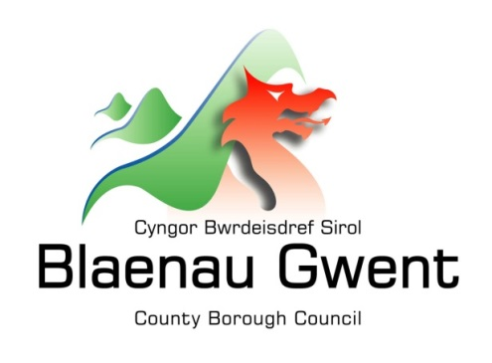

Privacy Notice – Trading Standards

This notice is provided for clarification on what information the Council needs in order to process requests for advice, registration and to deal with complaints/intelligence or service requests in relation to Trading Standards and Consumer Advice. It is necessary for the Council to gather, collect, store and process personal information in order to deliver its services. The Council puts measures in place to protect the privacy of individuals throughout this process.

Who is responsible for your information?
All personal information is held and processed by Blaenau Gwent County Borough Council in accordance with Data Protection legislation. For information on the role of the Data Controller, Data Protection Officer and Contact Details for the Council, please refer to the ‘Data Protection’ page of the Council’s website:
https://blaenau-gwent.gov.uk/en/Council/data-protection-foi/data-protection-act/

What Information do we need?
Blaenau Gwent County Borough Council will collect personal information about you, and if necessary, your family and other parties. This information will include:
• Details about you, such as, your name, address, telephone number, email address, date of birth;
• Other relevant information needed to process your request, such as a description of the service required;

We will use this information to process your request and/or administer the necessary action. We may check some of the information with other sources to ensure the information you have provided is accurate.

Why do we need your information?
This information is required by the Council in order to deliver the services you are requesting and to carry out its statutory functions.

Who will we share your information with?
To enable the Council to process your request and comply with our legal obligations, we will share your information with partner organisations, including:
• Department for Work and Pensions and other Government departments;
• Citizens Advice Consumer Service;
• Gwent Police (or other Police forces as necessary);
• Welsh Government;
• Auditors;
• External regulators eg. The Food Standards Agency , Health and Safety Executive.

• Other Sections or Departments within the Council.

• Trading Standards Services in other Councils and specialist teams of Trading Standards such as the regional Illegal Money Lending Unit and Scambusters.

• Her Majesty’s Courts and Tribunal Service (HMCTS)

The Council will also use the information for the purpose of performing any of its statutory enforcement duties. It will make any disclosures required by law and may also share this information with other bodies responsible for detecting/preventing fraud or auditing/administering public funds.

What is the Lawful basis for processing?
In order to comply with GDPR, personal data shall only be processed where a condition is met under article 6 of the legislation.

In this case, the lawful basis for processing is:

- a legal obligation that requires us to process your personal information;

- carrying out a public task, for instance, performing our safeguarding role, planning or waste services function.

If we have your consent to use your personal information, you have the right to remove it at any time. If you want to remove your consent, please contact DataProtection@blaenau-gwent.gov.uk and tell us which service you’re using so we can deal with your request.

How long do we keep your information?
The Council will only keep your information for as long as necessary. Full details of how long the Council retains your information can be obtained by contacting the relevant Department responsible for the services you require.
Council contact centre: info@blaenau-gwent.gov.uk / 01495 311556.

Providing accurate information
It is important that we hold accurate and up to date information about you in order to assess your needs and deliver the appropriate services. If any of your details have changed, or change in the future, please ensure that you tell us as soon as possible so that we can update your records.

Automated Decision Making
Some decisions are computer-based as the Council uses automated systems to support its services. If your personal data is processed by automated means, you will be notified of the outcomes and a summary of the criteria used in this process. The results are subject to a final decision by the relevant service manager.

